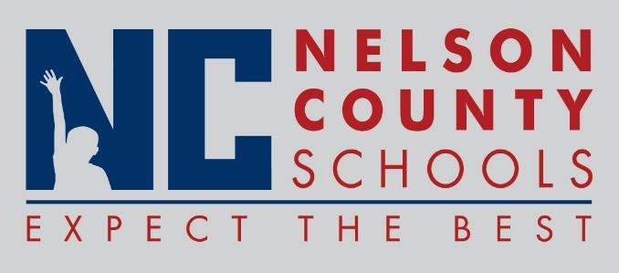

Decision Paper
To: | Nelson County Board of Education
From: | Bob Morris, Director of Student Support
cc: | Dr. Anthony Orr, Superintendent
Date: | May 16, 2017
Re: | Policy Updates for 2017-2018

RECOMMENDATION: Approve the below listed policy updates for 2017-2018 as written for their second reading.

03.13251 Certified Drug Free Schools Policy
03.13251 AP.1 Certified Drug Free Workplace Notice
03.23251 Classified Drug Free Schools Policy
03.23251 AP.1 Classified Drug Free Workplace Notice
09.423 Students Drug Free Schools Policy
09.423 AP.1 Students Drug Testing Procedures
09.423 AP.21 Student Drug Testing Consent Form
S08.1114 Pre School

RECOMMENDED MOTION: I move that the Nelson County Board of Education Approve the listed policy updates for 2017-2018.

