John Hardin SBDM Council
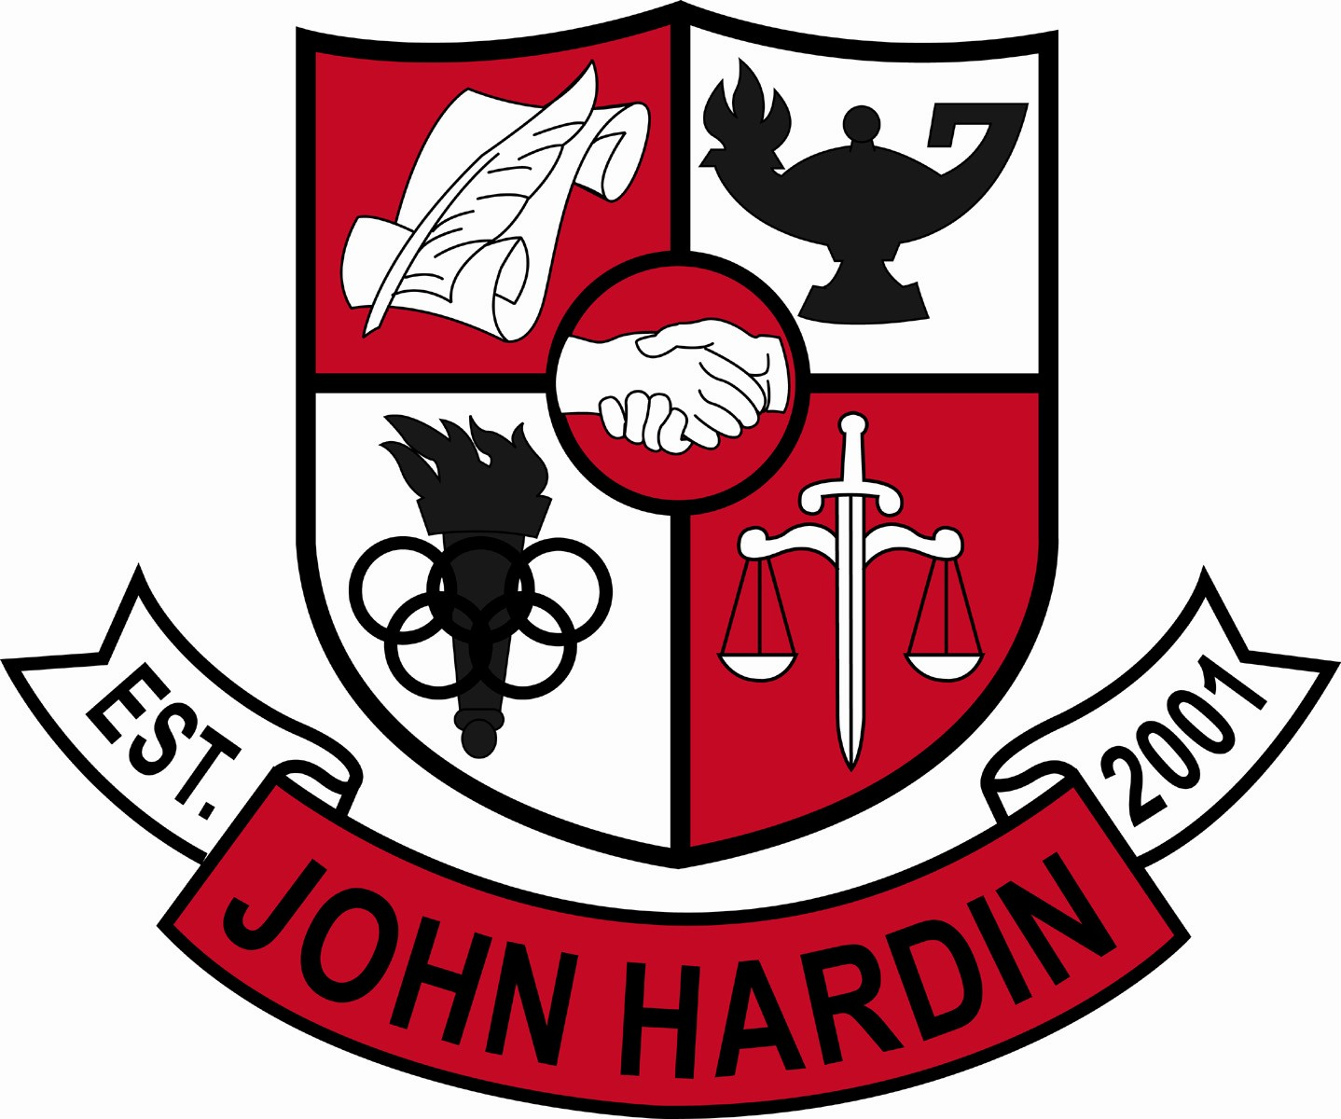
Meeting Minutes

December 14, 2017
4:00 pm

- Call to Order at 4:03
Members present: Mark Wells, Alex Shearer, Jan O’Daniel, Jacinta Pleasant, Michael Robinson and Kristin Humphrey.
Guest: Jo Million
Members Absent: Kelly Smith and James Frye
- Approval of Agenda ORDER #17-18/0027
The council approved the agenda as written.
Motion: Robinson Second: O’Daniel
O’Daniel – Yes
Shearer– Yes
Wells – Yes
Pleasant – Yes
Robinson – Yes
Humphrey- Yes
- Approval of Minutes ORDER #17-18/0028
The council approved the minutes as written.
Motion: Pleasant Second: O’Daniel
O’Daniel – Yes
Humphrey– Yes
Wells – Yes
Shearer – Yes
Pleasant – Yes
Robinson - Yes
- Public Comment – No Comment
- Good News Report
  - Green Team- The team collected enough caps for another bench.
  - KYA – Although the group was smaller this year, numerous awards were received.
  - Vex Robotics – Team 2886B won the Jessamine County Tournament.
  - Community Service – Several clubs and athletic teams are actively volunteering with different organizations within the community.
  - Chili/Dessert Bake Off – Staff members sign up to bring in desserts and chili for sampling and voting. Trophies are awarded for each category.
- Principal’s Update
  - Name and Claim – Freshman core teachers met and identified each student as novice, apprentice, and distinguished. Administration then spoke with novice students and their parents.
  - Focus 40 will be on Wednesdays during the third trimester. Students requiring intervention will be assigned closed sessions and open sessions will be offered to the remainder of the student body. During open sessions, teachers will teach their subject to provide additional assistance.
- Financial Report – November ORDER #17-18/0029
The financial report for November was reviewed and accepted.
Motion: Shearer Second: Robinson
O’Daniel – Yes
Humphrey - Yes
Wells – Yes
Shearer – Yes
Pleasant – Yes
Robinson – Yes
- College and Career Readiness (CCR) Policy – 2nd Reading
At this time, the committee did not vote on the policy due to concerns from other staff members, students and parents. The committee suggested other ideas to increase career readiness which will be considered.
- CSIP ORDER #17-18/0030
The Comprehensive School Improvement Plan (CSIP) was approved as written.
Motion:Shearer Second: Robinson
Humphrey – Yes
Shearer – Yes
Wells – Yes
Pleasant – Yes
Robinson – Yes
O’Daniel - Yes
- Personnel
Hired: Tim Snyder, Band Assistant
Vacancies: Coach – Golf; Coach - Boys Soccer Assistant; Coach – Baseball Assistant 90% Stipend; Coach – 9th Grade Softball Coach
- Agenda Items for Next Meeting
- Adjourn
The meeting was adjourned at 4:44 p.m. The motion was made by Mr. Shearer and seconded by Mr. Robinson.

