Regular Meeting Boone County Board of Education
November 08, 2018 7:30 PM
Ralph Rush Professional Development Center
99 Center Street
Florence, Kentucky 41042

I. CALL TO ORDER

The Regular meeting of the Boone County Schools Board of Education November 08, 2018 was called to order by Chairperson Ed Massey at the Ralph Rush Staff Development Center.
Attendance Taken at 7:30 PM:

Present Board Members:
Dr. Maria Brown
Mr. Ed Massey
Mr. Matt McIntire

Absent Board Members: Informed the board they would be unable to attend.
Ms. Bonnie Rickert
Ms. Karen Byrd

Gerry Dusing attended as Board Attorney
Karen Evans, Board Secretary, recorded the minutes.

II. VETERANS DAY RECOGNITION
Mr. Massey asked for a moment of silence in recognition of Veterans Day and asked all service men and women to stand to be recognized.

III. NATIONAL ANTHEM
The National Anthem was presented by students from Cooper High School.

IV. PLEDGE TO THE FLAG
The Pledge to the Flag was led by students from Florence Elementary.

V. STUDENT BOARD MEMBER REPRESENTATIVE REPORT
Student Board Member Representative report was given by Nick Rassenfoss, Interim Student Board Representative. Nick gave the board the highlights of the last Student Advisory Board Meeting and stated Anna Impellitteri would be returning at the next meeting. Nick also reported a Commander and a 1st Class Sargent visited as Community leaders and spoke to the students at the Council meeting on Leadership. Mrs. Hicks lead the Council with an activity on how to analysis priorities. Nick discussed the High School Drug Free Clubs of America and thanked the Florence Freedom for helping to gain sponsorships for the students.

VI. GOOD NEWS
VI.A. The board recognized and congratulated the November 2018 Break the Mold Recipient, Ms. Robin Mullins, Kindergarten Pare Educator, Yealey Elementary.

VI.B. The board recognized and congratulated the 2018 Transportation Safety Awards recipients.
Boone County Transportation announced that 61 drivers have qualified for safe driver awards this year. We are especially proud of two individuals who have qualified for the 10 year award and one individual who has qualified for a 20 year award. The drivers will be receiving their awards this year at our annual Christmas Luncheon in December.

1 Year Award | 5 Year award | 10 Year Award | 20 Year Award
Debbie Addington | Sheryl Beatty | David Banks | Tim Carrier
Roberta Banks-Powell | Joe Dean | Deron Jump
Wilson Bennett | Joy Hollon
Galen Burns | Kevin Hunter
Judy Burns | Shelley Ittig
John Burt | Kari Mahan
Steve Cable | Cheri Maldonado
Carol Casterline | Gregory Clayton
June Clevenger
Jerry Cook
Jackie Cramer
Bruce Demoret
Donna Dillon
Gary Dugan
Mike Duggins
Paul Dusing
Pam Elder
Susan Eslager
Sena Farrell
Johanna Ferguson
Michael Foltz
Tami Gibson
Paul Goodridge
Leann Haubner
Dennis Hoeben
Becky Holt
Vickie Kraus
Kelly Manning
Rob Marcelina
Michael Maschmeyer
Connie Broyhill
Janice Miskiewicz
Sean Mulligan
Denis Oliver
Kenneth Paratchek
Lori Phillips
Jerome Powell
William Quant
John Roth
William Sloan
Timothy Tepe
Stephen Thomas
Angela Vickers
Charles Vickers
Glenn Wells
John Willen
Ted Wingrove
Erik Maltener
Terry Barefoot
Michael Griffin

VI.C. 2018 Energy Star Re-Certification Awards
As a district, we work hard to be energy efficient. Not only is it important for financial and environmental reasons, but to teach our children the importance of conserving energy, as well. We are excited to announce four schools have earned an ENERGY STAR certification from the US Environmental Protection Agency, for the first time. To be an ENERGY STAR certified school, the school has proven and verified superior energy performance over a 12-month period, performing better than 75% of similar buildings nationwide; saving energy, money and protecting the environment by generating fewer greenhouse gas emissions.
Twelve schools were announced as earning their re-certifications for 2018.
High Schools:
Cooper
Middle School:
Camp Ernst Conner Gray Jones
Elementary School:
Burlington Erpenbeck Florence Kelly
Longbranch Stephens Thornwilde

VI.D. Boone County Business Association Golf Outing Check Presentation.
Check will be presented at a later date.

VI.E. November Parent Power Awards

Conner High School Nikki Newman
Shari Replogle

Cooper High School Jason Ishmael
Sabrina Ishmael

Ballyshannon Middle School Ashlee Wolf
Kasey Reed-Long
Diane Whalen

Camp Ernst Middle School Jeanette Ridener

Conner Middle School Karen Morelli
Jenny Murray

Mann Elementary School Amy Kremer
Kim Hoffman

VI.F. Ockerman Middle School Kentucky Green and Healthy School Award
The Kentucky Green & Healthy Schools (KGHS) is a project-based program involving a team of students, teachers and school administrators working together to improve the campus. The Director of the KGHS recognized Ms. Jennifer Davis of OMS for leading this program and her hard work along with her team.

VII. RECOMMENDED ACTION - CONSENT AGENDA
Dr. Poe, Superintendent, recommended the board to approve the Consent Agenda items A -DDD for Board approval as presented.

- A motion was made by Matt McIntire, seconded by Maria Brown, to approve the consent agenda items A-DDD, as presented. Matt McIntire, Maria Brown, and Ed Massey voted, “aye” MOTION: The motion passed 3-0.

VII.A. Minutes of the regular board meeting of Regular Board Meeting of October 11, 2018.
The board approved the minutes of the regular board meeting of October 11, 2018 Regular board meeting , as presented.
VII.B. Special Board Workshop Kern Book Study October 18, 2018
The board approved the Special Board Workshop Kern Book Study October 18, 2018, as presented.
VII.C. Bill List
VII.D. Treasurer's Report was given by Mrs. Linda Schild.
VII.E. Leaves of Absence
The following persons submitted leaves of absence requests were approved:
Recommended by Principal/Supervisor for approval:
Ahlman, Molly, Teacher @ Burlington ES 10/22/2018 – EOY
Couch, Michael, Maintenance Worker @ Maintenance 10/22/2018 – 1/3/2019
Dillon, Donna, Bus Driver @ Transportation 10/1/2018 – 1/3/2019
Forte, Dawn, Teacher @ Ryle HS 11/14/2018 – 12/5/2018
Gilliam, Jean, Café Worker @ Boone County HS 10/1/2018 – 10/16/2018
Hibbett, Ashley, Teacher @ ACE 11/5/2018 – 11/30/2018
Jeffries, Melissa, Teacher @ Yealey ES 11/19/2018 – 12/14/2018
Lovins, Marissa, Teacher @ Ockerman MS 10/25/2018 -12/31/2018
Martin, Emily, Teacher @ Conner HS 12/11/2018 – 1/4/2019
Menning, Leo, Bus Driver @ Transportation 10/19/2018 – 3/1/2019
Puff, Samantha, Teacher @ Conner HS 10/29/2018 – 01/02/2019
Ratliff, Dawn, Custodian @ Goodridge ES 10/12/2018 – 10/23/2018
Turner, Melissa, Teacher @ Thornwilde ES 10/22/2018 - EOY
Villari, Izetta, Teacher @ Ryle HS 9/18/2018 – 1/3/2019
Winterman, Elisa, Café Worker @ Conner HS 9/11/2018 – 12/3/2018
Zegarra, Debrorah, Teacher @ North Pointe ES 9/14/2018 – 12/19/2018
Not Recommended by Principal/Supervisor for approval:
Nothing to Report
Amended Leaves:
Anderson, Elizabeth, Teacher @ Burlington ES 9/18/2018 – 11/9/2018
Focke, Christy, Bus Driver @ Burlington ES 8/14/2018 – 10/30/2018
Hall, Cynthia, Bus Driver @ Transportation 9/28/2018 – 11/7/2018
Jackson, Erin, Café Worker @ Florence ES 8/29/2018 – 10/22/2018
Mcglasson, Kathleen, Teacher @ Stephens ES 8/28/2018 – 10/12/2018
Schneider, Eric, Teacher @ Ballyshannon ES 9/21/2018 – 10/16/2018
Warning, Mark, Custodian, @ Yealey ES 4/23/2018 – 12/10/2018
Cancelled Leaves:
Nothing to Report

VII.F. Bus Request- Union Pointe Academy
The board approved the bus request from Union Pointe Academy, as presented.
VII.G. Change Order #1- Central Office HVAC Upgrades BG# 18-036
The board approved the the Change Order #1 for Central Office HVAC Upgrades, as presented.
VII.H. Revised BG-1 for Steeplechase- New School BG#19-078
The board approved the revised BG-1 for Steeplechase, as presented.
VII.I. Change Order #1- Stephens Campus Bus Garage/Facility Management- Generators BG#17-280
The board approved the change order for Stephens Campus Bus Garage/Facility Management, as presented.
VII.J. Declaration of Books as Surplus from R.A. Jones Library
The board approved the declaration of books as surplus from R.A. Jones library, as presented.
VII.K. Surplus Technology Equipment
The board approved certain technology equipment be declared as surplus, as presented.
VII.L. Surplus Lawn and Garden Equipment
The board approved certain lawn and garden equipment be declared as surplus, as presented.
VII.M. Surplus Equipment from Stephens Elementary School
The board approved the items from Stephens Elementary School be declared as surplus, as presented.
VII.N. Ballyshannon Middle School Copier/Printer Lease Agreement
The board approved the Ballyshannon Middle School copier/printer lease agreement, as presented.
VII.O. Conner High School Copier/Printer Maintenance Agreement
The board approved the Conner High School copier/printer maintenance agreement, as presented.
VII.P. Ballyshannon Middle School Copier/Printer Maintenance Agreement
The board approved the Ballyshannon Middle School copier/printer maintenance agreement, as presented.
VII.Q. Quote for WeVideo Subscription Renewal at Thornwilde Elementary School
The board approved the Quote for WeVideo Subscription Renewal at Thornwilde Elementary School, as presented.
VII.R. Enrollment for Education Solutions Contract Extension
The board approved the 3 year extension of licensing services from Microsoft, as presented.
VII.S. Change Order #1- Paving 2018 BG#18-233
The board approved the change order for paving 2018, as presented.
VII.T. Executive Charter for Cooper High School Football
The board approved the agreement with Executive Charter for Cooper High School football, as presented.
VII.U. Memorandum of Understanding by and Between The Boone County School and the Northern KY Health Department for the Pediatric Abusive Head Trauma Safe Sleep of Infants
The board approved the Memorandum of Understanding by and Between The Boone County School and the Northern KY Health Department for the Pediatric Abusive Head Trauma Safe Sleep of Infants, as presented.
VII.V. Kenton County Facility Use Contract with Boone County High School
The board approved the Kenton County Facility Use Contract with Boone County High School, as presented.
VII.W. Savings Products Agreement with Ryle High School
The board approved the agreement with Savings Products Program Agreement and Ryle High School, as presented.
VII.X. Change Order #10- Ballyshannon Middle School BG#15-279
The board approved the change order #10 for Ballyshannon Middle School, as presented.
VII.Y. Field Trips
The board approved the field trip requests, as presented.

School | Date Of Trip | Location | Reason
ATC | December 4, 2108 | Lexington | Educational
Ryle High School | April 26-30, 2019 | Orlando, FL | Educational
Ryle High School* | November 1, 2018 | Chicago, IL | FBLA National Fall Leadership Conference
Ryle High School* | October 24, 2108 | Indianapolis, IN | FFA National Convention
Stephens Elementary | November 16, 2108 | COSI | Educational
Thornwilde Elementary | April 18, 2019 | Conner Prairie | Educational
- All travel by commercial carrier is due to schedule/cost.

*Preapproved by Board Chairperson

VII.Z. Revised BG-1 for Burlington Elementary School- Renovations BG#19-105
The board approved the revised BG-1 for Burlington Elementary, as presented.
VII.AA. Memorandum of Agreement by and between Cancer Family Care and Boone County Schools.
The board approved the Memorandum of Agreement by and between Cancer Family Care and Boone County Schools, as presented.
VII.BB. Memorandum of Agreement by and Between Fernside and Camp Ernst Middle School
The board approved the Memorandum of Agreement by and Between Fernside and Camp Ernst Middle School, as presented.
VII.CC. Agreement between TE21, Inc. and Florence Elementary School
The board approved the Agreement between TE21, Inc. and Florence Elementary School, as presented.
VII.DD. Lakefront Lines Transportation for Thornwilde Elementary
The board approved the Lakefront Lines Transportation for Thornwilde Elementary, as presented.
VII.EE. The Children's Theatre Performance Contract for Florence Elementary
The board approved The Children's Theatre Performance Contract for Florence Elementary, as presented.
VII.FF. Ballyshannon Middle School Copier/Printer Lease Agreement
he board approved the Ballyshannon Middle School Copier/Printer Lease Agreement, as presented.
VII.GG. BG-1 Application for Paving 2019
he board approved the BG-1 Application for Paving 2019, as presented.
VII.HH. BG-1 Application for Parking Lot Expansion
The board approved the BG-1 Application for Parking Lot Expansion, as presented.
VII.II. BG-1 Application North Pointe Elementary Roof
The board approved the BG-1 Application North Pointe Elementary Roof, as presented.
VII.JJ. BG-1 Application Central Office Roof and Roof Screens
The board approved the BG-1 Application Central Office Roof and Roof Screens, as presented.
VII.KK. BG-1 Application Collins Elementary/Jones Middle Dumpster Enclosures
The board approved the BG-1 Application Collins Elementary/Jones Middle Dumpster Enclosures, as presented.
VII.LL. BG-1 Application Jones Middle and Collins Elementary Underground Utilities
The board approved the BG-1 Application Jones Middle and Collins Elementary Underground Utilities, as presented.
VII.MM. BG-1 Application Boone County Schools Preschool Playground Barriers
The board approved the BG-1 Application Boone County Schools Preschool Playground Barriers, as presented.
VII.NN. BG-1 Application for Conner Middle School Flooring
The board approved the BG-1 Application for Conner Middle School Flooring, as presented.
VII.OO. KHSAA Bylaw 25 Coaching Qualifications
The board approved the utilization of the KHSAA Bylaw 25 Coaching Qualifications, as presented.
VII.PP. Architectural Services Agreement for Burlington Elementary School Renovations
The board approved the Architectural Services Agreement for Burlington Elementary School Renovations, as presented.
VII.QQ. Architectural Services Agreement for Paving 2019
The board approved the Architectural Services Agreement for Paving 2019, as presented.
VII.RR. Revised BG-1 for Paving 2018 BG# 18-233
The board approved the Revised BG-1 for Paving 2018 BG# 18-233, as presented.
VII.SS. Facility Use Agreement NKY All-Stars with Burlington Elementary
The board approved the Facility Use Agreement NKY All-Stars with Burlington Elementary, as presented.
VII.TT. Memorandum of Understanding by and between The Boone County Alternative Programs and Common Scents Canine Center, Inc.
The board approved the Memorandum of Understanding by and between The Boone County Alternative Programs and Common Scents Canine Center, Inc., as presented.
VII.UU. Letter of Request from Florence Elementary regarding Volunteers through Pet Partners
The board approved the Letter of Request from Florence Elementary regarding Volunteers through Pet Partners, as presented.
VII.VV. Cooperative Student Teacher Agreement- University of Louisville
The board approved the Cooperative Student Teacher Agreement- University of Louisville, as presented.
VII.WW. KETS 2019 Offer of Assistance
The board approved the KETS 2019 Offer of Assistance, as presented.
VII.XX. Queen City Transportation for ATC to Lexington
The board approved the Queen City Transportation for ATC to Lexington for field trip, as presented.
VII.YY. Bus Request Hebron Baptist Church
The board approved the bus request for Hebron Baptist Church, as presented.
VII.ZZ. Executive Charter for Stephens Elementary to COSI
The board approved the Executive Charter for Stephens Elementary to COSI, as presented.
VII.AAA. Facility Use Agreement Boone County Little Rebels with Collins Elementary
The board approved the Facility Use Agreement Boone County Little Rebels with Collins Elementary, as presented.
VII.BBB. Declaration of Sale of Surplus Bus
The board approved and declared sale of surplus bus, as presented.
VII.CCC. Memorandum of Understanding Thomas More University
The board approved the Memorandum of Understanding Thomas More University Educator Preparation Program, as presented.
VII.DDD. Agreement Between Receptions, Inc. and Cooper High School for Football Banquet
The board approved the Agreement Between Receptions, Inc. and Cooper High School for Football Banquet, as presented.

VIII. RECOMMENDED ACTION - OLD BUSINESS
VIII.A. 09.436 Board Policy Update Search and Seizure 2nd Reading

Dr. Poe, Superintendent, recommended the board approve the 09.436 Board Policy Update Search and Seizure 2nd Reading, as presented.

- A motion was made by Maria Brown, seconded by Matt McIntire, to approve the 09.436 Board Policy Update Search and Seizure 2nd Reading, as presented. Matt McIntire, Maria Brown, and Ed Massey voted, “aye” MOTION: The motion passed 3-0.

IX. RECOMMENDED ACTION - NEW BUSINESS
IX.A. No New Business

X. SUPERINTENDENT'S REPORT
- Mr. Jason Radford, Director of Process and Performance, reported on the district APQC work with the following PowerPoint that was handed to all board members.

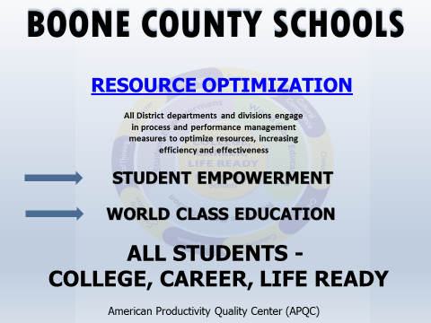

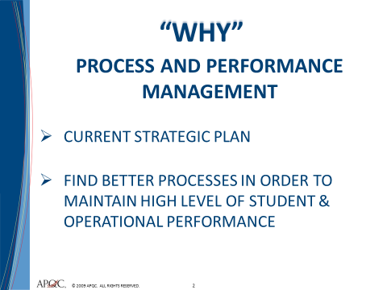

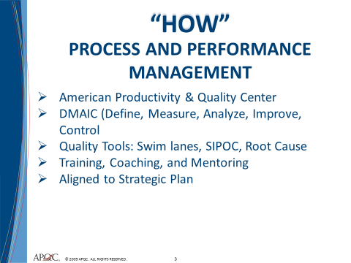
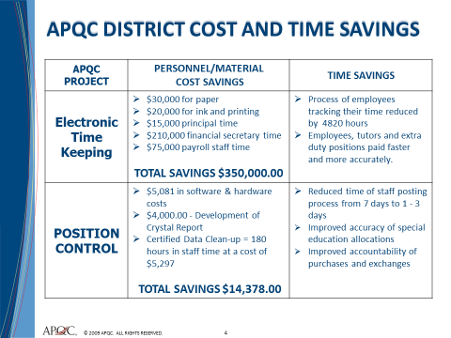

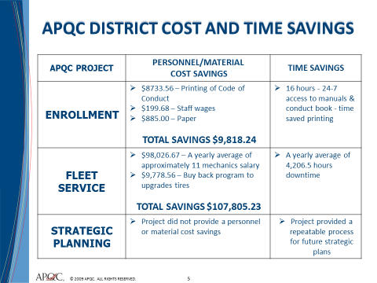

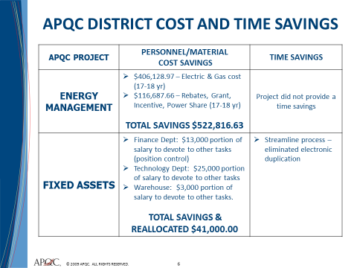
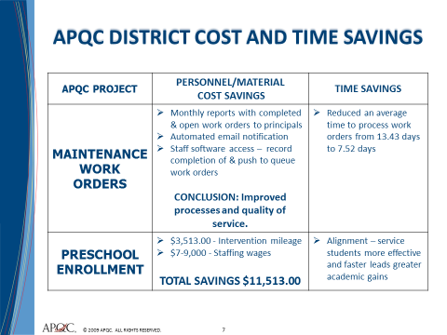

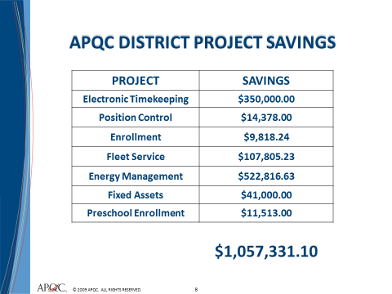
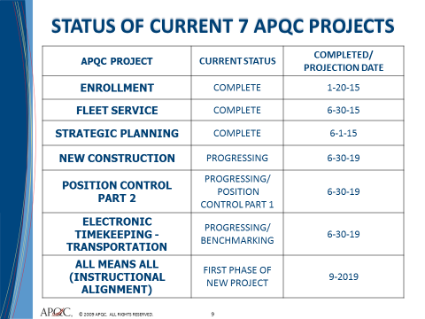

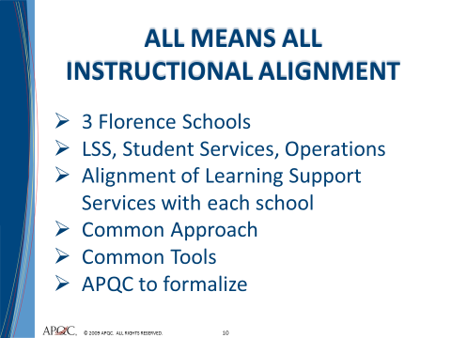

- Mrs. Barbara Kincaid, Director of Food Services, reported to the board on the annual District Wellness Report with the schools that participated. Mrs. Kincaid, reported on the Food Services Goals – Fall and Spring events in the cafeterias to promote nutrition education, increase number of breakfast served by 10% and seasonal menu varieties. Mrs. Kincaid gave highlights of the 2018-2019 School year which were unlimited fruits and vegetables, paid breakfast is .75 and new menu items. The full District Wellness Report can be found on the District website.

- Mrs. Krista Decker, LSS Director of Assessment, presented the board with the 2018 Graduating Class ACT data. Each board member received a copy of the following PowerPoint presentation.

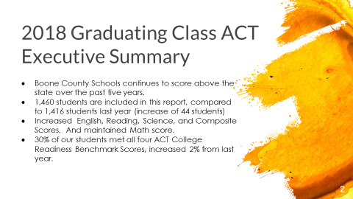

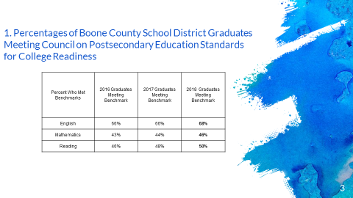
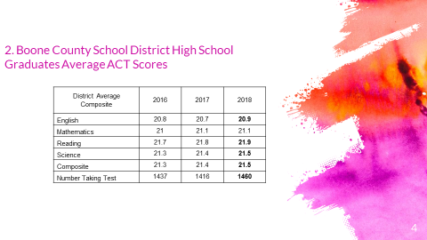

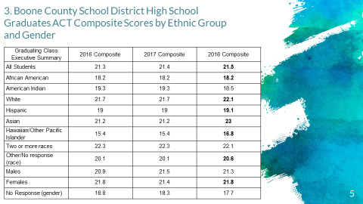

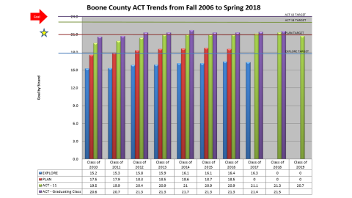

- Dr. Poe announced November 12-17, 2018 will be American Education Week. In celebration of American Education week the board will deliver cakes to the staff support at each school as Thank you for all they do for our district.

XI. INFORMATION, PROPOSALS, COMMUNICATIONS
XI.A. Human Resource Actions
XI.B. Worker's Compensation Claims
XI.C. Overtime Report
XI.D. Construction Status Report
XI.E. Energy Management Report
XI.F. 2018-2019 Boone County Schools District Energy Plan

Ed Massey congratulated Julia Pile and Karen Byrd for being elected to the Boone County Board of Education and thanked both Julia for her commitment to education and Karen Byrd for her continued work and commitment to the school board.

Dr. Poe, Congratulated Ed Massey for being elected as the District 66 State Representative in Kentucky.
XII. AUDIENCE OF CITIZENS
The following education major students attended the board meeting: NKU Students: Elysia Curry, Annie Smith, Breanna Massey, Robert Fausz, Sarah Stetter, Jessica Spenlay, Megan Timmerding, Gracie Compton, Lindsay Knollman, Andrea Moreno-Garza, Megan Huff, Rachel Six, Rebecca Peterson, Emily Dodd, Nicole Byrns. Cumberland School Students: Kristina Gutzwiller.

XIII. CLOSED EXECUTIVE SESSION PER KRS 61.810
XIII.A. No closed session

XIV. ADJOURN

- A motion was made by Matt McIntire, seconded by Maria Brown, to adjourn the meeting. Matt McIntire, Maria Brown, and Ed Massey voted, “aye” MOTION: The motion passed 34-0.

Meeting was adjourned at approximately 8:27 pm

_____________________________________
Bonnie Rickert/Chairperson

_____________________________________
Karen Evans/Secretary

