ACTION ITEM B
August 28, 2023
OLDHAM COUNTY BOARD OF EDUCATION
CONCERN
Consider Approval of the Draft KSBA Policy Manual.
DISCUSSION
The KSBA Draft Manual is available for review on the OCS website. Last month the board had the first reading of the Draft Manual.
The board is asked to approve the KSBA Draft Policy Manual for Oldham County Schools.
The Policy Manual will then be reviewed by chapter and customized for OCS throughout the remaining 2023-24 School year.
Policy Chapter Customization | First Reading | Adoption of Customization
Chapters 1, 2, 10 | September Board Meeting | October Board Meeting
Chapters 4 -7 | October Board Meeting | November Board Meeting
Chapters 3, 8, 9 | November Board Meeting | December and January Board Meeting

RECOMMENDATION
Approve the Draft KSBA Policy Manual for Oldham County Schools and begin the customization process as presented.

On a motion by _______________, seconded by _______________, the Board approved the Draft KSBA Policy Manual for Oldham County Schools and begin the customization process as presented.

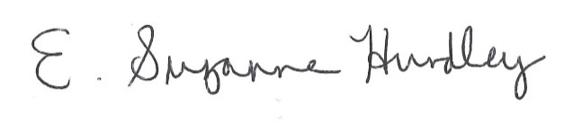
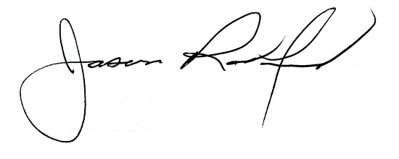

Suzanne Hundley, Board Chair Jason Radford, Superintendent/Secretary

