Regular Meeting Boone County Board of Education
January 09, 2020 7:30 PM
Ralph Rush Professional Development Center
99 Center Street
Florence, Kentucky 41042
I. CALL TO ORDER
The Regular meeting of the Boone County Schools Board of Education January 9, 2020 was called to order by Chairperson Karen Byrd at the Ralph Rush Staff Development Center.

Attendance Taken at: 7:30 PM
Present Board Members:
Dr. Maria Brown
Ms. Karen Byrd
Mr. Matt McIntire
Mrs. Julia Pile
Absent Board Members:
Mr. Troy Fryman

Gerry Dusing, Board Attorney
Karen Evans, Board Secretary
II. NATIONAL ANTHEM
The National Anthem was presented by students from Ryle High School.
III. PLEDGE TO THE FLAG
The Pledge to the Flag will be led by students from Ockerman Elementary.
IV. STUDENT BOARD MEMBER REPRESENTATIVE REPORT
Jessica Engler was unable to attend the meeting as the Student Board Member Representative. Alania McKeown, student board member, reported to the board on the recent Council meeting. Alania spoke on the council participating in the Superintendent Search Surveys, the four learning service projects of mental health, cyberbullying, education literacy, and homelessness. Alania discussed high school marketing the Council and a coming student voice audit for all schools project.
V. GOOD NEWS
A. The members of the school board were recognized with a proclamation read and presented by Judge Executive Gary Moore for National School Board Recognition Month.
B. The board recognized Ms. Karen Byrd for her service as the 2019 Boone County Board of Education Chairperson.
C. Mr. Jim Claxton, President of the Boone County Education Foundation and representatives on the board presented Mini Grant Recipients awards. The BCEF is strictly a volunteer organization and has raised over $84,000 dollars for teachers of Boone County Schools. The Foundation will have their next fund raiser at Turfway Park on March 28th and invite all to join in this fund raising event with 100% of funds going directly to the schools. See website for more details.
Congratulations to the following 2020 Teacher Award Recipients:
High Schools:
Cooper Erin Pifer Video Production iPad
Amy Michael Ebeam Edge

Ryle Elizabeth Schnelle Laser Jet Printer
Alexander Miosi Gross Motor Development
Lora Evans MS Office Testing Center
Middle Schools:
Camp Ernst Amanda Girvin RTI Reading

Ockerman MS Ilsa Barry Little Bits
Jennifer Davis STEM Bike Club

Elementary Schools:
Collins Kelly Hahlbeck STEAM Science Station

Longbranch Rebekah Arvin Ozobots

Mann Anne Oney Makerspace on Wheels
Eric Wilson Energy Interactions

New Haven Suzzane Strawn/ Minds & Motion
Lisa Duawe
Cathy Cyboron Flexible Seating

Ockerman ES Crystal Kleier Mindful Soft Starts
Katie Lynch Quaver Music
Sarah Sironen RTI Books

Stephens Chereste West Scholastic Book

Thornwilde Stephanie Kelso’s Choice
Strausbaugh
Yealey Dee Besl Music Theater Production
Rachel Anderson Middle School Book Study
Wendi Belk Learning Through Hands on Experience

VI. BOONE COUNTY BOARD OF EDUCATION ELECTION OF OFFICERS 2020
VI.A. Election of Boone County Board Chairperson for 2020
Nominations were open for the board to elect a Chairperson for 2020 by Dr. Randy Poe, Superintendent.
- A motion was made by Karen Byrd, seconded by Julia Pile, to nominate Matt McIntire as Chairperson for the year 2020 by acclamation and to close nominations. Karen Byrd, Dr. Maria Brown, Matt McIntire, and Julia Pile voted, “aye.” MOTION: The motion passed 4-0.
Matt McIntire accepted the nomination as new board Chair for 2020 year.
VI.B. Election of Vice-Chairperson for 2020
Nominations were open for the board to elect a Vice-Chairperson for 2020 by Dr. Randy Poe, Superintendent.

- A motion was made by Karen Byrd, seconded by Julia Pile, to nominate Dr. Maria Brown as Vice-Chairperson for the year 2020 by acclamation and to close nominations. Karen Byrd, Maria Brown, Matt McIntire, and Julia Pile voted, “aye.” MOTION: The motion passed 4-0.

Dr. Maria Brown accepted the nomination as new board Vice-Chair for 2020 year.

Matt McIntire began to run the meeting as the new Chair.

VII. RECOMMENDED ACTION - CONSENT AGENDA
Dr. Randy Poe, Superintendent, recommended the following Consent Agenda items A- JJ for Board approval, as presented.
- A motion was made by Karen Byrd, seconded by Julia Pile, to approve the consent agenda items A-JJ , as presented. Dr. Maria Brown recused herself from the minutes she was not in attendance at the December meeting. Matt McIntire, Karen Byrd, Maria Brown, and Julia Pile voted, “aye” MOTION: The motion passed 4-0.
A. Minutes of the regular board meeting of December 12, 2019.
The board approved the minutes of the regular board meeting of December 12, 2019, as presented.
B. Bill List
C. Treasurer's Report was given by Mrs. Linda Schild.
D. Leaves of Absence
The following persons submitted leave of absence requests were board approved:
Recommended by Principal/Supervisor for approval:
Bouwie, Erica, Psychologist @ Longbranch ES2/4/2020 – 3/6/2020
Chalk, Tiffany, Teacher @ Conner MS 11/13/2019 – 12/20/2019
Delph, Brandon (Adam), Custodian @ Northpointe ES 12/5/2019 – 1/30/2020
Hogle, Sabrina, Teacher @ Collins ES 12/13/2019- 2/13/2020
Jozsa, Tracey, Teacher @ Burlington ES 12/2/2020 – 1/30/2020
Poole, Jennifer, Café worker @ Conner HS 1/15/2020 – 1/31/2020
Senechal, Ashley, Café Worker @ Northpointe ES 12/5/2019 -1/30/2020
Not Recommended by Principal/Supervisor for approval:
None
Amended Leaves:
Burke, Karen, Café Worker @ Stephens ES 10/9/19 – 2/28/2020
Craddock, Jessica, Teacher @ Ockerman ES 10/4/2019 –EOY
Farrell, Sena, Bus Driver @ Transportation 9/12/2019 – 12/6/2019
Harvey, Eve, Custodian @ New Haven ES 12/16/2019 -2/14/2020
Palazzo, Keith, Bus Driver @ Transportation 12/5/2019 – 12/13/2019
Riley, Peggy, Bus Driver @ Transportation 10/10/2019 - 12/5/2019
Smith, Susan, Teacher @ Longbranch ES 10/10/2019 – 12/20/2019
Wingate, Greg, Teacher @ Conner HS 10/28/2019- 3/10/2020
Vannarsdall, Robert, Custodian @ Camp Ernst MS 10/23/2018 – 1/31/2020
Cancelled Leaves:
None

E. Memorandum of Understanding between Terri Huntington of Heimlich Heroes and the Boone County Schools
The board approved the Memorandum of Understanding between Terri Huntington of Heimlich Heroes and the Boone County Schools, as presented.
F. Queen City Transportation - Ryle High School Jazz Ensemble on April 30, 2020-May 3, 2020
The board approved the agreement between Queen City Transportation and Ryle High School Jazz Ensemble on April 30, 2020-May 3, 2020, as presented.
G. Memorandum of Agreement between Plan Ahead Smiles and the Boone County Schools.
The board approved the Memorandum of Agreement between Plan Ahead Smiles and the Boone County Schools, as presented.
H. Memorandum of Agreement between ThinkCERCA and Boone County Schools
The board approved the Memorandum of Agreement between ThinkCERCA and Boone County Schools, as presented.
I. Memorandum of Agreement between RA Jones Middle School and Teachers' Curriculum Institute
The board approved the Memorandum of Agreement between RA Jones Middle School and Teachers' Curriculum Institute, as presented.
J. Memorandum of Agreement between Florence Elementary School and McGraw-Hill
The board approved the Memorandum of Agreement between Florence Elementary School and McGraw-Hill, as presented.
K. Memorandum of Agreement between Collins Elementary School and Learning Without Tears
The board approved the Memorandum of Agreement between Collins Elementary School and Learning Without Tears, as presented.
L. Memorandum of Agreement between Florence Elementary School and ESGI
The board approved the Memorandum of Agreement between Florence Elementary School and ESGI, as presented.
M. Memorandum of Agreement between Cara Brown, BCBA and Boone County Schools
The board approved the Memorandum of Agreement between Cara Brown, BCBA and Boone County Schools, as presented.
N. Contract - Conner High School Character Counts Luncheon at Receptions, April 28, 2020
The board approved the Contract - Conner High School Character Counts Luncheon at Receptions, April 28, 2020, as presented.
O. Contract - Gray Middle with Lifetouch
The board approved the Contract - Gray Middle with Lifetouch, as presented.
P. Burlington Elementary - Contract with Showtime Photo Booth on February 22, 2020 - Family Dance
The board approved the Burlington Elementary - Contract with Showtime Photo Booth on February 22, 2020 - Family Dance, as presented.
Q. Bidding Documents and BG-3 for Paving 2020, BG #20-117
The board approved the Bidding Documents and BG-3 for Paving 2020, BG #20-117, documents will be hand carried to board meeting, as presented.
R. Contract - Camp Ernst Middle School with Broadway Junior Disney's Frozen on December 5, 2020
The board approved the Contract - Camp Ernst Middle School with Broadway Junior Disney's Frozen on December 5, 2020, as presented.
S. Queen City Transportation - Conner Middle Pidgeon Forge, TN Trip on May 1-3, 2020 Orchestra Trip
The board approved the Queen City Transportation - Conner Middle Pidgeon Forge, TN Trip on May 1-3, 2020 Orchestra Trip, as presented.
T. Bidding Documents and BG -3 for Boone County High Tuckpointing, BG #20-115
The board approved the Bidding Documents and BG -3 for Boone County High Tuckpointing, BG #20-115, to be hand carried to board meeting, as presented.
U. Contract-Conner Middle School with Music Road Resort, May 1, 2020 Orchestra Trip
The board approved the Contract-Conner Middle School with Music Road Resort, May 1, 2020 Orchestra Trip, as presented.
V. Duke Energy - PowerShare Agreement
The board approved the Duke Energy - PowerShare Agreement, as presented.
W. Florence Elementary - Contract with School Datebooks
The board approved the Florence Elementary - Contract with School Datebooks, as presented.
X. Contract - Cooper High School with Sound for Days, Music for the Senior Dinner Dance on January 25, 2020
The board approved the Contract - Cooper High School with Sound for Days, Music for the Senior Dinner Dance on January 25, 2020, as presented.
Y. Bidding Documents for Burlington Elementary Renovation, BG #19-105
The board approved the Bidding Documents for Burlington Elementary Renovation, BG #19-105, documents will be hand carried to board meeting, as presented.
Z. Contract - Cooper High School with MTI Production for Elf the Musical on December 3 through December 5, 2020
The board approved the Contract - Cooper High School with MTI Production for Elf the Musical on December 3 through December 5, 2020, as presented.
AA. Contract - Burlington Elementary with A-1 Amusement & Party Rental on February 22, 2020
The board approved the Contract - Burlington Elementary with A-1 Amusement & Party Rental on February 22, 2020, as presented.
BB. American Association of School Administrators (AASA) 2020 Spring Leadership Conference for Superintendent Randy Poe
The board approved the American Association of School Administrators (AASA) 2020 Spring Leadership Conference for Superintendent Randy Poe, on Feb. 13-15, 2019 with the estimated expenses to be $2500.00, as presented.
CC. Contract Cooper High School with Kentucky Safe Driver for Alive at 25 Class
The board approved the Contract Cooper High School with Kentucky Safe Driver for Alive at 25 Class, as presented.
DD. Reappointment of Board Treasure for 2020, Linda Schild
The board approved the Reappointment of Board Treasure for 2020, Linda Schild, as presented.
EE. Reappointment of Board Secretary for 2020-Karen Evans
The board approved the Reappointment of Board Secretary for 2020-Karen Evans, as presented.
FF. Agreement With CVG For COOP Experiences
The board approved the Agreement With CVG For COOP Experiences, as presented.
GG. Edgenuity Renewal
The board approved the Edguenity for 2020-2021 School Year, renewing early will provide Boone County a savings of $16,000.00, as presented.
HH. School Facilities Construction Commission Offer of Assistance
The board approved the School Facilities Construction Commission Offer of Assistance in the amount of $47,939.00, as presented.
II. Bus Request- Howell Elementary School
The board approved the bus request for Howell Elementary School on Feb. 21, 2020, as presented.
JJ. Interpreters for the Jan. 14, 2020 Superintendent Search Public Forum
The board approved the Interpreters for the January 14, 2020 Superintendent Search Public Forum from Affordable Languages Company, as presented.
VIII. RECOMMENDED ACTION - OLD BUSINESS
A. No Old Business
IX. RECOMMENDED ACTION - NEW BUSINESS
A. Draft Budget for 2021 Fiscal Year
Dr. Randy Poe, Superintendent, recommended the board approve the Draft Budget for 2021 Fiscal Year, as presented.
- A motion was made by Dr. Maria Brown, seconded by Karen Byrd, to approve the Draft Budget for 2021 Fiscal Year, as presented. Matt McIntire, Karen Byrd, Maria Brown, and Julia Pile voted, “aye” MOTION: The motion passed 4-0.

B. 2019-2020 Comprehensive District Improvement Plan
Dr. Randy Poe, Superintendent, recommended the board approve the 2019-2020 Comprehensive District Improvement Plan, as presented.

- A motion was made by Dr. Maria Brown, seconded by Karen Byrd, to approve the 2019-2020 Comprehensive District Improvement Plan, as presented. Matt McIntire, Karen Byrd, Maria Brown, and Julia Pile voted, “aye” MOTION: The motion passed 4-0.

X. SUPERINTENDENT'S REPORT
Mrs. Jenny Watson, LSS Assistant Superintendent, gave the board report on the Compressive District Improvement Plan (CDIP). Mrs. Watson reported on the Phase dates for Continuous Improvement Process. Discussion in detail was given on the six required goals of Proficiency (Reading and Math), Separate Academic Indicator(Science, Social Studies, Writing), Growth, Achievement Gap, Transition Readiness, and Graduation Rate. The Powerpoint presentation is below:

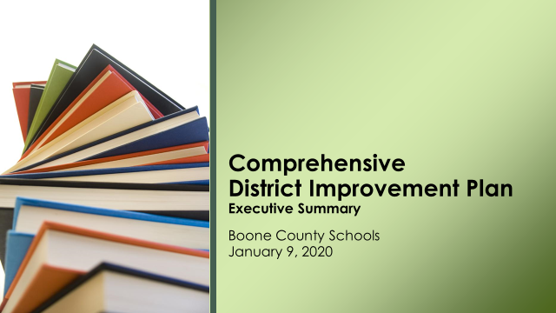

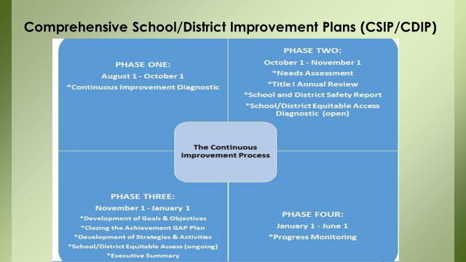
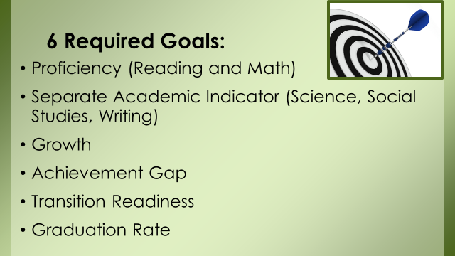
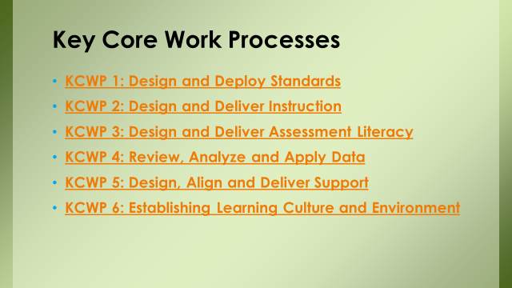

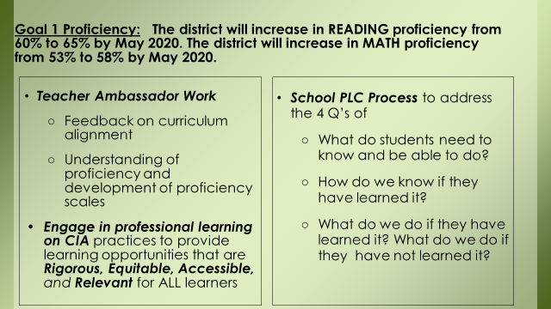

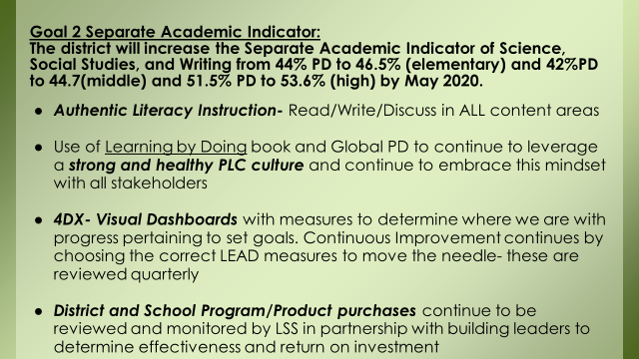

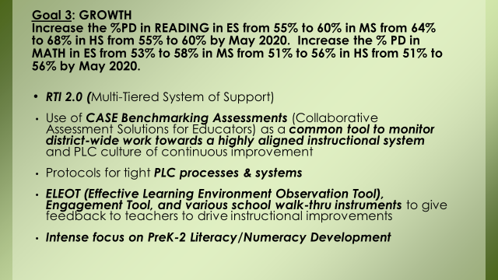
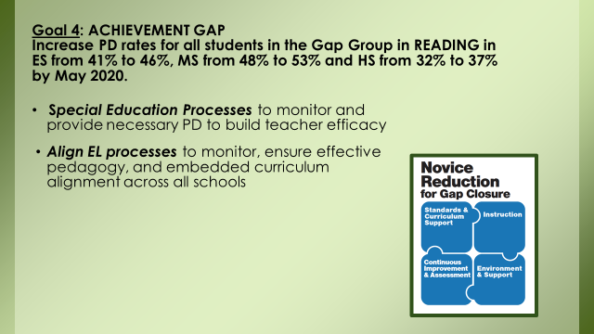
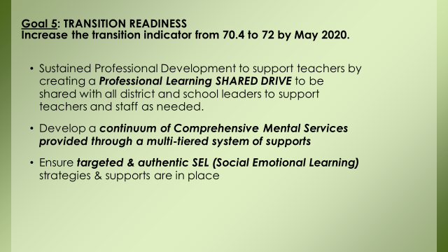
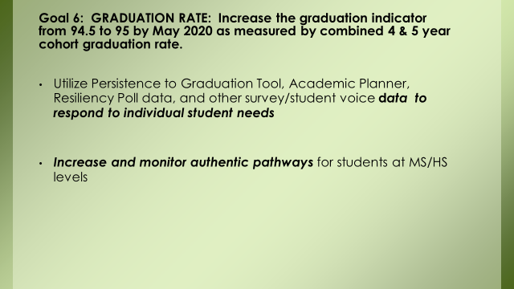

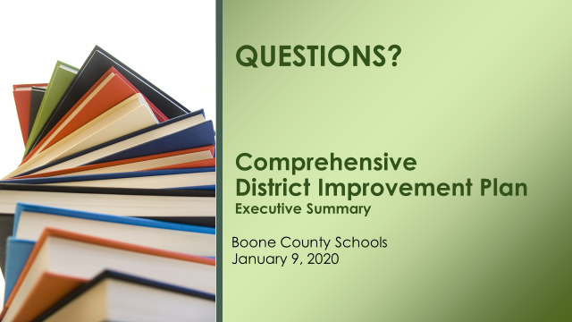

- Dr. Poe announced the Mid-Year Review board workshop on Feb. 6, 2020, at 6:30 pm at Ralph Rush Center.
- Karen Byrd announced the board members will have another meeting at 7:45 on Feb. 6th at Ralph Rush Center, For the Charge to the Superintendent Search Committee.

XI. INFORMATION, PROPOSALS, COMMUNICATIONS
A. Human Resource Actions
B. Worker's Compensation Claims
C. Overtime Report
D. Construction Status Report
E. Energy Management Report

- Karen Byrd announced the Public Forum for the Superintendent Search Input from the community would be at Ignite, at 6:30pm. All are welcome to attend. Ms. Byrd announced the Superintendent Search Survey would launch this night and would be available online for parents, community, and students to let the board know the criteria they feel is important for the next criteria for Boone County.
XII. AUDIENCE OF CITIZENS
No one spoke.
XIII. CLOSED EXECUTIVE SESSION PER KRS 61.810
No closed session
XIV. ADJOURN

- A motion was made by Karen Byrd, seconded by Dr. Maria Brown, to adjourn the meeting. Karen Byrd, Maria Brown, Julia Brown and Matt McIntire voted, “aye” MOTION: The motion passed 4-0.

Meeting was adjourned at approximately 8:36 pm.

_____________________________________
Matt McIntire /Chairperson

_____________________________________
Karen Evans/Secretary

