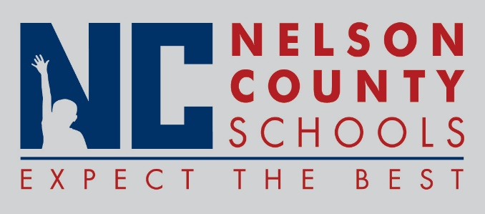

Information Paper
To: | Nelson County Board of Education
From: | Bob Morris, Executive Director of Student Support
cc: | Dr. Anthony Orr, Superintendent
Date: | July 6, 2017
Re: | Sick Bank Summary 2016-2017
CERTIFIED
Beginning Balance as of July 1, 2016 |  |  | 104
New Members 2016 - 2017 |  |  | 12
Days Returned for 2015 -2016 |  |  | 0
Days Returned for 2016 -2017 (non-usage) |  |  | 2.5
Days Granted for 2016 - 2017 |  |  | -26
Ending Balance on June 30, 2017 |  | 92.5

CLASSIFED
Beginning Balance as of July 1, 2016 | 52
New Members for 2016 - 2017 | 15
Days Returned for 2015 - 2016 | 0
Days Returned for 2016 - 2017 for non-usage | 3
Days Granted for 2016 - 2017 | -61
Ending Balance on June 30, 2017 | 9

