Communication Updates- September 2022
Candace Gibson- Communication and Outreach Coordinator

NEWSLETTER
No new updates on the newsletter. Views and opens remain consistent
MAILCHIMP- NEWSLETTER IMPACT (based on the latest edition)
Total Subscribers | 314 (+12)
Number of subscribers who engage via email | 132 opens, 4 link clicks
Social media impressions per week | 787 (Facebook), 132 (Twitter)

SOCIAL MEDIA
Facebook posts increased four-fold over the past month, aligning with the new goal of sharing 3-4 “storytelling” posts per day as well as the necessary informational posts. It’s no surprise that this increase in posts led to a 1,400% increase in engagements. Many of our posts surpassed 3,000 impressions, and our top performing post is shown below:
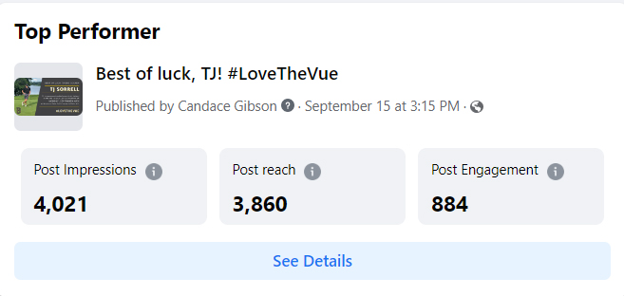
FACEBOOK MONTHLY IMPACT
Total post reach this month | 17,551
Total post engagement (likes, comments, etc) | 15,710 (up from 1,110 last month!)
Number of posts this month | 89 (up from 22)
New followers; new page likes | +47; +49
Total shares | 240

NEW OUTREACH PROJECTS
Advertising for the upcoming Community Forum will begin Friday, 9/23. It will be shared as a Facebook event to allow us to have a rough estimate of attendees.
At the end of the forum, we will announce our new community engagement series, “The Vue at the Brew.” BISD will host a conversation at Avenue Brew on the first Tuesday of each month at 9am. All members of the community are encouraged to attend. Mrs. Middleton and I will primarily lead the sessions, and guest hosts from the district will fill in from time to time. It is our hope to strengthen relationships between the district and the community by meeting Bellevue outside of the school buildings.
Letters were handed out and sent via email to local businesses, inviting them to participate in a friendly window decorating competition for Homecoming week! Several of our local business owners were very excited to join in and support the Tigers for Homecoming. Several of our businesses have a desire for more opportunities to partner with the schools, and I look forward to fostering those relationships and expanding those partnerships.

