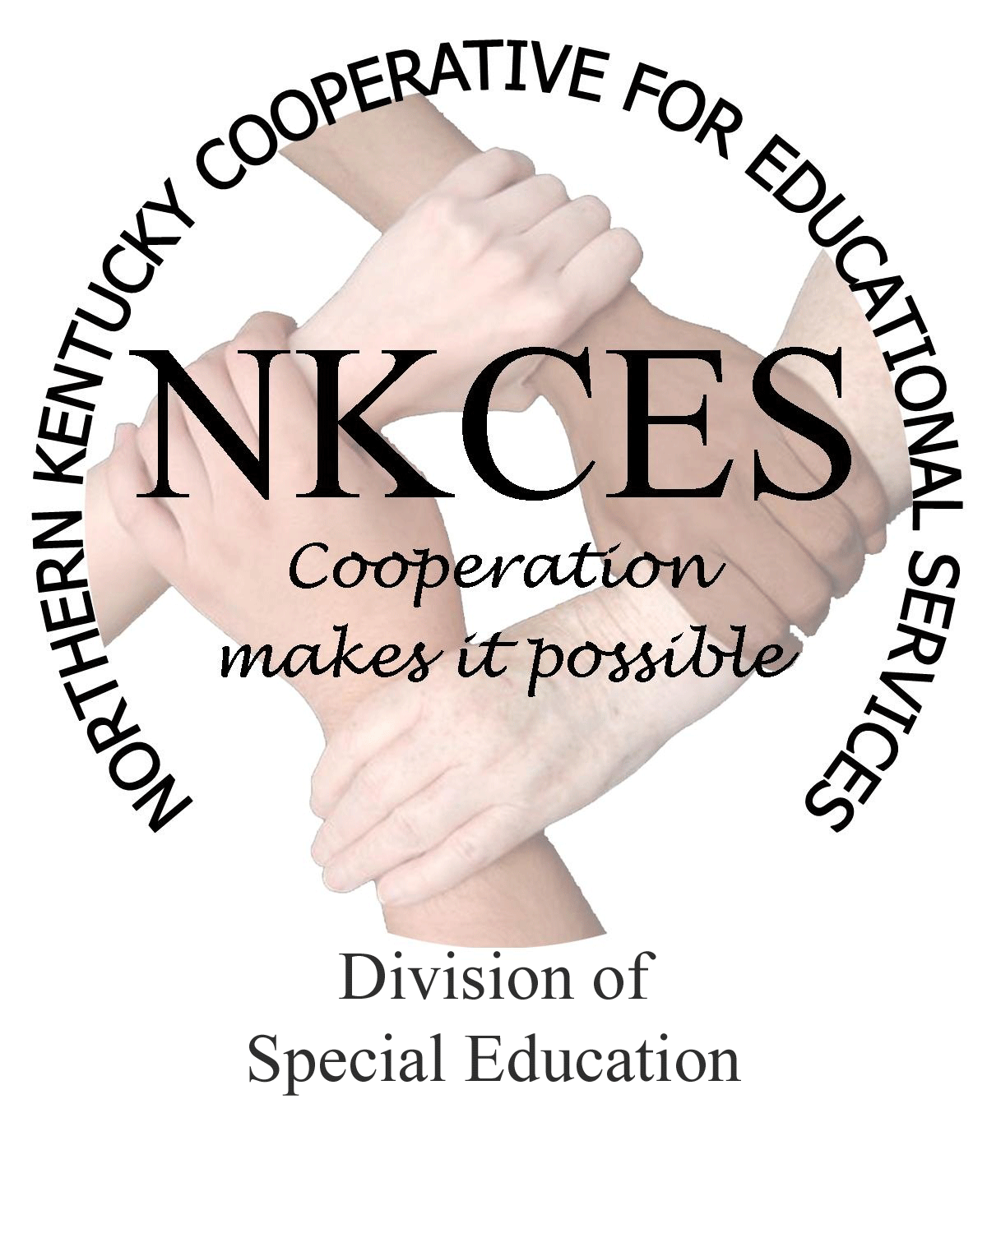
Northern Kentucky Cooperative for Educational Services, Inc.

Member Districts

Beechwood Independent • Bellevue Independent • Boone County • Campbell County

Covington Independent • Dayton Independent • Erlanger-Elsmere Independent

Ft. Thomas Independent • Kenton County • Ludlow Independent • Newport Independent

Pendleton County • Silver Grove Independent • Southgate Independent

Walton-Verona Independent • Williamstown Independent

April 2, 2014

Curtis Hall, Executive Director
NKCES
5516 E. Alexandria Dr.
Cold Spring, KY 4-176

Re: Superintendents Report

Dear Curtis:

March came in like a lion and so did our work. We started the month off by visiting several of our districts to go over this past years district plan, as well as plan for the 2014-15 school year. We have been busy reviewing each districts CDIP so we can propose some assistance and trainings for next year. Regarding the districts we have met with, we are on target with our annual plans and are pleased knowing this process has proved helpful.

The consultants and I have also met with a district to lay the foundation for a possible data retreat in their district. The leadership team was impressed and excited and will be getting back with us to confirm the training. We plan a data retreat this summer allowing the district to go through the process and providing them the opportunity to express the advantages to the other districts. The data retreat is a training that allows the school teams to take the process back to their school and tie it into the CSIP, KPREP, TGES etc. We are anxious to get started and believe this process will allow schools to look at data in a different way and provides them a targeted plan enabling improvement.

I am beginning our annual staff evaluations based upon observations, meetings, training evaluations, and overall effectiveness. I hope to have the evaluations completed by the end of this week. In order to become more effective next year, the consultants and I have reviewed, discussed, planned, brainstormed and looked at district data for many hours. We have determined that our work needs to focus on literacy strategies, math strategies, overall content strategies, and assisting teachers on how these apply to all students. Our low incidence consultant has several state initiatives and is working with teachers providing highly effective trainings and strategies as well. Co-teaching across the state is the main initiative for assisting districts in order to close the gap. A couple of our consultants are working with KDE and districts within our region, which assist their schools in becoming highly effective co-teaching models.

Instructional coaching is another main emphasis within our region and across the state. The consultants and I will be going through training in May and will bring the training to N KY on September 30-October 1. More information will be forthcoming as we partner with NKU as we plan to offer the same training to our regional instructional coaches. We are excited to see the door open with NKU as we work together in planning other trainings. NKU has provided excellent ideas that we may be able to incorporate with our district trainings and we look forward to working with them.

Along that same thought, several of the consultants and myself went to hear Eric Jensen in Lexington on March 7th. He is a dynamic speaker that focused on poverty and how it effects our students. We would like to look into bringing him to N KY this fall or next spring as we feel his energy, knowledge, and beliefs would lead to promote a positive change for our students and teachers. We will follow-up with the PD committee and receive their feedback on this thought.

Highly effective and exciting initiatives are happening and have happened this year. We are staying focused on how to move students to the next level with our schools. While we have a lot to do in order to close the gap, we can also see the overall improvement in our region and are proud to be a part of this exciting adventure. We will continue to make every effort to assist and offer trainings that focus on the work of closing the gap. Please let us know if you have any suggestions that will assist all of us moving in the same direction.

Sincerely,
Linda Alford
Regional Director of Special Education

