Communication Updates- January 2023
Candace Gibson- Communication and Outreach Coordinator

NEWSLETTER
Newsletter viewership remains consistent. Nothing new to report!
MAILCHIMP- NEWSLETTER IMPACT (based on the latest edition)
Total Subscribers | 315
Number of subscribers who engage via email | 135 opens, 1 link click
Social media impressions per week | Facebook- 489 (36 engagements)  Twitter- 147 (12 engagements)

SOCIAL MEDIA
This month’s social media report includes an additional few days (due to last month’s early board meeting), including our most popular newsletter post in the history of the Bellevue Bulletin, featuring Rob Sanders’ Hometown Hero feature. Below are the top three performing posts since my last report.
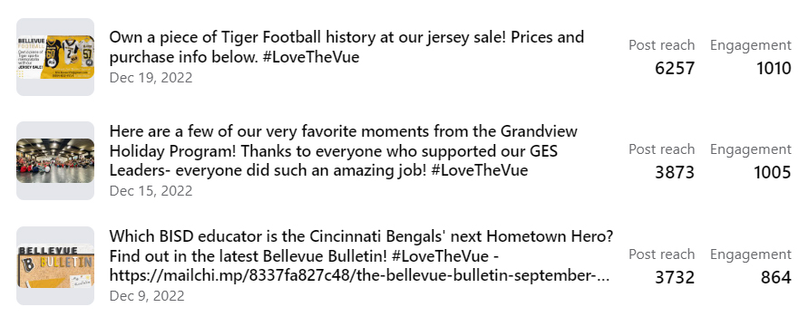
FACEBOOK MONTHLY IMPACT
Total post reach this month | 18,037
Total post engagement (likes, comments, etc) | 6,334
Number of posts this month | 44 (expected less posts, due to holidays)
New followers; new page likes | +24; +9
Total shares | 157

NEW VIDEO PROJECT
A new video project is in the works with Mr. Pelgen to highlight our vocational and career path options. We hope to have the video complete by mid-February.

OTHER DESIGN PROJECTS
I am collaborating with Ms. Teegarden to create new informational materials to promote our Career Pathways. Additionally, preliminary work is beginning on our Portrait of a Graduate graphics, which will set the tone for our new imagery regarding our updated vision for BISD.

WEBSITE UPDATES
My plan for the website is to update imagery and simplify the events calendar process over the next month. There is still a learning curve with our new website provider, and I am continuing to attend virtual trainings to improve my understanding of their system.

