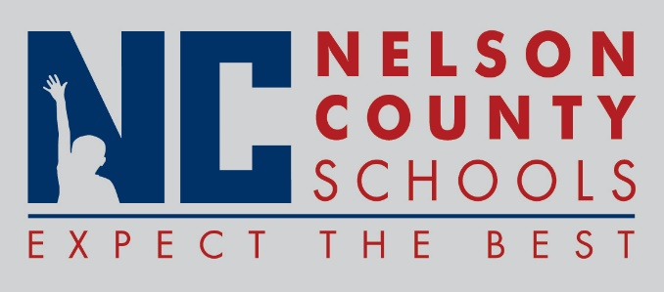

Information Update
To: | Nelson County Board of Education
From: | Robert Leathers, Director of Pupil Personnel
cc: | Tom Brown, Interim Superintendent
Date: | December 7, 2017
Re: | Nursing/Medical

- Medicaid Billing: Lincoln Trail District Health Department (LTDHD) Board of Health reviewed the possibility of Nelson County Schools contracting with LTDHD to implement their school health model. The Board of Health had no objection to implementing the program.
- Drug Testing: NCS and the testing agency The Way to Recovery are ready to implement testing as directed by our revised Board Policy.

