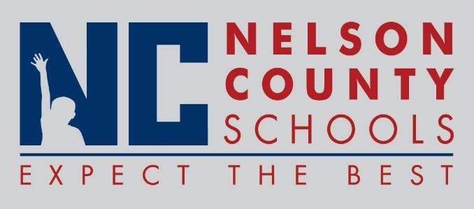

Decision Paper
To: | Nelson County Board of Education
From: | Bob Morris, Director of Student Support
cc: | Dr. Anthony Orr, Superintendent
Date: | June 20, 2017
Re: | 2017-2018 Code of Acceptable Behavior and Discipline

RECOMMENDATION: Approve the 2017-2018 Nelson County Schools Code of Acceptable Behavior and Discipline.

RECOMMENDED MOTION: I move that the Nelson County Board of Education Approve the 2017-2018 Nelson County Schools Code of Acceptable Behavior and Discipline.

