John Hardin SBDM Council
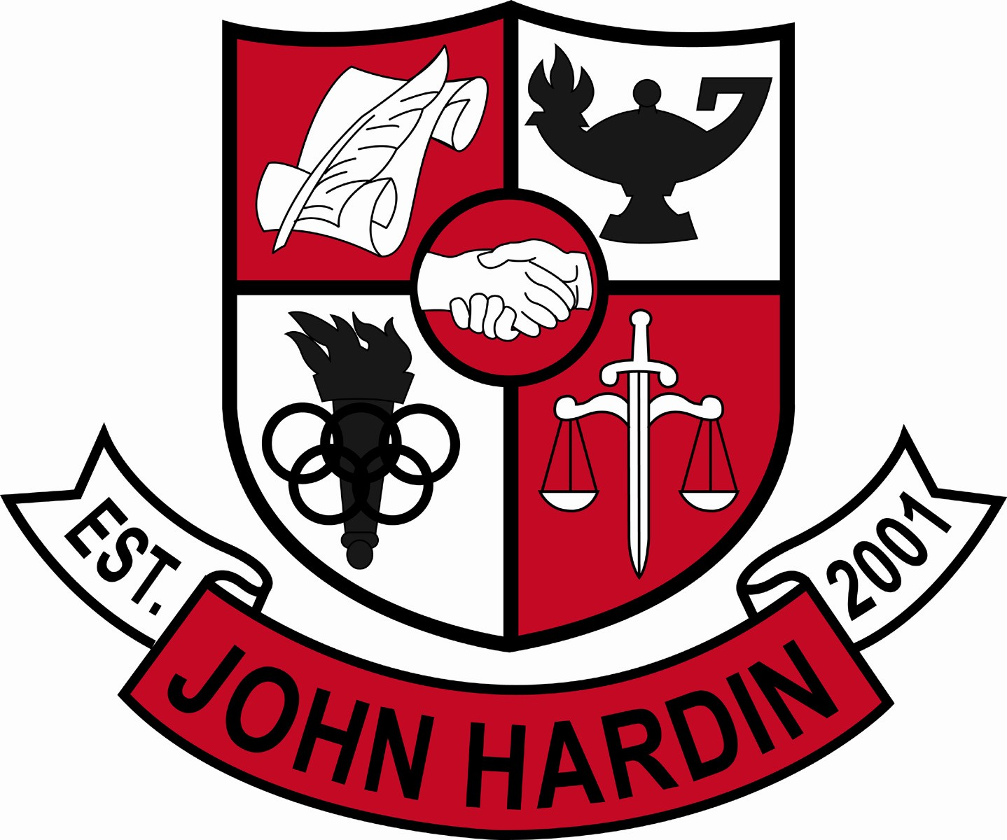
Meeting Minutes

December 10, 2015
4:00 p.m.

- Call to Order at 4:07p.m.
Members present: Mark Wells, Alex Shearer, Aurora Selbe, Kelly Smith, Stacey Moore, and Jan O’Daniel
Visitors: Brahim Benmoussa, Donna Bumper, and Cynthia French.
- Approval of Agenda ORDER #15-16/0030
The council approved the agenda as written.
Motion: Moore Second: Smith
Selbe – Yes
O’Daniel – Yes
Shearer– Yes
Wells – Yes
- Approval of Minutes ORDER #15-16/0031
The council approved the minutes as written.
Motion: Shearer Second: Selbe
O’Daniel – Yes
Moore – Yes
Smith – Yes
Wells – Yes
- Principal’s Update
- Procedures for questions and concerns from council – Questions and concerns are presented during the meeting and added to the next month’s agenda for discussion. If a question or concern arises between meetings, email Mr. Wells and Mrs. Feiler to have the item added to the agenda.
- Climate/Culture Committee – Committee is composed of 17 members. Ms. Cobb and Ms. Miller are forming a Pep Club. A membership due of $15 will include a T-shirt and supplies for signs. Students will be taught cheers by Ms. Miller. For staff, different events such as a chili cook off are scheduled.
- Financial Report ORDER #15-16/0032
The Financial Report for November was reviewed and accepted.
Motion: Shearer Second: O’Daniel
Smith– Yes
Moore – Yes
Wells – Yes
Selbe – Yes
- 2016-17 Extension Money ORDER #15-16/0033
The 2016-2017 Extension Money was approved as written.
Motion: Shearer Second: O’Daniel
Smith – Yes
Moore – Yes
Selbe – Yes
Wells – Yes
- World Language ORDER#15-16/0034
The council approved Performance/Proficiency based credit as written.
Motion: O’Daniel Second: Selbe
Shearer – Yes
Moore – Yes
Smith– Yes
Wells - Yes
- CSIP - Goals 7-9 ORDER #15-16/0035
The council approved the CSIP goals as written after receiving clarification for Goal 7.
Motion: Shearer Second: O’Daniel
Moore – Yes
Smith - Yes
Selbe -Yes
Wells – Yes
- Curriculum Guide Update
- Math ORDER#15-16/0036
Council approved the addition of the two electives as written
Motion: Moore Second: Smith
O’Daniel –Yes
Shearer – Yes
Selbe – Yes
Wells – Yes
- Science ORDER#15-16/0037
Council approved the addition and deletion of courses as written.
Motion: Shearer Second: Selbe
O’Daniel – Yes
Moore – Yes
Smith – Yes
Wells – Yes
- English ORDER#15-16/0038
Council approved the addition of Journalism and English III Part C.
Motion: Smith Second: O’Daniel
Selbe – Yes
Moore – Yes
Shearer – Yes
Wells – Yes
- Social Studies ORDER#15-16/0039
Council approved the addition and deletion of courses as written.
Motion: Selbe Second: Shearer
O’Daniel – Yes
Moore- Yes
Smith – Yes
Wells – Yes
- Health Sciences ORDER#15-16/0040
Council approved Health Science course requests as written.
Motion: Shearer Second: Smith
O’Daniel – Yes
Selbe – Yes
Moore – Yes
Wells – Yes
- Family Consumer Science (FCS) ORDER#15-16/0041
Council disapproved the addition of a check box on the freshmen schedule form.
Motion: Smith Second: Moore
Shearer – Yes
O’Daniel – Yes
Selbe – Yes
Wells - Yes
- Family Consumer Science (FCS) ORDER#15-16/0042
Council approved course requests as written for sophomores, juniors, and seniors.
Motion: Moore Second: O’Daniel
Shearer – Yes
Smith – Yes
Selbe – Yes
Wells – Yes
- Business ORDER#15-16/0043
Council approved Business course request as written.
Motion: Shearer Second: O’Daniel
Smith – Yes
Selbe – Yes
Moore – Yes
Wells – Yes
- Band, Chorus, Art ORDER#15-16/0044
Council approved the addition and removal of courses as written.
Motion: Smith Second: Moore
Selbe – Yes
Shearer – Yes
O’Daniel – Yes
Wells – Yes
- Foreign Language ORDER#15-16/0045
Council disapproved the addition of French I and French II.
Motion: Moore Second: Smith
O’Daniel – Yes
Wells – Yes
Shearer – Sustain
Selbe – Sustain
- Foreign Language ORDER#15-16/0046
Council approved the Spanish course request as written.
Motion: Smith Second: Shearer
O’Daniel – Yes
Selbe – Yes
Moore – Yes
Wells – Yes
- Honor Courses ORDER#15-16/0047
Council approved the addition of Honors level courses as written.
Motion: O’Daniel Second: Shearer
Smith – Yes
O’Daniel – Yes
Selbe – Yes
Wells - Yes
- PE/ROTC/Agriculture
No schedule request changes submitted.
- Personnel
Hired: Kristin Shonkwiler for Freshmen Girls Basketball
Vacancies: Asst. Band Dir #3; Freshmen Softball Coach; Asst. Wrestling Coach
- Agenda Items for Next Meeting
- Dress Code Committee
- Parking lot pick up procedures
- World Language – Mr. Brahim Benmoussa
- Adjourn
The meeting was adjourned at 5:06 p.m. The motion was made by Ms. Selbe and seconded by Mr. Shearer. Ms. Smith exited the meeting at 5:00 pm.

