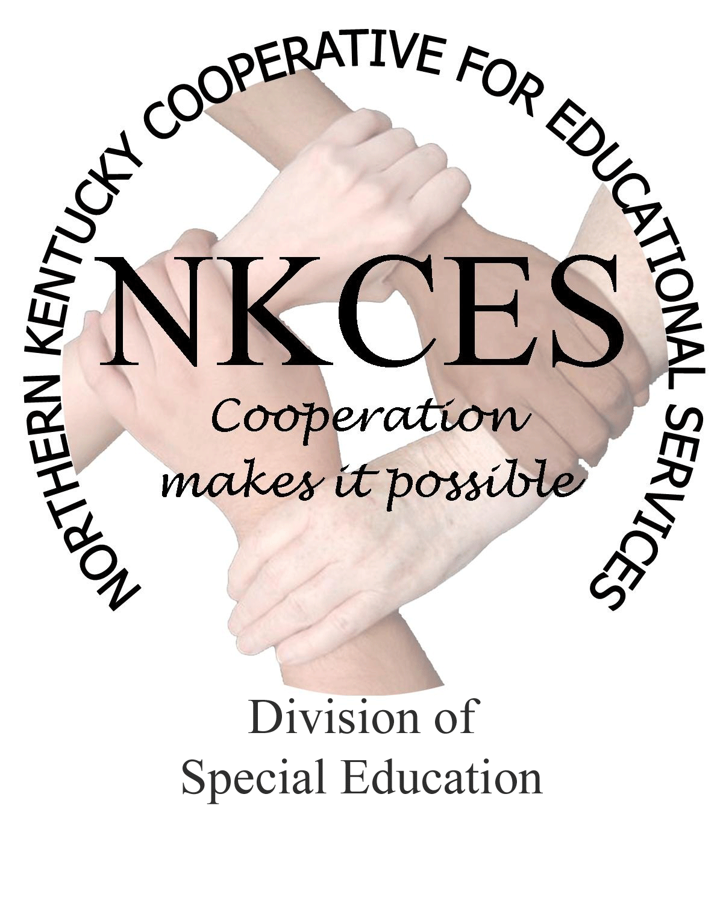
Northern Kentucky Cooperative for Educational Services, Inc.

Member Districts

Beechwood Independent • Bellevue Independent • Boone County • Campbell County

Covington Independent • Dayton Independent • Erlanger-Elsmere Independent

Ft. Thomas Independent • Kenton County • Ludlow Independent • Newport Independent

Pendleton County • Silver Grove Independent • Southgate Independent

Walton-Verona Independent • Williamstown Independent

February 4, 2014

Curtis Hall, Executive Director
NKCES
5516 E. Alexandria Dr.
Cold Spring, KY 4-176

Re: Superintendents Report

Dear Curtis:

The snow may be coming down, but our work continues each day as we prepare for the trainings scheduled in our districts. As evident with our January schedules, we were busy with meetings and trainings held throughout the districts. We had 588 contacts, which participated in face to face training or various trainings held within the district. We provided 21 in district programs, and 16 multiple district programs, which provided consultations, reviews, support services or trainings as scheduled by our district planning sessions. We are pleased to report that we are on target meeting the request of our districts and helping them to achieve their goals and standards for the 2013 – 2014 school year.

We continue to tweak our state logic plan and narrow our target to meet the initiatives we committed our resources and services to within the region. Literacy. Math, Standards, CCR, Behavior, Low incidence and Compliance make up the bulk of these services. Also we are doing a number of trainings in preschool in the areas of math, literacy and behavior. This has been a rewarding experience and one of partnership as we have brought the programs to the teachers , which exposed them to the content that will make a difference within their preschool settings.

Plans are moving forward with the 2014 Summer Workshop scheduled to be held July 28-31, 2014, at Gateway Community and Technical College. We are in the final stages of our planning sessions and will have the information into the hands of the schools by the end of the month. These workshops will be FREE and require an on-line registration. Due to the size of the classrooms our sessions will be limited to 25-30 person. With this all inclusive workshop, we are excited to announce that the presentations are certain to provide something for everyone, including regular education teachers as well as the special education teachers. We will begin registrations in early March and fully expect the sessions to fill up quickly.

The KDE is moving forward with training university professors on the IEP Guidance Document. This is a great opportunity for KDE to be working with the universities, which assures our teachers are exposed to the most current information regarding IEP procedures. This will hopefully enable special education teachers to hit the ground running with IEP’s and will detour a lot of time and training, promoting a greater ease of transition when a teacher is hired, as well as the assurance that the hiring district will remain within compliance of the IEP requirements. I have been asked to assist with this training and am graciously and happy to provide the services to help our educators at the university level.

We have begun contacting our district’s Superintendents and Dose to schedule our District Planning Meetings for early spring meetings. These meetings are not only beneficial to both our districts as well as NKCES Consultants, but are essential to proper planning and goal setting regarding KDE’s standards and requirements for achievement. We will provide a schedule once completion has been confirmed. As always, we are proud and consider our positions an honor to be an integral part of the future lives of our children.

Sincerely,

Linda Alford
Regional Director of Special Education

