Regular Meeting Boone County Board of Education
November 14, 2019 7:30 PM
Ralph Rush Professional Development Center
99 Center Street
Florence, Kentucky 41042

I. CALL TO ORDER

The Regular meeting of the Boone County Schools Board of Education November 14, 2019 was called to order by Chairperson Karen Byrd at the Ralph Rush Staff Development Center.
Attendance Taken at 7:30 PM:

Present Board Members:
Dr. Maria Brown
Ms. Karen Byrd
Mr. Troy Fryman
Mr. Matt McIntire
Mrs. Julia Pile

Gerry Dusing attended as Board Attorney
Karen Evans, Board Secretary, recorded the minutes.

II. VETERANS DAY RECOGNITION
Chairperson, Ms. Karen Byrd recognized all the Veterans in the audience by asking them to stand and thanked them all for their service.

III. NATIONAL ANTHEM
The National Anthem was presented by students from Cooper High School.

IV. PLEDGE TO THE FLAG
The Pledge to the Flag was led by students from Erpenbeck Elementary.

V. STUDENT BOARD MEMBER REPRESENTATIVE REPORT
Jessica Engler gave the Student Board Member Representative report. Jessica reported on the two major projects the Council would be working on this year - Leadership Skills and the HOPE Squad in the High Schools.

VI. GOOD NEWS
VI.A. The board recognized and congratulated the 2019 November Break the Mold recipient, Mr. Brian King, Automotive Technology Instructor, Area Tech Center.
VI.B. The board recognized the 2019 Energy Star Certifications
2019 EPA Energy Star Certification:
Ballyshannon
2019 EPA Energy Star Re-Certification
Burlington Elementary
Florence Elementary
Kelly Elementary
Longbranch Elementary
Cooper High School

VI.C. Boone County Business Association representatives President Don Riley, Bill DeAndre, and Donald Martin presented the 2019 Golf Outing Fund Raiser Check for over $6000.00. The outing raises funds to support our Alternative Center for Education and helps to provide cold weather clothing for our district children in need.
VI.D. November 2019 Parent Power Awards

Boone County Schools Parent Power Award Recipients are:

Conner High School: Jodi Petersime
Allison Schier
Erpenbeck Elementary: Kelly McCallum
Heather Hoskins
Sarah Limbacher
Laura Gorman
Jennifer Williams
CiCi Luna
Ockerman Elementary: Lori Kenyon Morgan
Erin Benson
Regina Fink
Joel Bramlage
My - Hanh Nguyen
Thornwilde Elementary Jennifer Fay
Tiffany Wege
Dennie Carter
Judy Carter

VII. RECOMMENDED ACTION - CONSENT AGENDA
Dr. Randy Poe, Superintendent, recommended the board approve Agenda items A-QQQ for Board approval, as presented.

- A motion was made by Troy Fryman, seconded by Maria Brown, recommended the Consent Agenda items A-QQQ for Board approval, as presented. Karen Byrd, Maria Brown, Matt McIntire, Julia Pile, and Troy Fryman, voted, “aye.”MOTION: The motion passed 5-0.

VII.A. Minutes of the regular board meeting of October 10, 2019.
The board approved the minutes of the regular board meeting of October 10, 2019, as presented.
VII.B. Minutes of the October 24, 2019 Special Board Meeting Expulsion Hearing.
The board approved the Minutes of the October 24, 2019 Special Board Meeting Expulsion Hearing, as presented.
VII.C. Bill List
VII.D. Treasurer's Report was presented by Mr. Eric McArtor, Deputy Superintendent COO.
VII.E. Leaves of Absence
The following persons submitted leave of absence requests were approved:
Recommended by Principal/Supervisor for approval:
Anspach, Paul, Bus Driver @ Transportation 9/9/2019 – 10/4/2019
Bettis, Sara, Teacher @ Camp Ernst MS 11/25/2019 - 12/20/2019
Burke, Karen, Café Worker @ Stephens ES 10/11/2019 – 1/6/2020
Craddock, Jessica, Teacher @ Ockerman ES 10/4/2019 – 12/20/2019
Eskew, Rachel, Teacher @ Ockerman ES 10/25/2019 – 12/12/2019
Ison, Julie, Teacher @ Cooper HS 9/23/2019 – 10/21/2019
Jackson, Connie, Café Worker @ Erpenbeck ES 9/25/2019 – 10/10/2019
Ratcliff, Dawn, Café Worker @ RA Jones MS 10/16/2019 - 11/1/2019
Riley, Peggy, Bus Driver @ Transportation 9/30/2019 – 12/1/2019
Sinclair, Nicole, Teacher @ Boone County HS 10/25/2019 – 12/20/2019
Tepe, April, Speech Therapist @ Florence ES 9/9/019 – 11/11/2019
Wingate, Greg, Teacher @ Conner HS 10/28/2019 – 1/6/2020
Not Recommended by Principal/Supervisor for approval:
None

Amended Leaves:
Black, Timothy, Custodian @ Thornwilde ES 6/21/2019 – 10/22/2019
Farrell, Sena, Bus Driver @ Transportation 9/12/2019 – 1/3/2020
Gelement, Bethanie, Teacher @ Florence ES 11/11/2019 – 1/5/2020
Giron, Sagat, Bus Driver @ Transportation 9/23/2019 – 1/6/2019
Madison, Rodgers, Bus Driver @ Transportation 9/25/2019 – 10/29/2019
O’Daniel, Samantha, Café Worker @ Conner HS 8/14/52019 – 11/1/2019
Paulin, Jennifer, Teacher @ Erpenbeck ES 8/15/2019 – 10/10/2019
Sawyer, Donna, Café Worker @ Boone County HS 8/9/2019 – 11/8/2019
Shinkle, Gretchen, Custodian @ Thornwilde ES 09/06/2019 – 11/27/2019
Cancelled Leaves:
Heap, Sarah, Bus Driver @ Transportation 9/25/2019 – 10/21/2019

VII.F. Schematic Design/Design Development Drawings and BG-2 and BG-3 for Kelly Elementary Plumbing Upgrades BG #20-106
The board approved the Schematic Design/Design Development Drawings and BG-2 and BG-3 for Kelly Elementary Plumbing Upgrades BG #20-106, as presented.
VII.G. Schematic Design/Design Development Drawings and BG-2 and BG-3 for Central Office Fiber Relocation, BG#20-118.
The board approved Schematic Design/Design Development Drawings and BG-2 and BG-3 for Central Office Fiber Relocation, BG#20-118, as presented.
VII.H. Schematic Design/Design Development Drawings and BG-2 and BG-3 for Boone county High Electric Upgrades
The board approved the Schematic Design/Design Development Drawings and BG-2 and BG-3 for Boone County High Electric Upgrades, as presented.
VII.I. Schematic Design/Design Development Drawings and BG-2 and BG-3 for Conner High & Ryle High Gym Upgrades, BG#20-105
The board approved the Schematic Design/Design Development Drawings and BG-2 and BG-3 for Conner High & Ryle High Gym Upgrades, BG#20-105, as presented.
VII.J. Schematic Design/Design Development Drawings and BG-2 and BG-3 for Erpenbeck Elementary Upgrades, BG #20-122
The board approved the Schematic Design/Design Development Drawings and BG-2 and BG-3 for Erpenbeck Elementary Upgrades, BG #20-122, as presented.
VII.K. Schematic Design/Design Development Drawings and BG-2 and BG-3 for HVAC Upgrades, BG#20-121
The board approved the Schematic Design/Design Development Drawings and BG-2 and BG-3 for HVAC Upgrades, BG#20-121, as presented.
VII.L. Schematic Design/Design Development Drawings and BG-2 and BG-3 for Geothermal Upgrades, BG #20-119
The board approved the Schematic Design/Design Development Drawings and BG-2 and BG-3 for Geothermal Upgrades, BG #20-119, as presented.
VII.M. Change Order #1 Access Controls, BG#19-194
The board approved the Change Order #1 Access Controls, BG#19-194, with an increase of $ 3,256.00, as presented.
VII.N. Change Order #1 LSS Renovations, BG # 19-104
The board approved the Change Order #1 LSS Renovations, BG # 19-104 with a decrease of $4,622.00, as presented.
VII.O. Salary Schedule Addition/Modification 21st Century Grant Coordinator/FRC Coordinator
The board approved the Salary Schedule Addition/Modification 21st Century Grant Coordinator/FRC Coordinator, as presented.
VII.P. 21st Century Grant Coordinator Job Description Update
The board approved the 21st Century Grant Coordinator Job Description Update, as presented.
VII.Q. Declaration as Surplus: Technology and Other Equipment
The board approved the Declaration as Surplus: Technology and Other Equipment, as presented.
VII.R. Security Cameras and Installation for Conner High School
The board approved the Security Cameras and Installation for Conner High School, as presented.
VII.S. Memorandum of Agreement between Yealey Elementary School and Mobymax
The board approved he Memorandum of Agreement between Yealey Elementary School and Mobymax, as presented.
VII.T. Memorandum of Agreement between Boone County Schools and Transact Communications, Inc.
The board approved the Memorandum of Agreement between Boone County Schools and Transact Communications, Inc., as presented.
VII.U. Memorandum of Agreement between Longbranch Elementary School and Wonder Workshop, Inc
The board approved the Memorandum of Agreement between Longbranch Elementary School and Wonder Workshop, Inc., as presented.
VII.V. Field Trips
The board approved the Field Trips, as presented.
School | Date Of Trip | Location | Reason
Yealey Elementary | 4/1-3/2020 | Townsend, TN | Great Smoky Mountains Institute at Tremont
Conner High School | 2/6-10/2020 | Orlando, FL | National Cheer Competition
Ryle High School | 11/14-17/2019 | Dallas, TX | FCCLA National Fall Leadership Conference
Camp Ernst Middle | 2/5-10/2020 | Orlando, FL | UCA Nationals Cheer Championship
Conner Middle | 3/27-29/2020 | Huntsville, AL | Space Camp
Ryle High School | 4/30-5/3/2020 | Chicago, IL | Chicago Jazz Festival
Erpenbeck Elementary | 12/11/19 | Lexington, KY | UK 5th Grade Field Trip
Thornwilde Elementary | 5/1/2020 | Fischers, IN | Conner Prairie

VII.W. Speaking Engagement Agreement by and between Emma Benoit and the Boone Count Schools
The board approved the Speaking Engagement Agreement by and between Emma Benoit and the Boone Count Schools, as presented.
VII.X. Sales Campaigns
The board approved the Sales Campaigns, as presented.
VII.Y. Memorandum related to Kentucky 21st CCLC Community Learning Centers Contractual Agreement - Brianna Wright - Archery Instructor
The board approved the Memorandum related to Kentucky 21st CCLC Community Learning Centers Contractual Agreement - Brianna Wright - Archery Instructor, as presented.
VII.Z. Technology Department Job Description Update
The board approved the Technology Department Job Description Updates, as presented.
VII.AA. Memorandum of Agreement Between Ockerman Elementary School and Generation Genius
The board approved the Memorandum of Agreement Between Ockerman Elementary School and Generation Genius, as presented.
VII.BB. Memorandum of Understanding between Rescued Consulting, LLC and the Boone County Schools
The board approved the Memorandum of Understanding between Rescued Consulting, LLC and the Boone County Schools, as presented.
VII.CC. Revised BG-1 HVAC Upgrades for Collins and Stephens BG#17-263
The board approved the Revised BG-1 HVAC Upgrades for Collins and Stephens BG#17-263, as presented.
VII.DD. Memorandum related to Kentucky 21st Century Community Learning Centers Cycle 17 RFA-Camp Ernst Middle School
The board approved the Memorandum related to Kentucky 21st Century Community Learning Centers Cycle 17 RFA-Camp Ernst Middle School, as presented.
VII.EE. Revised BG-1 and BG-4 Gray Middle MEP Improvements BG#17-121
The board approved the Revised BG-1 and BG-4 Gray Middle MEP Improvements BG#17-121, as presented.
VII.FF. Memorandum of Understanding by and between the Boone County School District and Ramey Estep/Re-Group
The board approved the Memorandum of Understanding by and between the Boone County School District and Ramey Estep/Re-Group, as presented.
VII.GG. Memorandum of Understanding Mental Health Service Providers - Hope Behavioral Health and Boone County Schools
The board approved the Memorandum of Understanding Mental Health Service Providers - Hope Behavioral Health and Boone County Schools, as presented.
VII.HH. Memorandum of Agreement by and between Fernside and Kelly Elementary School
The board approved the Memorandum of Agreement by and between Fernside and Kelly Elementary School, as presented.
VII.II. Thomas More University Standard Affiliation Agreement
The board approved Thomas More University Standard Affiliation Agreement, as presented.
VII.JJ. Gray Middle- Contract with the Cincinnati Shakespeare Company for October 15, 2109
The board approved the Gray Middle- Contract with the Cincinnati Shakespeare Company for October 15, 2109, as presented.
VII.KK. Appointment of School Board Attorney
The board approved the Appointment of School Board Attorney, as presented.
VII.LL. Duel Credit Memorandum of Agreement with Kentucky State University
The board approved the Duel Credit Memorandum of Agreement with Kentucky State University, as presented.
VII.MM. Maintenance Agreement for Copier at Ignite Institute
The board approved the Maintenance Agreement for Copier at Ignite Institute, as presented.
VII.NN. 2020 KETS Offer Of Assistance
The board approved the 2020 KETS Offer Of Assistance, as presented.
VII.OO. Change Order #6-Ignite, BG #17-279
The board approved the Change Order #6-Ignite, BG #17-279, with an increase of $202,803.00, as presented.
VII.PP. Revised BG-1 for Ignite, BG #17-279
The board approved the Revised BG-1 for Ignite, BG #17-279, as presented.
VII.QQ. Burlington Elementary School (BES) Copier Lease and Maintenance Agreement
The board approved the Burlington Elementary School (BES) Copier Lease and Maintenance Agreement, as presented.
VII.RR. North Pointe elementary School (NPES) Copier Lease and Maintenance Agreement
The board approved the North Pointe elementary School (NPES) Copier Lease and Maintenance Agreement, as presented.
VII.SS. Memorandum related to Kentucky 21st Century community Learning Centers Cycle 17 RFA-Goodridge Elementary
The board approved the Memorandum related to Kentucky 21st Century community Learning Centers Cycle 17 RFA-Goodridge Elementary, as presented.
VII.TT. Facility Use Agreement - Boone County High School using NKU Indoor Pool, October 8, 2019-February 14, 2019 for the Swim Team
The board approved the Facility Use Agreement - Boone County High School using NKU Indoor Pool, October 8, 2019-February 14, 2019 for the Swim Team, as presented.
VII.UU. Facility Use Agreement - Ryle High School using NKU Indoor Pool, October 8, 2019-February 18, 2019 for the Dive Team practice
The board approved the Facility Use Agreement - Ryle High School using NKU Indoor Pool, October 8, 2019-February 18, 2019 for the Dive Team practice, as presented.
VII.VV. Bus Request-Hebron Baptist Church on Monday, November 25, 2019
The board approved the Bus Request-Hebron Baptist Church on Monday, November 25, 2019, as presented.
VII.WW. Contract-Kelly Elementary with The Children's Theatre on March 5, 2020
The board approved the Contract-Kelly Elementary with The Children's Theatre on March 5, 2020, as presented.
VII.XX. Queen City Transportation-Yealey elementary Great Smoky Mountains Institute at Tremont on April 1-3, 2020
The board approved the agreement of Queen City Transportation-Yealey Elementary Great Smoky Mountains Institute at Tremont on April 1-3, 2020, as presented.
VII.YY. Lakefront Lines-Conner Middle School to Space Camp-Huntsville, AL on March 27-29, 2020
The board approved the agreement between Lakefront Lines-Conner Middle School to Space Camp-Huntsville, AL on March 27-29, 2020, as presented.
VII.ZZ. Contract-Yealey Elementary with Great Smoky Mountains Institute at Tremont on April 1-3, 2020
The board approved the Contract-Yealey Elementary with Great Smoky Mountains Institute at Tremont on April 1-3, 2020, as presented.
VII.AAA. Contract-Yealey Elementary with Missoula Children's Theatre on December 2-7, 2019
The board approved the Contract-Yealey Elementary with Missoula Children's Theatre on December 2-7, 2019, as presented.
VII.BBB. Contract-Ryle High School Senior Dinner Dance on January 11, 2020 at Newport Aquarium
The board approved the Contract-Ryle High School Senior Dinner Dance on January 11, 2020 at Newport Aquarium, as presented.
VII.CCC. Facility Use Agreement-Conner High School using YMCA Indoor Pool, January 18, 2020 and February 1, 2020 for the Swim Team Meets
The board approved the Facility Use Agreement-Conner High School using YMCA Indoor Pool, January 18, 2020 and February 1, 2020 for the Swim Team Meets, as presented.
VII.DDD. Facility Use Agreement-Conner High School using YMCA Indoor Pool, October 16, 2019-February 19, 2020 for the Swim Team
The board approved the Facility Use Agreement-Conner High School using YMCA Indoor Pool, October 16, 2019-February 19, 2020 for the Swim Team, as presented.
VII.EEE. Contract-Conner High School with Party Pleasers for the Prom, April 25, 2020
The board approved the Contract-Conner High School with Party Pleasers for the Prom, April 25, 2020, as presented.
VII.FFF. Child Care Food Program Meal Service Agreement with Children, Inc.
The board approved the Child Care Food Program Meal Service Agreement with Children, Inc., as presented.
VII.GGG. Facility Use Agreement-Yealey Elementary with Brian Ferguson for Basketball on Wednesday and Friday evenings
The board approved the Facility Use Agreement-Yealey Elementary with Brian Ferguson for Basketball on Wednesday and Friday evenings, as presented.
VII.HHH. Facility Use Agreement-Boone County High School using Scott High School Indoor Pool on December 21, 2019 for Swim Team Practice
The board approved the Facility Use Agreement-Boone County High School using Scott High School Indoor Pool on December 21, 2019 for Swim Team Practice, as presented.
VII.III. Burlington Elementary-Contract with The Children's Theatre on 12/10/19-A Charlie Brown Christmas
The board approved the Burlington Elementary-Contract with The Children's Theatre on 12/10/19-A Charlie Brown Christmas, as presented.
VII.JJJ. Queen City Transportation-Erpenbeck Elementary UK 5th Grade Field Trip on December 10, 2019
The board approved the agreement between Queen City Transportation-Erpenbeck Elementary UK 5th Grade Field Trip on December 10, 2019, as presented.
VII.KKK. Change Order #1-Preschool Playground Barriers, BG #19-145
The board approved the Change Order #1-Preschool Playground Barriers, BG #19-145, with a decrease of $5,099.00, as presented.
VII.LLL. Facility Use Agreement-Boone County High School using Silverlake Indoor Pool, October 2, 2019-February 19, 2020 for the Swim Team
The board approved the Facility Use Agreement-Boone County High School using Silverlake Indoor Pool, October 2, 2019-February 19, 2020 for the Swim Team, as presented.
VII.MMM. Contract-Cooper High School Banquet at Receptions
The board approved the Contract-Cooper High School Banquet at Receptions on November 25, 2019, as presented.
VII.NNN. Facility Use Agreement-Ignite Institute with Dispatch Video for Children's Hospital TOPS Project, December 7-8, 2019
The board approved the Facility Use Agreement-Ignite Institute with Dispatch Video for Children's Hospital TOPS Project, December 7-8, 2019, as presented.
VII.OOO. Memorandum of Agreement between Reaching You Ministries and the Boone County Schools
The board approved the Memorandum of Agreement between Reaching You Ministries and the Boone County Schools, as presented.
VII.PPP. AIA Standard Form of Agreement between Owner and Architect for the following 2020 Projects
The board approved the AIA Standard Form of Agreement between Owner and Architect for the following 2020 Projects, as presented.
VII.QQQ. Schematic Design/Design Development Drawings and BG-2 and BG-3 for Access Controls Phase 2, BG #20-109
The board approved the Schematic Design/Design Development Drawings and BG-2 and BG-3 for Access Controls Phase 2, BG #20-109, as presented.

VIII. RECOMMENDED ACTION - OLD BUSINESS
VIII.A. No Old Business

IX. RECOMMENDED ACTION - NEW BUSINESS
IX.A. Addition of Two Technicians and Set Ratio for District Technicians to Devices
Dr. Randy Poe, Superintendent, recommended the board approve the addition of two technicians and set the ratio for allocation 1 to 800 District Technicians to Devices, as presented.

- A motion was made by Maria Brown, seconded by Troy Fryman, to approve the addition of two technicians and set the ratio for allocations 1-800 District Technicians to Devices, as presented. Karen Byrd, Maria Brown, Matt McIntire, Julia Pile, and Troy Fryman, voted, “aye” MOTION: The motion passed 5-0.

IX.B. 2020-2021 School Calendar
Dr. Randy Poe, Superintendent, recommended the board approve the 2020-2021 School Calendar first reading, as presented.

- A motion was made by Matt McIntire, seconded by Julia Pile, to approve the 20-21 School Calendar first reading, as presented. Karen Byrd, Maria Brown, Matt McIntire, Julia Pile, and Troy Fryman, voted, “aye” MOTION: The motion passed 5-0.

X. SUPERINTENDENT'S REPORT (brief summaries)

- Dr. Jim Detwiler, Deputy Superintendent CAO, Mrs. Jenny Watson, LSS Assistant Superintendent, and Dr. Jason Radford, Assistant Superintendent of Office of Schools and System Improvement, gave the report to the board on "Intentional Instruction + Accountability Cadence=Student Achievement". The detailed power point was also given to each board member as a handout. The team discussed the 4 Disciplines of Execution, The Boone County Schools Theory of Action, Intentional Instructions Determined by DeFour’s Essential Questions, Building a System of Data Users to Make Instructional Decisions. Dr. Jason Radford reviewed the Office of Schools & Systems Improvement department team members, vision, team values, goals and expanding work of the department to other schools based on data and each school’s needs. Boone County Schools 2019-2020 goals in reading is to increase from 60% to 65% proficient/distinguished by May 2020 and math to increase from 53% to 58% proficient/distinguished by May 2020. The team discussed the next steps to meet the goals in student achievement along with the powerpoint, the team was open for questions from the board.

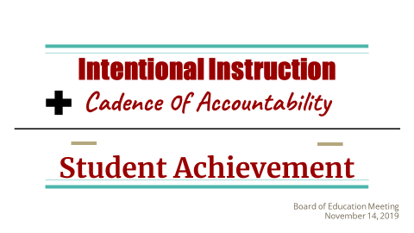
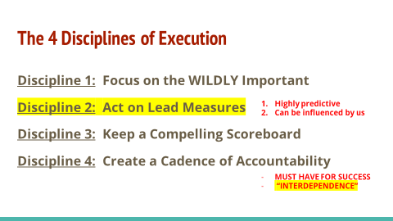

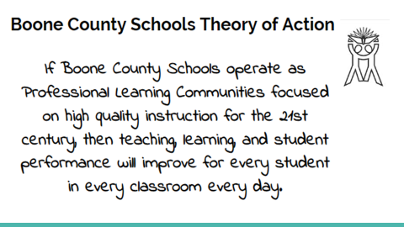

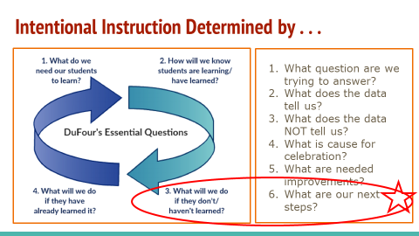

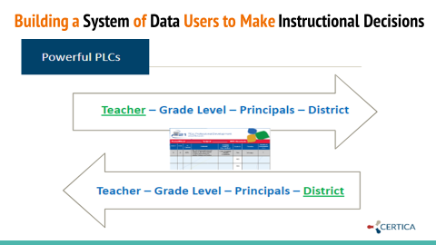

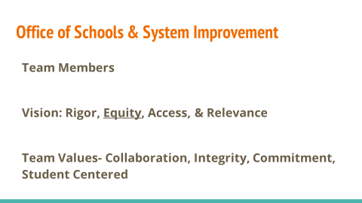
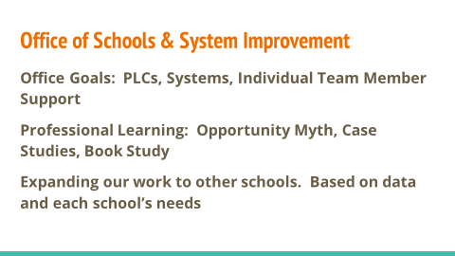

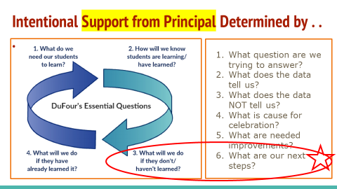

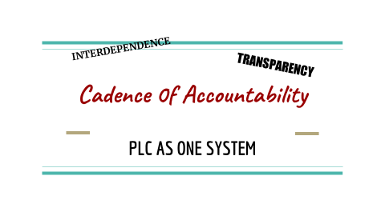

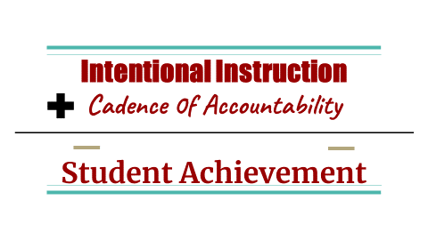

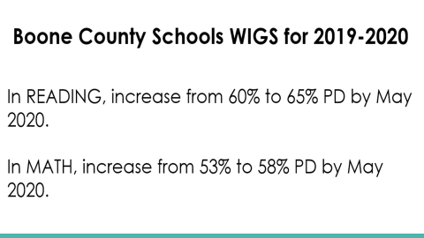

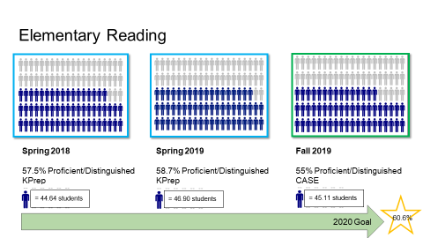

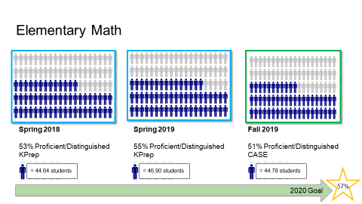
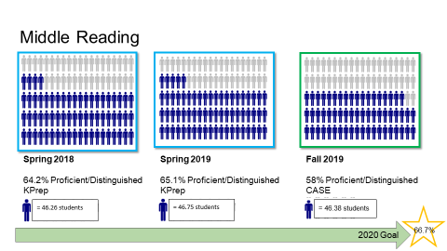

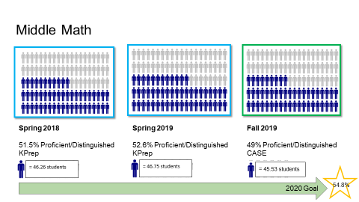

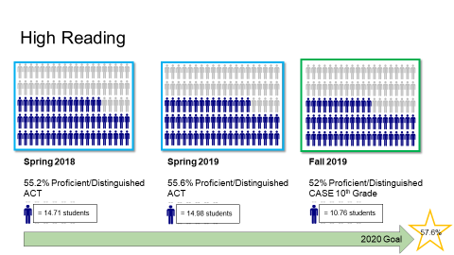

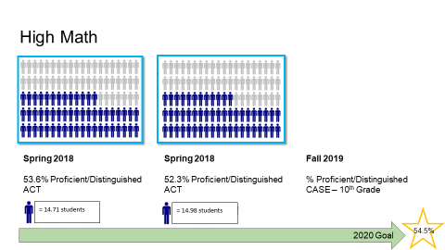

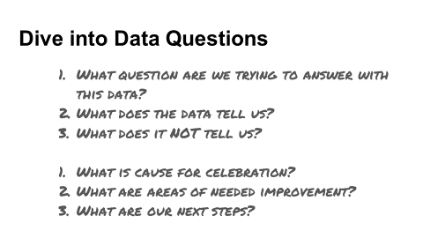
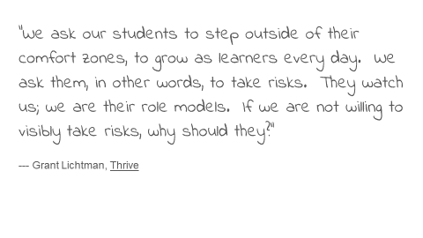

- Dr. Randy Poe, Superintendent reported the board has received a copy of the district goals and objectives for 2020 and after their review and additions that may need made, the goals would be on the next board agenda.
- Dr. Randy Poe, Superintendent announced next week is American Education Week – November 18-22, 2019. In celebration of American Education Week he would like to thank all the support staff for our schools and the tremendous work they do each and every day for our students.
- Dr. Randy Poe, Superintendent, addressed the board to formally announce his retirement from the district on June 20, 2020. In this announcement Dr. Poe, stated this is a bittersweet time for him because for the last 37 years Boone County School District has been his second home. He started his educational career in the district, with student teaching and is extremely proud of where the district is now as a World Class Education center focused on student achievement. He took the opportunity to thank the board members present and past for the trust and support each had given him in the past 12 years as Superintendent of Schools. Dr. Poe thanked the administrators, principals, bus driver, staff, teachers, cafeteria workers, and custodians of whom have all contributed to the accomplishments of this district and for that he is immensely grateful. Dr. Poe stated that he did accept an extension of his contract last year to help finish the work within our 2020 Strategic Plan, open the Ignite Institute and the new schools and the design completion of Steeplechase Elementary. As the district embarks on a new five-year strategic plane next year, he feels now is the best time for the Board to select a new leader that will continue to carry out the work of the district. He stated for the record “There is not a better district in this country to work in!” he is extremely proud of the career and the students of Boone County Schools. (a copy of the announcement letter was given to all board members) Karen Byrd thanked Dr. Poe for his many years of service and discussed the future.

- Don Martin, KSBA Superintendent Search Consultant, spoke to the board of the superintendent search services offered by KSBA. Mr. Martin discussed the outline of services and the contract if the board would like to use the KSBA services for the search. Mr. Martin discussed the process of the search to maintain the legality and ethical three to four months process. He went over the determination of criteria, timelines, and search committee participants by law and application processes of the service. The board discussed his cost of $6000 plus mileage for consultant over other Nation Search Agents fees of $30,000. Discussion on the search committee needs and deadlines. The board agreed to put before the board an amended agenda to contract with KSBA services for the Superintendent search to meet the deadlines. The board also discussed which board member would be appointed to the committee.

XI. AMENDMENT OF AGENDA
- Amendment of Agenda KSBA Services for the Superintendent Search Contract.
Karen Byrd, Board Chairperson, recommended the board to amend the agenda to add the KSBA Services for the Superintendent Search Contract of $6000.00 plus mileage for the consultant, and to name Ms. Karen Byrd as the board representation on the Search Committee.

- A motion was made by Maria Brown, seconded by Troy Fryman, to amend the agenda to add the KSBA Services for the Superintendent Search Contract of $6000.00 plus mileage for the consultant, and to name Ms. Karen Byrd as the board representation on the Search Committee for the 2019-2020 Superintendent search, as presented. Karen Byrd, Maria Brown, Julia Pile, Matt McIntire, and Troy Fryman voted, “aye” MOTION: The motion passed 5-0.

- A motion was made by Maria Brown, seconded by Julia Pile, to approve the amended agenda to add the KSBA Services for the Superintendent Search Contract of $6000.00 plus mileage for the consultant, and to name Ms. Karen Byrd as the board representation on the Search Committee for the 2019-2020 Superintendent search, as presented. Karen Byrd, Maria Brown, Julia Pile, Matt McIntire, and Troy Fryman voted, “aye” MOTION: The motion passed 5-0.

XII. INFORMATION, PROPOSALS, COMMUNICATIONS
XI.A. Human Resource Actions
XI.B. Worker's Compensation Claims
XI.C. Overtime Report
XI.D. Construction Status Report
XI.E. Energy Management Report

XIII. AUDIENCE OF CITIZENS
The following College of Education students introduced themselves to the board: NKU students- Trevor Chartrum, Mason Kinsella, Hannah Hall, Linda Pinson, Hannah Bittlinger, Robert Elrod, Aaron BrockCaroline Schmidt, Maeve Dunn, Seneca Kunatzar, Kaylin Conley, Melissa Young,, Troy Caseltine, Caitlin Ostates, Kyle Curry; Conner High School – Vosey Garrison, Lexi Helmig, Griffin Hammond, Julia Rothoaus; Thomas More Univeristy – Cayla Hamilton.

XIV. CLOSED EXECUTIVE SESSION PER KRS 61.810
XIII.A. No closed session

XV. ADJOURN

- A motion was made by Maria Brown, seconded by Julia Pile, to adjourn the meeting. Karen Byrd, Maria Brown, Julia Pile, Matt McIntire, and Troy Fryman voted, “aye” MOTION: The motion passed 5-0.

Meeting was adjourned at approximately 9:21 pm.

_____________________________________
Karen Byrd/Chairperson

_____________________________________
Karen Evans/Secretary

