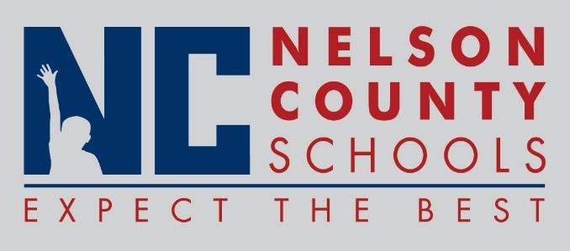

Information Paper
To: | Nelson County Board of Education
From: | Bob Morris, Director of Student Support
cc: | Dr. Anthony Orr, Superintendent
Date: | February 02, 2017
Re: | New Procedure

Early Entrance Petition Process and Application.

