Grandview Elementary
Board Report
October 27, 2021

Great things happening at GES……

- Friday, October 22nd, State Representative Rachel Roberts spent time at Grandview Elementary as a part of the “Principal for a Day” program created by the Kentucky Association of School Administrators (KASA).
- In-person and virtual parent-teacher conferences scheduled Oct. 25th -27th. Report cards and student progress will be discussed at parent-teacher conferences.
- The Test to Stay program is up and running. This program has helped keep students at school and limited quarantines.
- GES Book Fair was the week of Oct 15th- Oct 22nd. Book Fair Parent Night was Thurs. 3-6.
- Preschool students will trick or treat through the school on Oct. 28th. GES annual Halloween Parade Kinder-5th will be at 10am on October 29th. Halloween Parade Route: Grandview- down Foote to Center to Washington and back to Grandview
- Teachers will participate in a Scholastic Professional Development day on November 1st.
- Bellevue High School Haunted House Oct 29th 9pm-11pm, Oct 30th – 31st 6pm-11pm. Proceeds benefit the BHS Drama Club.
- MTSS Data PLC teacher meetings are every 6 weeks. We track progress and discuss where each student is in their learning journey.

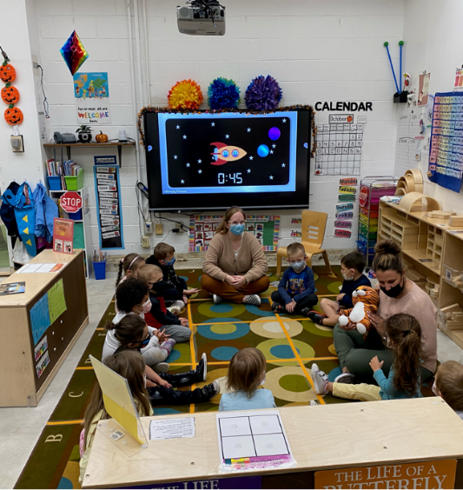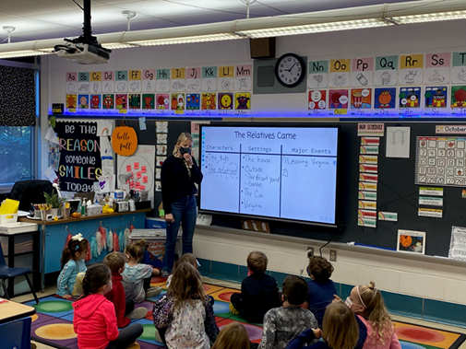
Ms. Moore’s Preschool Classroom Ms. Weyer’s 1st Classroom

Upcoming Dates
Oct 18h-22nd GES Bookfair
Oct 21st GES Bookfair Family Night
Oct. 25th Entries for staff Pumpkin Contest Due
Oct. 25th-27th Parent Teacher Conference (virtual or in-person)
October 28th Preschool Trick or Treat through the school
October 29th Halloween Parade with high school students 10am
November 1st Scholastic PD day for all certified staff- 8:30-3:30

GESLeaders Philosophy
Our goal is to build intentional relationships, inspire passionate learners, provide personalized learning, identify leadership in self, staff and students and challenge our team to exceed expectations.

