John Hardin SBDM Council
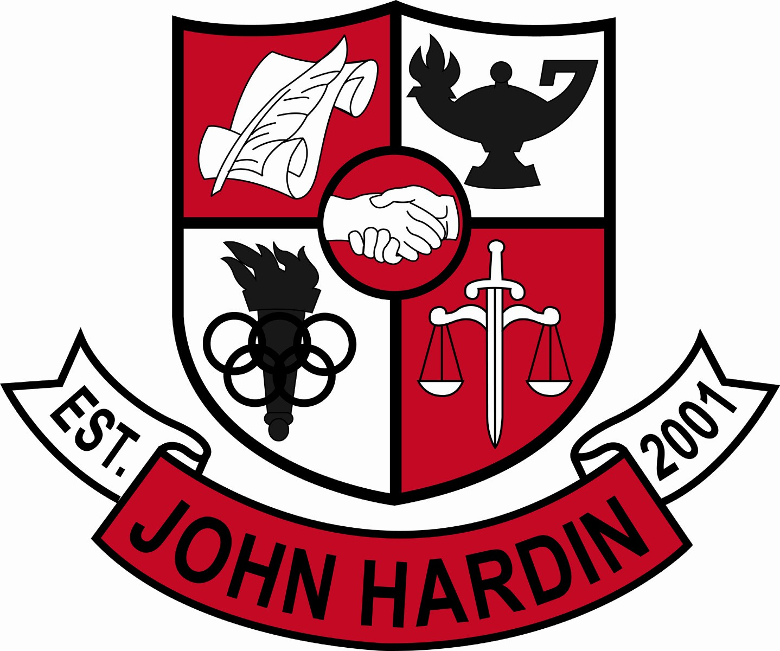
Meeting Minutes

January 14, 2016
4:00 p.m.

- Call to Order at 4:08 pm
Members present: Mark Wells, Alex Shearer, Aurora Selbe, Kelly Smith, Stacey Moore, and Jan O’Daniel
Visitors: Mark Kopp, Brahim Benmoussa, Fawnda Cox and Vicki Sagar.
- Approval of Agenda ORDER #15-16/0048
The council approved the agenda as written.
Motion: O’Daniel Second: Moore
Selbe – Yes
O’Daniel – Yes
Shearer– Yes
Wells – Yes
O’Daniel – Yes
Moore - Yes
- Approval of Minutes ORDER #15-16/0049
The council approved the minutes as written.
Motion: Shearer Second: Moore
O’Daniel – Yes
Selbe– Yes
Smith – Yes
Wells – Yes
Moore – Yes
Shearer - Yes
- Principal’s Update
  - Academic team won their match against LaRue Co.
  - Midterms – Data was organized with charts and graphs. Information was presented to EOC teachers. The goal is for teachers to be meeting standards and to improve instruction.
  - Pick up procedures – Our main security officer will speak with the other officers to be more consistent. The yellow gate will be opened to allow additional traffic flow in the afternoon.
  - Dress Code Committee – Fawnda Cox reported the committee has contacted other schools regarding their dress code policy and found our policy is basically the same as theirs. A survey will be created for parents, students, and teachers to gather information for the 2016-2017 school year dress code.
- Financial Report ORDER#15-16/0050
The Financial Report for December was reviewed and accepted
Motion: Selbe Second: Smith
O’Daniel – Yes
Shearer – Yes
Wells – Yes
Moore – Yes
Selbe – Yes
Smith - Yes
- Dual Credit Grading/Attendance Points Policy 1st Reading
Attendance points will not be awarded to students taking Dual Credit Classes. College grades are equated to high school grades.
- Appeal Decision about French – Brahim Benmoussa
Written appeal and response enclosed. Discussion followed.
Motion: Stay with Original Decision to Eliminate French ORDER #15-16/0051
Motion: Moore Second: Selbe
O’Daniel – Yes
Shearer – No
Smith – Yes
Wells – Yes
Selbe – No
Moore – Yes
- Personnel
Hired; Lisa Biddle for Asst. Band Dir #3
Vacancies: Freshmen Softball Coach; Asst. Wrestling Coach
- Agenda Items for Next Meeting
- Second Reading of Dual Credit Grading/Attendance Points Policy
- PD Plan
- Adjourn
The meeting was adjourned at 6:28 p.m. The motion was made by Ms. Selbe and seconded by Mr. Shearer. Ms. Smith exited the meeting at 5:35.

