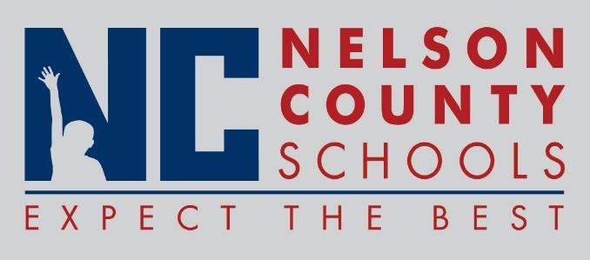

Decision Paper
To: | Nelson County Board of Education
From: | Bob Morris, Director of Student Support
cc: | Tom Brown, Superintendent
Date: | Sept 19, 2017
Re: | Policy Updates for 2017-2018

RECOMMENDATION: Approve the below listed policy updates as written for their second reading.

09.36 School Related Student Trips
05.1 Construction

RECOMMENDED MOTION: I move that the Nelson County Board of Education Approve the listed policy updates.

