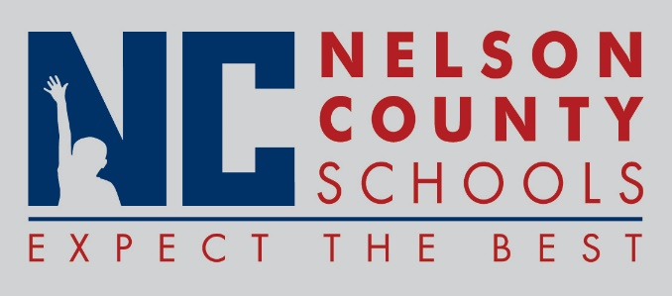

Information Paper
To: | Nelson County Board of Education
From: | Kimberly Brown
cc: | Dr. Anthony Orr, Superintendent
Date: | July 7, 2016

INFORMATION: 2011 – 2016 Nelson County Schools ACT Composite and Content Scores

