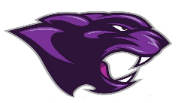

Board Meeting
November 2021

November 2021 Board Meeting
Jr/Sr. High School Principal

Fall Festival
- Was a Huge Success

Window Painting
- Was a Huge Success

SBDM Meeting
- SBDM meeting scheduled for November 10th had to be cancelled due to not having quorum

Jr. Beta Induction
- Went very well, we inducted our 7th and 8th grade students

Beta Induction on the 17th

