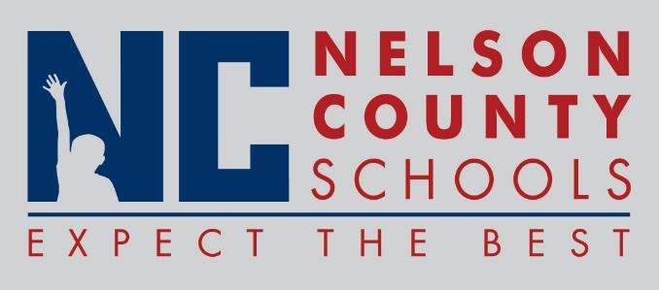

Decision Paper
To: | Nelson County Board of Education
From: | Tim Beck, Director of Student Support
cc: | Dr. Anthony Orr, Superintendent
Date: | July 19, 2016
Re: | Policy Updates for 2016-2017

RECOMMENDATION: Approve the below listed policy updates for 2016-2017 as written for their second reading.

03.4 Substitute Teachers
09.123 Absences and Excuses

RECOMMENDED MOTION: I move that the Nelson County Board of Education Approve the listed policy updates for 2016-2017.

