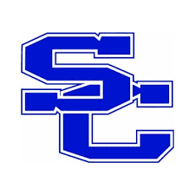
SPENCER COUNTY PUBLIC SCHOOLS
Board of Education Agenda Item

Meeting Date 7/25/2022

Topic/Title SCMS PTSO Independent Booster Organization

Presenter(s)

Type of Information/Board Action
☐ Information only. No Board action required.
☐ Action requested at a future meeting: Click or tap to enter a date.
☐ Consent agenda for approval at this meeting.
☒ Action requested at this meeting.

Board review is a result of:
☐ State or federal law or regulation.
☐ Board of Education policy.
☐ Past practice.
☐ Other:

Previous Review, Discussion, or Action
☐ No previous Board review, discussion, or action.
☐ Previous review/action on: Click or tap to enter a date. Action: Click or tap here to enter text.

Background/Summary of Presented Information
SCMS has a group of parents that have experience in running a standalone PTSO at SCES. Mr. Mercer has met with these parents and they would like to run the PTSO at SCMS as an independent booster organization. Mr. Mercer has asked that they focus our supporting their PBIS Initiative by funding and running the Positive Behavior Store both online and in person. He will meet with this group monthly.

Financial Considerations
☒ There is NO financial impact on resources.
☐ There is a financial impact on Board resources. Chief Financial Officer must review.
Click or tap here to enter text. Chief Financial Officer’s initials, if required

Superintendent’s Recommendation
☒ Recommend approval as presented.

