John Hardin SBDM Council
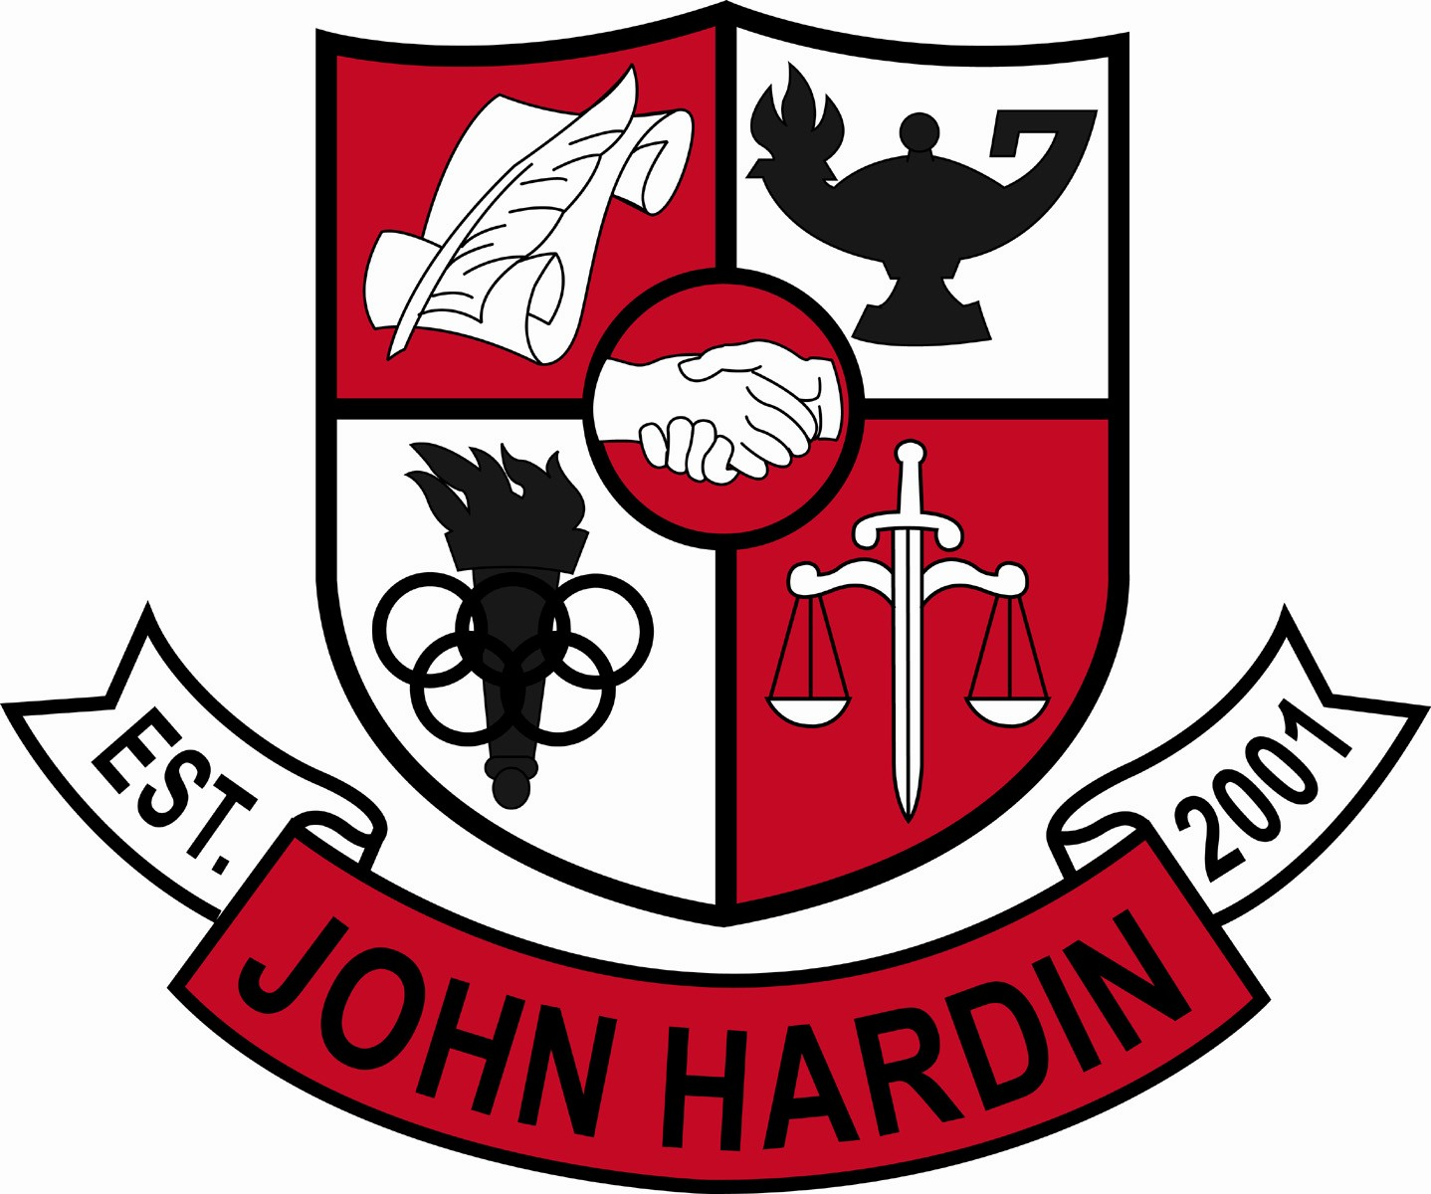
Meeting Minutes

March 9, 2017
4:00 p.m.

- Call to Order at 4:03
Members present: Jan O’Daniel, Alex Shearer, Aurora Selbe, Kelly Smith and Mark Wells.
Members absent: Mike Moritz (arrived at 4:17)
Guest: Erin Bird
- Approval of Agenda ORDER #16-17/0038
The council approved the agenda as written.
Motion: Selbe Second: Shearer
Selbe – Yes
O’Daniel – Yes
Shearer– Yes
Wells – Yes
Smith - Yes
- Approval of Minutes ORDER #16-17/0039
The council approved the minutes as written.
Motion: Shearer Second: Smith
O’Daniel – Yes
Selbe– Yes
Wells – Yes
Shearer – Yes
Smith - Yes
- Good News Report –
  - Archery – Featured in KY NASP Region 5 Newsletter
  - Work Ethic Certification – 98% of our seniors completed the Work Ethic process and 130 of them scored high enough to qualify for an interview. Our English department, collaborators, and a few power hour teachers have done a tremendous job working with and encouraging students through this process.
  - FCCLA – Brandon Hubert, Isaiah Yocum, and Breanna Mark are region 5 winners in Culinary. Each one of these students will receive $12,000 to attend Sullivan University.
- DECA – Eighteen students placed at the Region 3 DECA conference. These eighteen students just finished competing at state and eleven of them have qualified for the international conference.
- Bowling – Sam Grant qualified for state.
- Wrestling- The season concluded with six wrestlers qualifying for state.
- Boys and Girls Basketball – Both teams had an impressive season. The boys were the 17th District Champions and the girls were 17th District Runner-ups. Caleb Smith was named “Coach of the Year” by KHSAA.
- Academic Team – The Academic Team was named the overall champions for the 5th Region. Our Quick Recall team went undefeated and the FPS team took 3rd place. Individual awards included 1st and 3rd place in Science, 1st place in Language Arts, 2nd place in Social Studies, 3rd place in Arts and Humanities and 4th place in Mathematics.
- National Merit Finalist – Kevin Young
- Public Comment – No comments
- Principal’s Update
  - Second Trimester Finals- Finals went well. Teachers were challenged to look at instruction and improve on areas needed. End of Course exams allow teachers to compare individual questions and to get suggestions in areas where results may not have been as high.
  - Staffing Allocations – The council reviewed the staffing allocation submitted by the board. The 2017-18 allocations will provide an additional special education teacher and no reductions in other areas.
Financial Report ORDER #16-17/0040
The financial report for February was approved as written.
Motion: Shearer Second: Selbe
O’Daniel – Yes
Selbe– Yes
Wells – Yes
Shearer – Yes
Smith - Yes
- Project Graduation Committee -
Last year, 176 of 212 seniors attended and everyone received a prize valued at $25 at the minimum. Both the students and adults were appreciative and complimentary. This year, we have already concluded two fundraisers, received several donations from businesses and purchased $2300 in prizes.
- Personnel
Hired: No Hires
Vacancies: Assistant Girls Track Coach
- Agenda Items for Next Meeting
- Adjourn
The meeting was adjourned at 4:53p.m. The motion was made by Ms. Selbe and seconded by Ms. O’Daniel.

