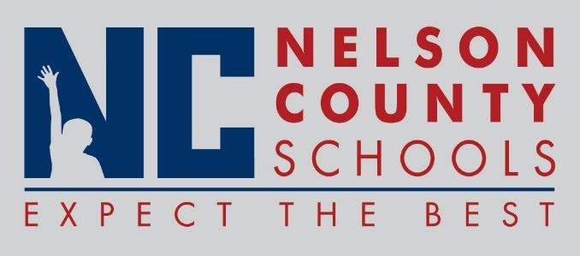

Decision Paper
To: | Nelson County Board of Education
From: | Bob Morris, Director of Student Support
cc: | Dr. Anthony Orr, Superintendent
Date: | October 13, 2016
Re: | Emergency Certifications

RECOMMENDATION: Approve request for the Emergency Certifications.

RECOMMENDED MOTION: I move that the Nelson County Board of Education Approve the requested Emergency Certifications as presented.

Jessica Kephart English TNHS
John Durbin Math New Haven
Tara Burkhead English OKH
Amy Chavez Science TNHS

.

