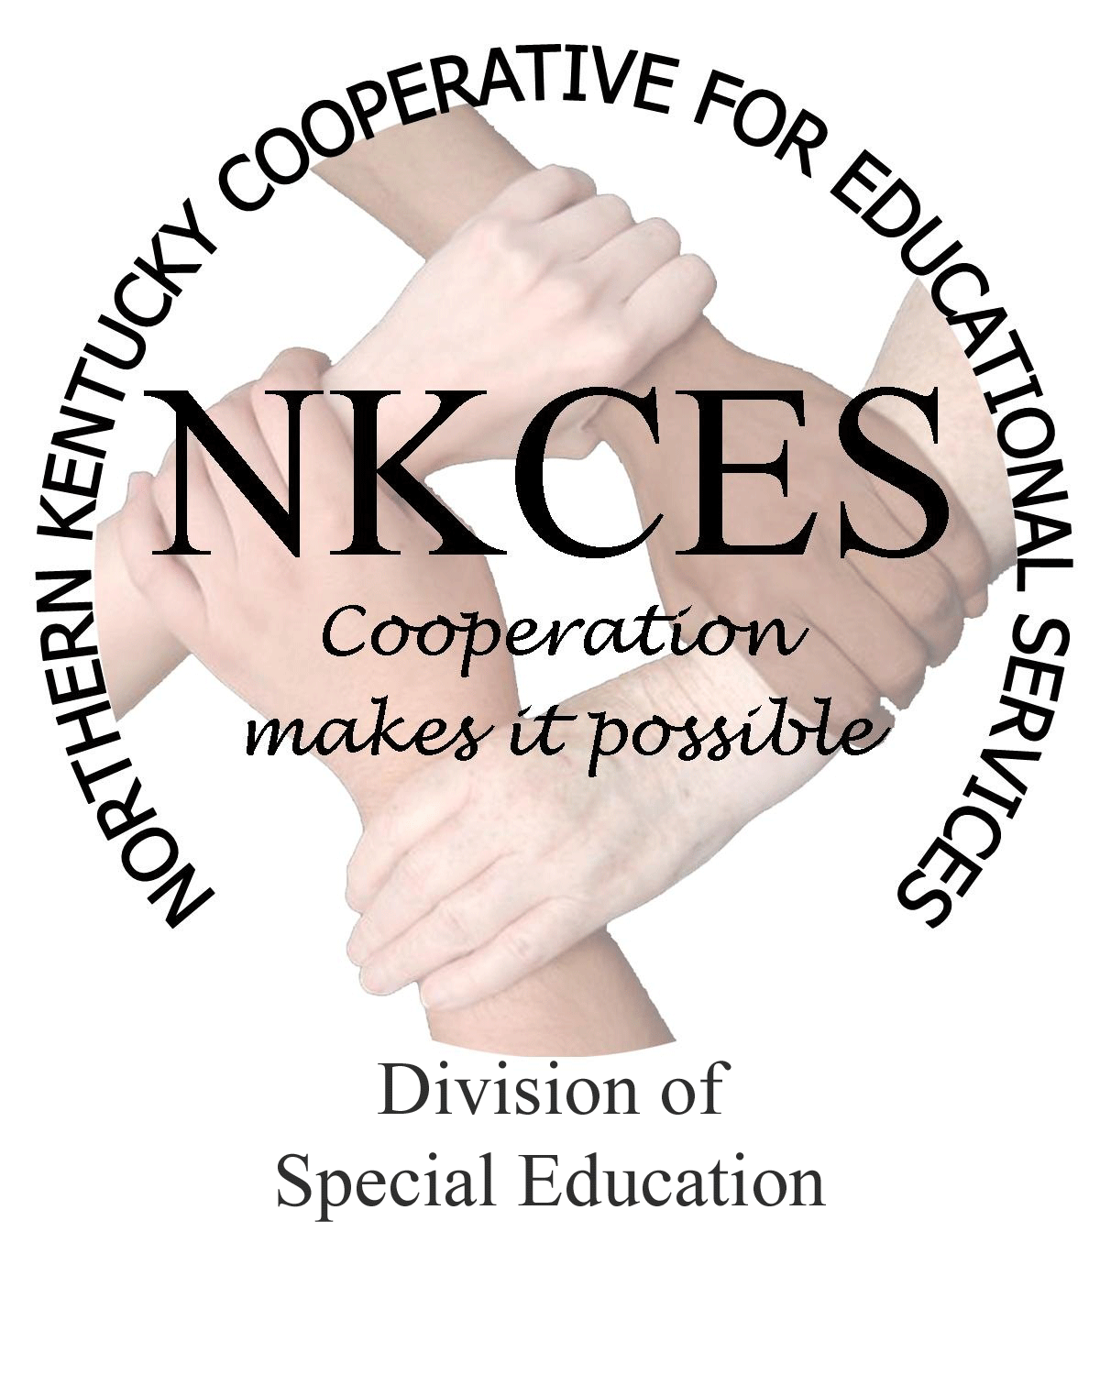
Northern Kentucky Cooperative for Educational Services, Inc.

Member Districts

Beechwood Independent • Bellevue Independent • Boone County • Campbell County

Covington Independent • Dayton Independent • Erlanger-Elsmere Independent

Ft. Thomas Independent • Kenton County • Ludlow Independent • Newport Independent

Pendleton County • Silver Grove Independent • Southgate Independent

Walton-Verona Independent • Williamstown Independent

February 6, 2015

Curtis Hall, Executive Director
NKCES
5516 E. Alexandria Dr.
Cold Spring, KY 4-176

Re: Superintendents Report

Dear Curtis:

Our focus has been providing professional learning within our schools, as well as effective trainings at the NKCES PD Room. The teacher training evaluations have provided a revealing truth about their current needs, which we are drilling down into new strategies. Even still, we are having great success with the PLC's within some of the districts, and in may of the districts we have been able to engage in discussions revealing our next steps required to assist teachers become more effective within their classrooms. These steps will drive our work for the remainder of this school year.

Changes have come about from our January 9th consultant's meeting. In order to determine the effectiveness of our work the following questions were developed and discussed.
- How do you know you are on track?
- What impact have you had this year?
- What evidence do you have?
- What does your work look like by the end of the year?
- What changes would you like to see occur July1st?
- If you could change one thing this year what would it be?

Upon lengthly discussion, we discovered a few areas which required attention and improvement. Still other areas were found to be highly effective and with positive results. After tweaking and refocusing in the needed areas, I am proud to report we are seeing immediate results. Our main discovery showed that our role is changing from consultants to instructional coaches. That discovery has led us to respond to the imperative and immediate attention to come alongside individual teachers providing them assistance in their identified areas of focus.

Our upcoming February consultants meeting will address possible dates for our annual district meetings, which will take place from March into May. In order to address and improve our integrated services, we plan to invite the Content Leaders, (Science, Social Studies, and PGES), within the region this year.

In review of our Consultants Activity Log for the month of January, I am happy to report that we were able to impact 477 participants within 14 districts, which included trainings, coaching, follow-ups, observations, face to face meetings, fidelity checks, and walk throughs. The role NKCES provides to our school districts is ever changing, and just like technology, we must stay with the current flow and provide our districts with the utmost expertise and updated techniques regarding educational skills. For this purpose we strive each month to bring the “best” to the very “best.”

Sincerely,
Linda Alford
Linda Alford, Regional Director of Special Education

