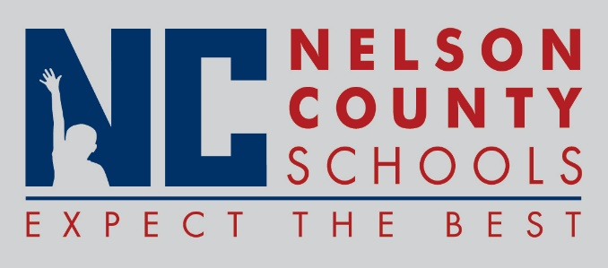

Decision Paper
To: | Nelson County Board of Education
From: | Anthony Orr, Superintendent
Date: | December 13, 2016
Re: | 2017 Board Meeting Dates

RECOMMENDATION: Approve request for 2017 Board Meeting Schedule.

RECOMMENDED MOTION: I move that the Nelson County Board of Education approve the 2017 Board Meeting Schedule as presented.

