Strategic Prevention Framework
I3 (Inspired, Individualized, Inclusive)
March 2024 - April 2024

SPF Grant Goal –
To reduce the onset and progression of substance misuse and its related problems in Bellevue, KY, by supporting the development and delivery of community substance misuse prevention and mental health promotion services.

Objectives 1-3
Reduce the use of alcohol, vaping, and cigarette smoking among students.

Objectives 4
Decrease students reporting serious psychological distress.

Objectives 5
Expand collaboration with community prevention partners.

Assessment –
- Identification of community gaps in services – I3 is resource mapping within school support and community and regional support for students and caregivers. This will assist in creating a continuum of care and partnerships with local businesses to address access barriers. Will be working with Prevention First to create an assessment to re-evaluate community needs to align resources.

- Specification of intervention data—All participants received a Dinner Table Project post-assessment. This data will evaluate the Dinner Table Project's effectiveness and determine quality improvement measures for future initiatives.

- Data was collected through the #iCANendthetrend tobacco and vaping prevention initiative through the University of Kentucky. They collected pre- and post-survey data. Once the data collection is complete, we will review the program's effectiveness to evaluate for future use.

- Specification of baseline data - External Referrals for mental health and prevention services.
  - 10 student/family external referrals
  - 4 student/family Care Solace referrals

- Specification of baseline data - Internal Referrals for mental health and prevention services.
  - 7 internal referrals for services

- Specification of baseline data and progress monitoring for all students identified in Tier 2 and 3. BISD's social-emotional tiered system is showing progress in proactively supporting student needs by delivering services.
  - GES –
    - Tier 2 – Skill groups resumed the week of April 1st. Based on SEB data.
3 skill-based groups; 10 students
    - Tier 2 – Performance – 34 students
    - Tier 3 – Mental Health Services- 20 students
  - BMHS
    - Tier 2 – Skill groups - 2 groups
    - Tier 3 – 38 students

Build Capacity—
- Building coalitions- I3 staff continue to meet and interact with community partners to become familiar with the needs of the Northern Kentucky community. Those partners include the Campbell County Drug-Free Alliance, the BISD Transition Coordinator, the Northern KY Institute for Strategic Planning (NKISP), the Kentucky Prevention Network, Adult Allies, and Prevention First.

- Trauma-Informed Grant and School-Based Mental Health Grant – Resources to support BISD and SPF grant initiatives.

- Meet with the Northern KY Health Department to discuss Too Good for Drugs—a Universal Curriculum for K-12. Alexis Bond is interested in facilitating the 10-week curriculum in one K-5 and one 6-12 classroom.

- Staff to complete N-O-T (Not on Tobacco®) Youth Cessation Facilitator Training to aid with tobacco/vaping cessation needs for students.

Planning—
- I3 Quarterly Newsletter – I3 is designing materials targeting prevention messaging for a quarterly newsletter sent to caregivers and students. This newsletter will share community resources, caregiver/child conversation starters, mental health information such as coping skills, and more.
  - The Next Newsletter is set for May 17th, 2024

- Dinner Table Project—I3 and the Youth Service Center are working with GES/BMHS to create the Dinner Table Project. This prevention project is based on research showing that families that eat are less likely to use substances. We continue to monitor for quality improvement and adjust what is included in the meal kit to meet the needs of the families.
  - Next meal kit will be sent home in April (TBD)
  - Theme will be a growth mindset

- The mental health team and the I3 team are working together to create and embed SEL activities into Grandview’s field day on May 17th, 2024.

- I3 is working to create a fundraiser (to be approved) for Mental Health Action Day, May 17th, 2024.

- Identification/coordination/allocation of resources –
We continue to receive requests from stakeholders to 1) provide substance prevention training, 2) design custom training for students, parents, and staff, and 3) share and distribute resources. Using evidence-based programs, we are guiding BISD in developing a three-tiered approach to vaping prevention, intervention, and cessation.
Tier 1 - #Icanendthetrend & John’s Ambassadors (GES – Too Good for Drugs & Dinner Table Project)
Tier 2- John’s Ambassadors & In-depth - alternative to suspension
Tier 3 - Cessation programming, N.O.T., My Life My Quit, Not for Me (Not on Tobacco)

- I3 working with staff and school admin surrounding Character Strong Curriculum and tier levels of support.
  - The prevention specialist facilitates Tier 2 groups with BMHS students
  - Data Analyst completed Tier 2 groups at GES.
  - The Project Director is working with students at GES as a mentor.

- Articulation of a vision for prevention activities—The Prevention Specialist is working with BMHS to establish a substance use/misuse prevention referral process.

- Articulation of a vision for prevention activities – The I3 team is working toward creating a Mental Health/Prevention referral pathway, processes, and MTSS handbook.

- Articulation of a vision for Mental Health and Prevention Activities/resources – Exploring the use of BISD’s new website capabilities to support resources for mental health and prevention services (such as referral forms, provider resources, phone numbers, and more)

Implementation—
- #iCANendthetrend – Universal Substance Prevention Programming through the University of Kentucky completed a one-day training to all middle school students on March 5th.

- #SELday—I3, Trauma-Informed Grant, and admin worked to create 55+ trauma-informed boxes for educators. These boxes contained books, mindfulness cards, breathing lights, fidgets, and more.
  - Project distributed March 8, 2024

- GES Math Night—On March 11, 2024, I3 and the Mental Health team provided resources for mental health and prevention. The team ran a booth that embedded SEL into math.

- The March I3 Newsletter was published on the new district website's mental health/prevention page.

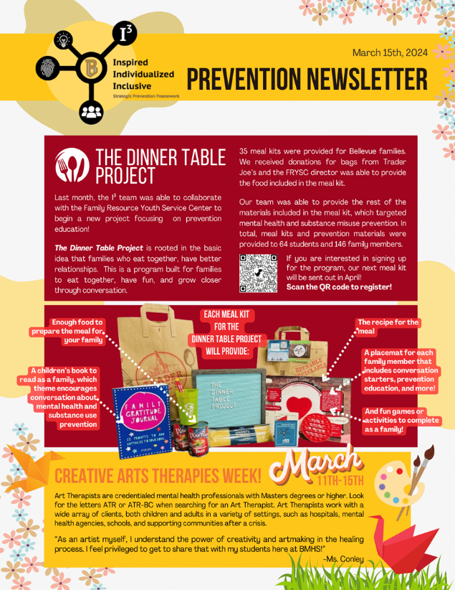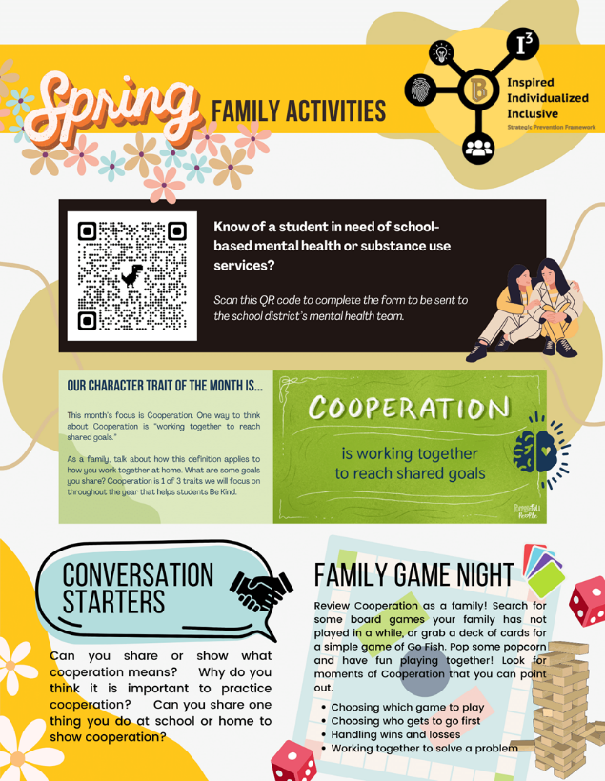

- I3 continues to provide medication lock boxes for families and community members to procure for medication safety. Four of 55 have been distributed.

- Character Strong—I3 is working with the school admin to implement the Character Strong SEL Curriculum. We are beginning to implement tier 2 performance-based and small group interventions in addition to tier 3 support at all sites.

- The I3 team continues to work toward refining the Mental Health referral pathway and process.

- I3 is working with BMHS to develop substance use/misuse prevention to implement an In-Depth Alternative to Suspension or Citation. The American Lung Association has developed an evidence-based nicotine intervention program designed for teens. This program is of interest, as the number of students caught vaping has increased markedly this past school year.
  - Prevention Specialist sees 9 students weekly at a tier 2 level of service.

Evaluation-
- Currently evaluating data from the Character Strong Curriculum and proactive detection tool to support our developing MTSS.

- Quality improvement will continue for all new programs and initiatives to monitor success/barriers and modify to the community's needs.

- Specification of intervention data—The Dinner Table Project post-assessment was given to all participants. This data is used to evaluate the Dinner Table Project's effectiveness and to develop quality improvement measures for future initiatives. 35 meal kits were provided, reaching 146 family members and 64 students. 14 of the 35 families completed the post-assessment.
  - 85.7% of respondents enjoyed the family gratitude journal the most
  - 57.1% of respondents found the conversation starters to be the most useful element within the meal kit provided
  - 71.4% of respondents would like to see more of the conversation starters in future meal kits
  - 78.6% of respondents feel more comfortable talking with their children about healthy coping skills and other tools that benefit their mental health
  - 64.3% of respondents feel more comfortable talking to their children about mental health and substance use
  - 64.3% of respondents feel they know more about the consequences related to substance misuse involving recreational drugs, prescription drugs, tobacco, e-cigarettes, alcohol, etc.

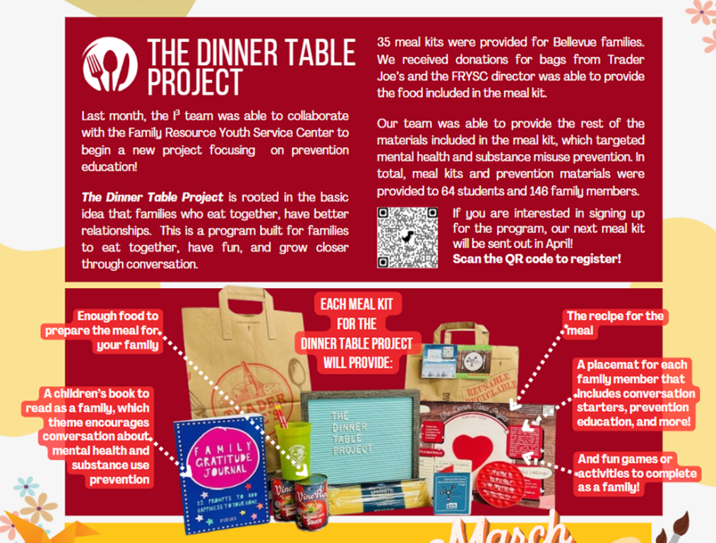

- SPF Project Director completed and submitted eRa Commons Year 1 Annual Performance Review due Dec.31- pending

- SPF Project Director completed and submitted eRa Commons Year 2 Detailed Budget and Narrative Revision - pending

- SPF Project Director submitted Year 3 Continuation Report – pending

- The SPF Project Director submitted a Year 1 formal carry-over request. The formal carry-over request was denied. PI will work with the Financial Director to update year 1 financials and apply for intent to carryover funds.

- Events – Provided Mental Health and Prevention Resources during all events.
  - Math Night

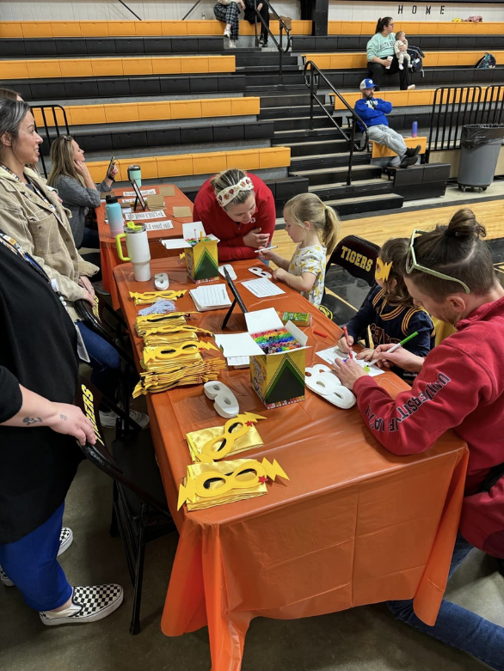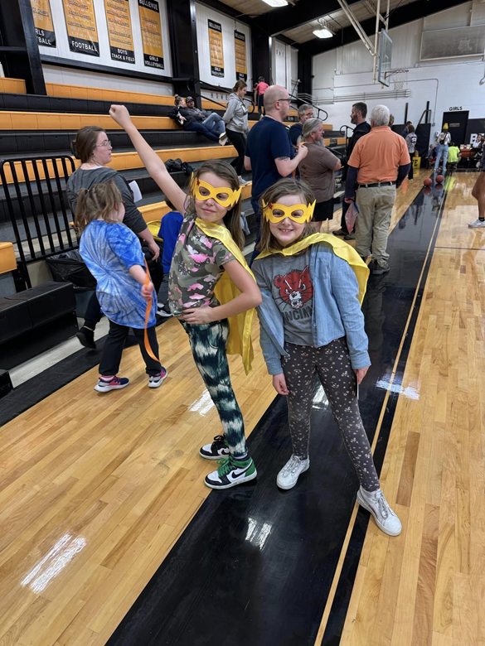

Sustainability- Continue developing and improving the district's MTSS system and mental health supports. SEL teams deliver substance abuse prevention curriculum to students.

School-Based Mental Health
March 2024 – April 2024
March 2024

Staffing Changes: N/A

Completed trainings/ initiatives: Creative Arts Therapies Week 3/18-3/22

Heather Conley: Passed ATCBE exam 3/2/2024 - ATR-BC and LPAT applications in process
Jessica Martin: Why Schools Struggle with Tier 3 Supports (online)
Dialectical Behavioral Therapy Training in progress (online)

Breakdown of time and/or number of students reached/seen:
Direct Hours* (for Feb/March as of 3/6/24)
Heather: 51.34 hours = 7.92 hours of crisis (15.4%)
Jessica: 40.8 hours; 60 minutes of crisis (2%); 1.8 hours of student disengagement (7%)
- Collaborative meetings related to care: 6.8 hours

*(Parent calls, client notes, meetings, paperwork are not included in direct hours)

Caseload numbers as of 02/07/2024
GES - 20 active, 0 referrals, 5 on radar
BMHS - 41 active, 5 new referrals (consents/intakes in progress), 10 on radar,
James - BMHS 12 active(including student mentoring)

Programming/ Initiatives:
- Student referral form on BMHS staff Google Classroom and being utilized
- Screener in progress during Engage at BMHS for the past 2 weeks
- I Can End the Trend assemblies presented to all middle school 3/5/2024 w/James
- Jessica will be taking over two tier 2 small groups once this session has been completed
- The universal screener has been completed at GES. This data will be evaluated and then used to assign students to tier 2 groups.

April 2024

Staffing Changes: N/A

Completed trainings/ initiatives: Creative Arts Therapies Week 3/18-3/22

Heather Conley: Passed ATCBE exam 3/2/2024 - ATR-BC active, LPAT application in process
CSTOP Now - Stopping Child Sex Trafficking
Jessica Martin: Implement Tier 3 with Confidence and Fidelity (online)
Going from Reactive to Proactive to Get Tier 3 Right (online)
Dialectical Behavioral Therapy Training in progress (online)
James: Started tier2 (Self Management) with MS/HS
- Completed trainings: Trauma-Informed Practices for Educators and School Personnel Learning Collaborative
- #iCANendthetrend Prevention Program
- SEL participation (Trip to U of L)
- Understanding Addiction: Moving Throughout the Spectrum of Mental, Emotional, and Behavioral Interventions

Breakdown of time and/or number of students reached/seen:
Direct Hours* (for March/April as of 4/3/24)
Heather: 52.18 = 9.5 hours of crisis (18%)
James: 45.5= 15 hours tier 2, 15 hours =Meetings related to Vaping, 5 hours= trainings,10.5=Student mentoring.
Jessica: 38.8 hours; 40 minutes of crisis (2%); 2.1 hours of student disengagement (6.1%)
- Collaborative meetings related to care: 12.3 hours

*(Parent calls, client notes, meetings, paperwork are not included in direct hours)

Caseload numbers as of 04/03/2024
GES - 21 active, 0 referrals, 5 on radar
BMHS - 41 active, 3 new referrals (consents/intakes in progress), 10 on radar,

Programming/ Initiatives:
- Student referral form on BMHS staff Google Classroom and being utilized
- Screener been issued at BMHS - completion rate = 67.9% of classes or 19/28 classes are completed
- Announcing design contest for t-shirts for Mental Health Action Day - presented to students the week of 4/01/2024 daily on announcements
- Creation of BMHS kits for Mental Health Awareness Month - HC w/ Carr/ Huff
- Creating an SEL station for field day for Mental Health Action Day at GES

