Southgate Independent School District

2014
Certified Evaluation Plan

Southgate Independent School District
Professional Growth and Effectiveness Plan

PROFESSIONAL GROWTH AND EFFECTIVENESS SYSTEM OVERVIEW
Effective teaching and school leadership depend on clear standards and expectations, reliable feedback, and the tools, resources and support for professional growth and continuous improvement. The Kentucky Department of Education, with the guidance and oversight of various steering committees, has designed, developed, field tested and piloted a new statewide Professional Growth and Effectiveness System (PGES).

With the passage of Senate Bill 1 in 2009, Kentucky embarked on a comprehensive system of education reform integrating:
    - relevant and rigorous standards
    - aligned and meaningful assessments
    - highly effective teaching and school leadership
    - data to inform instruction and policy decisions
    - innovation
    - school improvement
All are critical elements of student success, but it is effective teaching supported by effective leadership that will ensure all Kentucky students are successful and graduate from high school college/career-ready.

The PGES is designed to measure teacher, leader and other professionals’ effectiveness and serve as a catalyst for professional growth and continuous improvement, and is a key requirement of Kentucky’s Elementary and Secondary Education Act (ESEA) flexibility waiver and the state’s Race to the Top grant.

The Certified Evaluation Plan was developed by a 50/50 committee consisting of two teachers and two administrators. The plan was approved by the Southgate Board of Education on May 13, 2014. The principal shall serve as the point of contact for monitoring the evaluation training and implementing the Professional Growth and Effectiveness System.

Professional Growth and Effectiveness System – Certified Teacher
The vision for the Professional Growth and Effectiveness System (PGES) is to have every student taught by an effective teacher. The goal is to create a fair and equitable system to measure teacher effectiveness and act as a catalyst for professional growth.

Roles and Definitions

- Administrator: Means an EPSB certified administrator who devotes the majority of employed time in the role of principal, for which administrative certification is required by the Education Professional Standards Board pursuant to 16 KAR 3:050
- Evaluator: The immediate supervisor of certified personnel, who has satisfactorily completed all required evaluation training and, if evaluating teachers, observation certification training. The immediate supervisor will be designated primary evaluator.
- Evaluatee: District/School personnel being evaluated
- Peer Observer: Observation and documentation by a trained certified school personnel.
- Professional Growth Plan: An individualized plan that is focused on improving professional practice and leadership skills and is aligned with educator performance standards and student performance standards, is built using a variety of sources and types of student data that reflect student needs and strengths, educator data, and school/district data, is produced in consultation with the evaluator.
- Self-Reflection: Means the process by which certified personnel assesses the effectiveness and adequacy of their knowledge and performance for the purpose of identifying areas for professional learning and growth.
- Student Voice: The state-approved student perception survey, administered each year, that, provides data on specific aspects of the classroom experience and of teaching practice.
- For Additional Definitions and Roles, please see 704KAR 3:370 Professional Growth and Effectiveness System

The Kentucky Framework for Teaching
The Framework for Teaching is designed to support student achievement and professional practice through the domains of Planning and Preparation, Classroom Environment, Instruction, and Professional Responsibilities. The Framework also includes themes such as equity, cultural competence, high expectations, developmental appropriateness, accommodating individual needs, effective technology integration, and student assumption of responsibility. It provides structure for feedback for continuous improvement through individual goals that target student and professional growth, thus supporting overall school improvement. Evidence supporting a teacher’s professional practice will be situated within one or more of the four domains of the framework. Performance will be rated for each component according to four performance levels: Ineffective, Developing, Accomplished, and Exemplary. The summative rating will be a holistic representation of performance, combining data from multiple sources of evidence across each domain.

The use of professional judgment based on multiple sources of evidence promotes a more holistic and comprehensive analysis of practice, rather than over-reliance on one individual data point or rote calculation of practice based on predetermined formulas. Evaluators will also take into account how educators respond to or apply additional supports and resources designed to promote student learning, as well as their own professional growth and development. Finally, professional judgment gives evaluators the flexibility to account for a wide variety of factors related to individual educator performance, such as: school-specific priorities that may drive practice in one domain, an educator’s number of goals, experience level and/or leadership opportunities, and contextual variables that may impact the learning environment, such as unanticipated outside events or traumas.

Evaluators must use the following categories of evidence in determining overall ratings:
Required Sources of Evidence
  - Professional Growth Planning and Self-Reflection
  - Observation
  - Student Voice
  - Student Growth Percentiles and/or Student Growth Goals
- Other Measures of Student Learning
- Products of Practice
- Other Sources (e.g., surveys)

All components and sources of evidence related supporting an educator’s professional practice and student growth ratings will be completed and recorded in the Educator Development Suite (EDS) housed within the Continuous Instructional Improvement Technology System (CIITS).

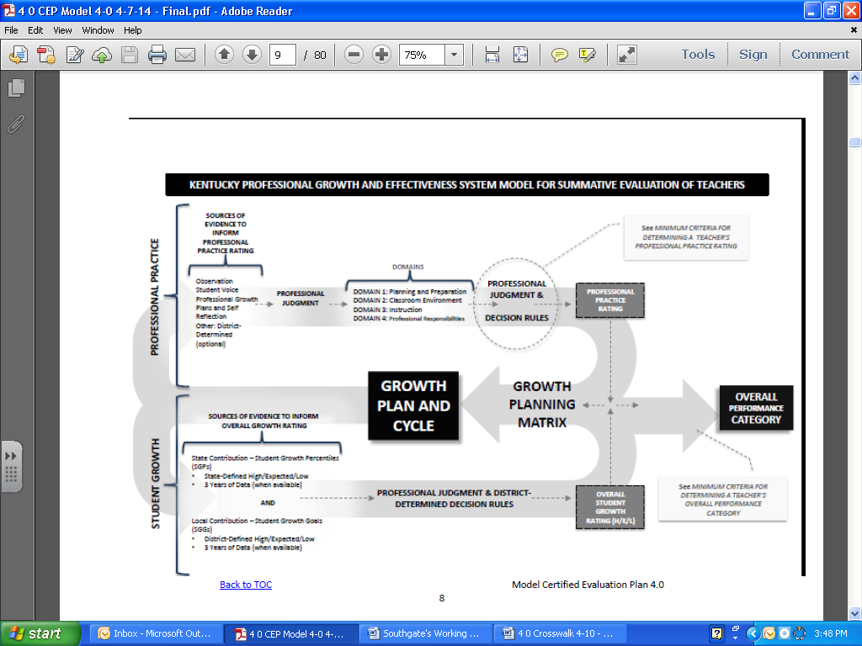
5
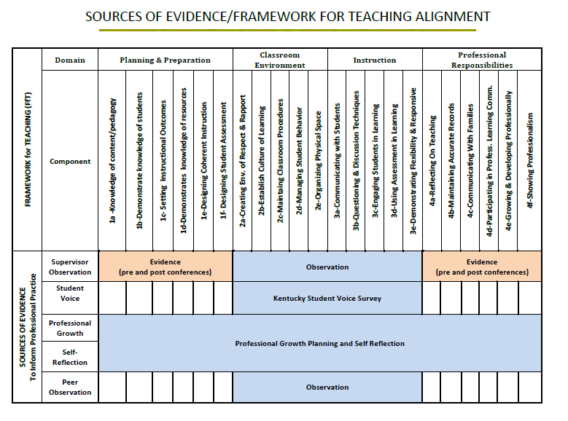

Professional Practice
Professional Growth Planning and Self-Reflection
The Professional Growth Plan will address realistic, focused, and measurable professional goals. The plan will connect data from multiple sources including classroom observation feedback, data on student growth and achievement, and professional growth needs identified through self-assessment and reflection. In collaboration with the administrators, teachers will identify explicit goals which will drive the focus of professional growth activities, support, and on-going reflection.
Reflective practices and professional growth planning are iterative processes. The teacher (1) reflects on his or her current growth needs based on multiple sources of data and identifies an area or areas for focus; (2) collaborates with his or her administrator to develop a professional growth plan and action steps; (3) implements the plan; (4) regularly reflects on the progress and impact of the plan on his or her professional practice; (5) modifies the plan as appropriate; (6) continues implementation and ongoing reflection; (7) and, finally, conducts a summative reflection on the degree of goal attainment and the implications for next steps.

- All teachers will participate in self-reflection and professional growth planning each year.
- All teachers will document self-reflection and professional growth planning in CIITS.
- All teachers will complete the SGG and PGP template on page 24.
Teacher Evaluation Timeline
Description of Events | Dates
Orientation | Annually within the first 30 days of school
Notification of Evaluations | Beginning of school year
Self Reflections | A minimum once per year
Peer Observation Training | Prior to peer observations
Student Growth Goals | Within the first 30 days of the start of the school year
Professional Growth Plans Goals | Within the first 30 days of the start of the school year
Midyear Review of Student Growth Goals and Professional Growth Goals | Within the second or third quarter of the school calendar
Optional Pre-Observation conference – Face to face or written | Prior to observation
Observations | Planned or unannounced
Post Observation conference – Face to face or written | Within 5 working days of the observation
Student Voice Surveys | Two week period during the spring semester
Formal & Informal Observation and Data collection | Ongoing throughout the school year
Summative Evaluation and Conferences | Due in district office by April 15 – for continuing contract
7
Observation
The observation process is one source of evidence to determine teacher effectiveness that includes supervisor and peer observation for each certified teacher. Both peer and supervisor observations will use the same instruments. The supervisor observation will provide documentation and feedback to measure the effectiveness of a teacher’s professional practice. The evaluatee will receive a copy of evaluation. Only the supervisor observation will be used to inform calculate a summative rating. Peer observation will only be used for formative feedback on teaching practice in a collegial atmosphere of trust and common purpose. NO summative ratings will be given by the peer observer. The rationale for each type of observation is to encourage continued professional learning in teaching and learning through critical reflection.

Observation Model

- The summative cycle, 3 years for tenure teachers and 1 year for non-tenure teachers, will include four (4) observations.
  - A minimum of 3 observations conducted by the supervisor and 1 observation conducted by the peer. The observations can be any combination of mini (20 -30 minutes) or full observations.
  - Additional observations may be added.
  - The required peer observation must occur in the final year of the cycle.
  - Final observation is conducted by the supervisor and is a full observation.
- All observations must be documented in CIITS.
  - During mini observation the observer will make notes of components observed in order to identify "look fors" in the next mini observation session. The final observation is a formal observation consisting of a full class or lesson observation.

Observation Conferencing

Observers will adhere to the following observation conferencing requirements
- Pre conferences are not mandatory but may occur at the discretion of the evaluator.
- Post conferences will take place for full observations, but are not required for mini observations.
- All conferences can be conducted either face-to-face, written, or electronically.
- Conduct post observation conference within five (5) working days.
- The summative evaluation conference shall be held at the end of the summative evaluation cycle.
- Timeline: Refer to the Teacher Evaluation Timeline on page 7.

Observation Schedule

- Observations may begin after the initial evaluation training within the first month of employment.
- Timeline for when observations must be completed
- Timeline: refer to the Teacher Evaluation Timeline on page 7.

Observer Certification

To ensure consistency of observations, evaluators must complete the Teachscape Proficiency Observation Training, the current approved state platform. The system allows observers to develop a deep understanding of how the four domains of the Kentucky Framework for Teaching (FfT) are applied in observation. There are 3 sections of the proficiency system:
- Framework for Teaching Observer Training
- Framework for Teaching Scoring Practice
- Framework for Teaching Proficiency Assessment
The cycle for observation certification established is as follows [NOTE: This evaluation certification cycle mirrors the existing 704 KAR 3:370 related to initial and update training for certified evaluators]:
Year 1 | Certification
Year 2 | Calibration
Year 3 | Calibration
Year 4 | Recertification
- Only supervisors who have passed the proficiency assessment can conduct mini and full observations for the purpose of evaluation. In the event that a supervisor has yet to complete the proficiency assessment, or if the supervisor does not pass the assessment, the district will provide the following supports:
  - Observation data provided by a substitute observer is considered a valid source of evidence only if the supervisor participated (passively) in the observation.
  - In cases where the supervisor is not certified though the proficiency system and is therefore unable to conduct observations during the observation window, the district will use the following process to ensure teachers have access to observations and feedback:

Considerations to ensure supervisors have the support needed to be successful in the proficiency system. Examples include
- A scaffolded approach, beginning with initial supports to ensure success during the first administration of the assessment, supports for those who do not pass after one attempt and, supports for those unable to pass the assessment after the second attempt and are subsequently locked out of the system for 90 days.
  - These processes could include collaboration during the initial training (consider a cohort approach to initial certification), additional professional learning opportunities, and mentors.

Considerations the district will use to ensure teachers will have access to certified observers in cases where the supervisor is not certified through the proficiency system and therefore unable to conduct the observation.
- This may include district-level personnel or principals from another building (certified through the proficiency system) conducting the observation with the principal (modeling the process).
  - It is important to note that observation data provided by a substitute observer is considered a valid source of evidence only if the supervisor participated (passively) in the observation.

Observer Calibration
As certified observers may tend to experience “drift” in rating accuracy, the district will establish a calibration process to be completed each year where certification is not required (see chart under Observer Certification). This calibration process will be completed in years two (2) and three (3) after certification. Calibration ensures ongoing accuracy in scoring teaching practice; an awareness of the potential risk for rater bias; and that observers refresh their knowledge of the training and scoring practice.

- Observer calibration during years 2 & 3 of the Observer Certification process based on Teachscape, the current state approved technology.
- Re-certification after year 3.

District evaluators will utilize Teachscape to review the Framework for Teaching and discuss for accuracy.

Peer Observation

A Peer Observer will observe, collect, share evidence, and provide feedback for formative purposes only. Peer Observers will not score a teacher’s practice, nor will peer observation data be shared with anyone other than the Observee unless permission is granted.

- All teachers will receive a peer observation in their summative year.
- All Peer observers participating during the summative year observations will complete the state developed training.
- All required peer observations must be documented in CIITS.
- The following table provides a description of how peer observers are identified, trained, and assigned to teachers.

Selection & Assignment of Peer Observers
District Level | School Level | Teacher Level
- A pool of Peer Observers will be formed from which teachers can choose or be assigned | - A pool of Peer Observers will be formed from which teachers can choose or be assigned | - A pool of Peer Observers will be formed from which teachers can choose or be assigned
**NOTE** All peer observers will complete peer observation training on PD360.

Student Voice
The Student Voice Survey is a confidential, on-line survey that collects student feedback on specific aspects of the classroom experience and teaching practice.
Required
- All teachers will participate in the state-approved Student Voice Survey annually with a minimum of one identified group of students.
- Student selection for participation must be consistent across the district.
- Results will be used to inform Professional Practice.
- Formative years’ data will be used to inform Professional Practice in the summative year.
- All teachers and appropriate administrative staff read, understand, and sign the district’s Student Voice Ethics Statement.
- The Student Voice Survey will be administered between the hours of 7 AM and 5 PM local time.
- The survey will be administered in the school during a two week period during the spring semester.
- Survey data will only be considered when 10 or more students are respondents.
- The Student Voice Point-of-Contact will be the principal.

Student Voice Assignment for Teachers
Kindergarten – 2nd Grade | 3rd and 4th Grade | 5th – 8th Grade | Special Education and Special Area Teachers
Homeroom Teacher | Homeroom Teacher | Teachers will be assigned a class for the Student Voice Survey dependent upon their schedule. | Special Education teachers will be assigned a class for the Student Voice Survey dependent upon their schedule and caseload.

- If any given grade has less than 10 students another grade will be assigned to them if possible.

Student Growth
The student growth measure is comprised of two possible contributions: a state contribution and a local contribution. The state contribution pertains to teachers of the following content areas and grade levels participating in state assessments:
- 4th – 8th Grade
- Reading
- Math
The state contribution is reported using Student Growth Percentiles (SGP). The local contribution uses the Student Growth Goal Setting Process and applies to all teachers in the district, including those who receive SGP. The following graphic provides a roadmap for determining which teachers receive which contributions:
YES
YES
YES
NO
NO
NO

State Contribution – Student Growth Percentiles (SGP)
The state contribution for student growth is a rating based on each student’s rate of change compared to other students with a similar test score history (“academic peers”) expressed as a percentile. The median SGP for a teacher’s class is compared to that of the state. The scale for determining acceptable growth will be determined by the Kentucky Board of Education and provided to the district by the Kentucky Department of Education.

Local Contribution – Student Growth Goals (SGG)
The local contribution for the student growth measure is a rating based on the degree to which a teacher meets the growth goal for a set of students over an identified interval of instruction (i.e. trimester, semester, year-long) as indicated in the teacher’s Student Growth Goal (SGG). All teachers, regardless of grade level and content area, will develop a SGG for inclusion in the student growth measure. All SGG will be determined by the teacher in collaboration with the principal and will be grounded in the fundamentals of assessment quality (Clear Purpose, Clear Targets, Sound Design, Effective Communication, and Student Involvement).
Rigor-congruency to the Kentucky Core Academic Standards

Comparability- Data collected for the student growth goal must use comparable criteria across similar classrooms (classrooms that address the same standards) to determine progress toward mastery of standards/enduring skills. Examples of similar classrooms might be 6th grade science classrooms, 3rd grade classrooms, English 1 classrooms, band or art classes. For similar classrooms, teachers would be expected to use common measures or rubrics to determine competency in performance at the level intended by the standards being assessed. Although specific assessments may vary, the close alignment to the intent of the standard is comparable.
Student Growth Goal Criteria
- The SGG is congruent with Kentucky Core Academic Standards and appropriate for the grade level and content area for which it was developed.
- The SGG represents or encompasses an enduring skill, process, understanding, or concept that students are expected to master by taking a particular course (or courses) in school.
- The SGG will allow high- and low-achieving students to adequately demonstrate their knowledge.
- The SGG provides access and opportunity for all students, including students with disabilities, ELLs, and gifted/talented students.

Rigor and Comparability of Student Growth Goals
To fulfill the criteria of measuring student growth at the local level, a protocol must be established to ensure rigorous and comparable growth measures used for all teachers.
- All teachers will write a student growth goal based on the criteria (pgs 14 – 15)
- Protocol for ensuring rigor
- Protocol for ensuring comparability
Rigor
- The following rubric guides the student growth goal process assuring appropriate rigor.

STUDENT GROWTH GOAL SETTING Rubric

Teacher
School
Administrator

Initial | Content  - The goal is being written around which grade/subject/level?
Context
- What are the characteristics or special learning circumstances of my class(es)?
Baseline Data
- What are the learning needs of my students?
- Attach supporting data.
Student Growth Goal Statement
- Does my goal meet the SMART criteria?
Strategies for Improvement
- How will I help students attain this goal?
- Provide specific actions that will lead to goal attainment.

Mid-Course Review | Collaborative Mid-Course Data Review  - What progress has been made?  - Attach supporting data
Strategy Modification
- What adjustments need to be made to my strategies?

End of Year | End-of-Year Data  - What does the end of the year data show?  - Attach data
Reflection on Results
- Overall, what worked, or what should be refined?
 | Connection to Framework for Teaching |  | I | D | A | E
Professional Growth Plan Implications
- How can I use these results to support my professional growth?

Step-By-Step SMART Goal Process

*Adapted for Kentucky from Stronge, J. H., & Grant, L. W. (2009). Student achievement goal setting: Using data to improve teaching and learning. Larchmont, NY: Eye on Education, Inc

Comparability
Include both assurances for establishing Comparability:

Administration Protocol | Administrative protocol procedures will ensure rigor and comparability by ensuring that Student Growth Goals meet the SMART rubric criteria on page 15.
Scoring Process | Step 1: Principal and teacher will collaboratively review relevant data sources and determines area of focus.  Step 2: Teacher will use the SGG rubric on page 14 to develop the Student Growth Goal. The student growth goal shall contain both growth and proficiency measures.  Step 3: The principal and teacher will determine the goal. See template page 24.

Determining Growth for a Single Student Growth Goal

Process for determining growth (high, expected, low) | The process for determining high, expected, or low growth will be determined in the following manner:  High Growth: one (1) percentage point or more than the goal  Expected Growth: five (5) percentage points below goal to goal  Low Growth: six (6) or more percentage points below goal
Measures | Pre-Test/Post –Test-Teachers will use pre/post tests to determine the growth identified in their goal. These assessments can be identical or comparable versions.

Products of Practice/Other Sources of Evidence
Teachers may provide additional evidences to support assessment of their own professional practice. These evidences should yield information related to the teacher’s practice within the domains.

Required
- observations conducted by certified supervisor observer(s)
- student voice survey(s)
- self-reflection and professional growth plans
- Other sources that may be used include:

- Program Review evidence
- team-developed curriculum units
- lesson plans
- communication logs
- timely, targeted feedback from mini or informal observations
- student data records
- student work
- student formative and/or summative course evaluations/feedback
- minutes from PLCs
- teacher reflections and/or self-reflections
- teacher interviews
- teacher committee or team contributions
- parent engagement surveys
- records of student and/or teacher attendance
- video lessons
- engagement in professional organizations

Determining the Overall Performance Category
Supervisors are responsible for determining an Overall Performance Category for each teacher at the conclusion of their summative evaluation year. The Overall Performance Category is informed by the educator’s ratings on professional practice and student growth. The evaluator determines the Overall Performance Category based on professional judgment informed by evidence that demonstrates the educator's performance against the Domains, district-developed rubrics (see local contribution for student growth), and decision rules that establish a common understanding of performance thresholds to which all educators are held.

Rating Professional Practice
The Kentucky Framework for Teaching stands as the critical rubric for providing educators and evaluators with concrete descriptions of practice associated with specific domains. Each element describes a discrete behavior or related set of behaviors that educators and evaluators can prioritize for evidence-gathering, feedback, and eventually, evaluation. Supervisors will organize and analyze evidence for each individual educator based on these concrete descriptions of practice.

Supervisors and educators will be engaged in ongoing dialogue throughout the evaluation cycle. The process concludes with the evaluator’s analysis of evidence and the final assessment of practice in relation to performance described under each Domain at the culmination of an educator’s cycle.
REQUIRED
- Observation
- Student Voice
- Professional Growth Plans and Self Reflection
OPTIONAL
- Other: District-Determined – Must be identified in the CEP
PROFESSIONAL PRACTICE

DOMAIN RATINGS
DOMAIN 1: [I,D,A,E]
SOURCES OF EVIDENCE TO INFORM PROFESSIONAL PRACTICE

PROFESSIONAL JUDGMENT
DOMAIN 2: [I,D,A,E]
DOMAIN 3: [I,D,A,E]
DOMAIN 4: [I,D,A,E]

- Provide a summative rating for each domain based on evidence.
- All ratings must be recorded in CIITS.

Student Growth Rating

The overall Student Growth Rating is a result of a combination of professional judgment and the district-developed instrument for summative student growth ratings. The designed instrument aids the supervisor in applying professional judgment to multiple evidences of student growth over time. The Student Growth Rating must include data from SGG and SGP (where available), and will be considered in a three year cycle (when available).
STATE
- SGPs
- State Predefined Cut Scores
LOCAL
- SGG
- Maintain current process
- Rate on H/E/L
STUDENT GROWTH
STUDENT GROWTH RATING
STUDENT GROWTH [H,E,L]
SOURCES OF EVIDENCE TO INFORM STUDENT GROWTH

PROFESSIONAL JUDGMENT AND DISTRICT-DETERMINED RUBRICS

- SGG and SGP(when available) will be used to determine overall Student Growth Rating
- Three years of student growth data (when available) will be used to determine overall Student Growth Rating
Decision Rules
A teacher has any “Low” ratings | CANNOT be rated as HIGH
Teacher has 50% or more of their ratings as “LOW” | SHALL be rated as LOW
Teacher has more than 50% of their ratings as  “Expected and/or HIGH” | CANNOT be rated as “LOW”

- The procedures for ensuring rigor and comparability are based off the student growth goal on page 16.

Determining the Overall Performance Category

An educator’s Overall Performance Category is determined by the following steps:

- Determine the individual domain ratings through the use of sources of evidence and professional judgment.
- Apply State Decisions Rules for determining an educator’s Professional Practice.

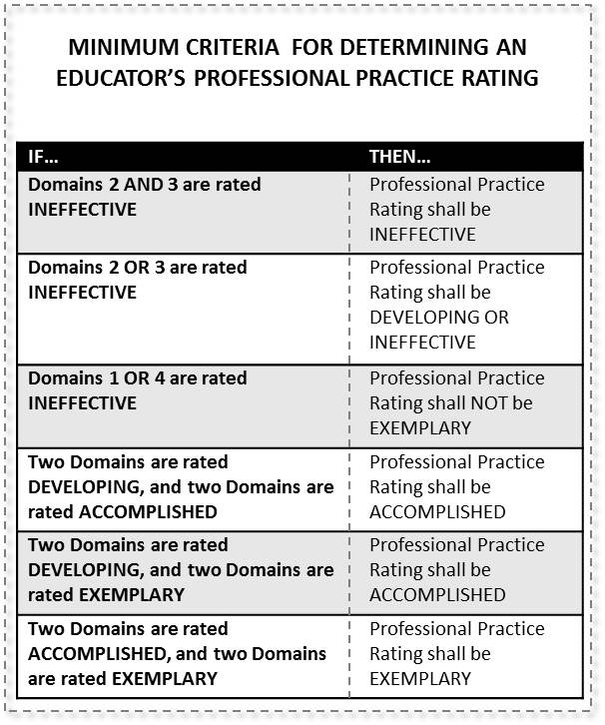

Use Local Student Growth Goal instrument to determine overall Student Growth Rating.
Process for determining growth (high, expected, low) | The process for determining high, expected, or low growth will be determined in the following manner:  High Growth: one (1) percentage point or more than the goal  Expected Growth: five (5) percentage points below goal to goal  Low Growth: six (6) or more percentage points below goal
Measures | Pre-Test/Post –Test-Teachers will use pre/post tests to determine the growth identified in their goal. These assessments can be identical or comparable versions.

- Apply State Overall Decision Rules for determining educator’s Overall Performance Category.
- Implement the Overall Performance Category process for determining effectiveness.
Professional Growth Plan and Summative Cycle
Based on the overall Professional Practice rating and Student Growth rating, supervisors will help tenured teachers determine the type of Professional Growth Plan and the length of the summative cycle.
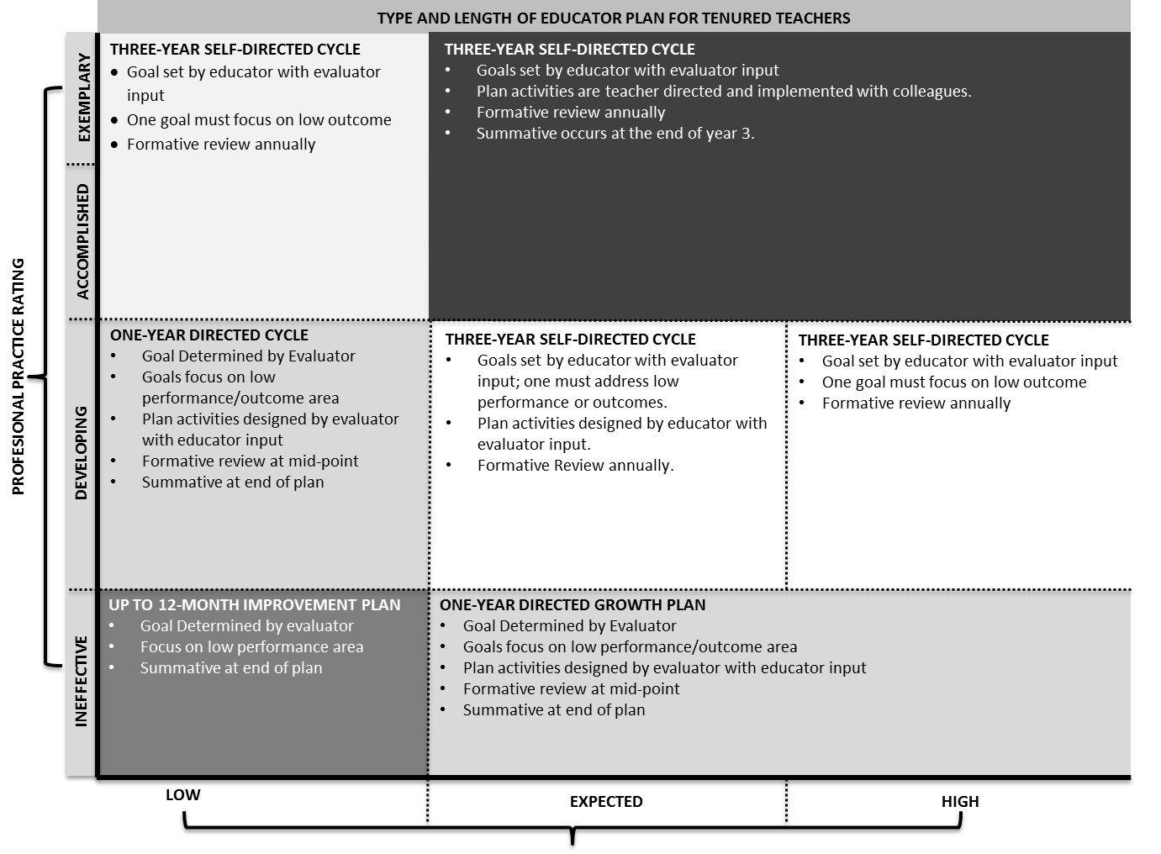

Appeals
According to 156.557 Section 9,
Section 9. (1) A certified employee who feels that the local district is not properly implementing the evaluation plan according to the way it was approved by the Kentucky Department of Education shall have the opportunity to appeal to the Kentucky Board of Education.
(2) The appeal procedures shall be as follows:
(a) The Kentucky Board of Education shall appoint a committee of three (3) state board members to serve on the State Evaluation Appeals Panel. Its jurisdiction shall be limited to procedural matters already addressed by the local appeals panel required by KRS 156.557(5). The panel shall not have jurisdiction relative to a complaint involving the professional judgmental conclusion of an evaluation, and the panel's review shall be limited to the record of proceedings at the local district level.
(b) No later than thirty (30) days after the final action or decision at the local district level, the certified employee may submit a written request to the chief state school officer for a review before the State Evaluation Appeals Panel. An appeal not filed in a timely manner shall not be considered. A specific description of the complaint and grounds for appeal shall be submitted with this request.
(c) A brief, written statement, and other document which a party wants considered by the State Evaluation Appeals Panel shall be filed with the panel and served on the opposing party at least twenty (20) days prior to the scheduled review.
(d) A decision of the appeals panel shall be rendered within fifteen (15) working days after the review.
(e) A determination of noncompliance shall render the evaluation void, and the employee shall have the right to be reevaluated. (11 Ky.R. 1107; Am. 1268; eff. 3-12-85; 12 Ky.R. 1638; 1837; eff. 6-10-86; 15 Ky.R. 1561; 1849; eff. 3-23-89; 17 Ky.R. 116; eff. 9-13-90; 19 Ky.R. 515; 947; 1081; eff. 11-9-92; 20 Ky.R. 845; eff. 12-6-93; 23 Ky.R. 2277; 2732; eff. 1-9-97; 27 Ky.R. 1874; 2778; eff. 4-9-2001.)
Local Appeals Process
If, for any reason, the evaluatee is dissatisfied with the final evaluation results, he/she may submit to the evaluator and chair of the appeal panel a written response to the report a copy of which will become a part of the evaluatee’s personnel file.
If the evaluatee feels he/she has received an unfair summative evaluation, he/she may appeal to a panel formed for that purpose. The panel is composed of three members, two of whom are selected by the certified employees and one by the Southgate Board of Education. Only certified employees of the Southgate Independent School System are eligible to serve on the panel. Members are elected/appointed for two-year terms and may be reelected/appointed for two consecutive terms. The term begins July 1 of the first year and ends June 30 of the second year.
The appeals panel shall annually select a chair from the panel members. The chair shall be responsible for scheduling and facilitating the activities of the panel and for communicating on behalf of the panel to all parties involved in any appeal.
To appeal an evaluation, the evaluatee must make a request for a hearing in writing to the appeals panel within 5 working days of the receipt of the summative evaluation. A copy of the request must be submitted to the chair of the appeals panel and must include a justification for such request.
The panel will conduct a hearing with 15 days from the date of receipt of the letter request. Both the evaluatee and evaluator will be invited to appear at the hearing. All discussions between the panel members and evaluatee and evaluator shall be confined to the hearing(s).
After completing the hearing, the panel will declare the evaluation as fair or unfair. If the evaluation is found to be fair, the process ends. If the evaluation is found to be unfair, the panel may recommend removing, from the personnel file, the summative or any part of the summative, which the panel finds in error.

Appeals Panel Hearing Process
The purpose of the Appeals Panel Hearing is to review the summative evaluation of the employee. Confidentiality and fairness shall be the primary concerns of the panel.
A preliminary hearing will be held to provide documentation to all parties and the panel. Four copies of all documentation shall be available to the committee at this time. Both the evaluatee and evaluator will be give access to review all material submitted to the panel. The chair shall convene the hearing and explain procedures for the process. Legal counsel or their chosen representative may represent the evaluatee and evaluator. The Board of Education shall provide legal counsel to the panel if requested. The evaluatee has the right to determine whether the hearing is open or closed. A closed hearing will include the panel, evaluatee, evaluator, and their chosen representatives. Witnesses may be called by either party, but will not be allowed to observe the hearing process other than during their testimony. After the evaluatee and evaluator leave, the appeals committee shall remain and review all documents and formulate questions for the hearing.
Within 3 working days a hearing will convene to allow previously provided material to evaluatee and evaluator to be presented to the Appeals Hearing Committee. The chair will convene the hearing and establish procedures. The evaluatee shall present his/her opening statements followed by the evaluator’s statements. Each pary will then be allowed to present his/her documentation including witnesses pertinent to the summative evaluation. The panel shall consider both substance and procedural issues. An opportunity for questioning each party shall be provided to the panel. The panel will then consider all the information provided them to make a determination. A decision regarding their findings shall be presented to the Superintendent within 15 days of the filing of the appeal. The chair will present the decision to the Superintendent for action within 3 working days of the decision.
An evaluatee who feels that procedural issues were violated may appeal the decision to the State Board for Elementary and Secondary Education Appeals Panel.

Teacher
Southgate Independent School District PGP and SGG Form
School
Content Area(s)
Grade Level

Professional Growth Plan Goal: Initial conference in CIITS for feedback and approval | Goal
Mid-Year Review | Status of Professional Goal and what revisions or modifications are needed?
Summative Reflection | End of Year Reflection and Next Steps

Student Growth Goal: Initial conference in CIITS for feedback and approval | Goal
Mid-Year Review | What progress has been made? What adjustments need to be made?
Summative Reflection | What does the end of year data show? What worked? What should be refined?

Conference | Date | Evaluator | Evaluatee
Initial
Mid-Year
Summative

OPGES – Other Professionals Growth and Effectiveness System:
The current evaluation standards and procedures for “Other ” (speech language pathologists, counselors, psychologist, library media specialist, and instructional coaches) included in this evaluation plan will remain in effect until the OPGES is fully implemented in Kentucky. OPGES is scheduled to be piloted in Kentucky during the 2014-15 school year.

Professional Growth and Effectiveness System – Principal and Assistant Principal
The vision for the Professional Growth and Effectiveness System (PGES) is to have every school led by an effective principal. The goal is to create a fair and equitable system to measure principal effectiveness and act as a catalyst for professional growth.
Roles and Definitions
- Administrator: means an administrator who devotes the majority of employed time in the role of principal, for which administrative certification is required by the Education Professional Standards Board pursuant to 16 KAR 3:050
- Documentation: Artifacts created in the day-to -day world of running a school that can provide evidence of meeting the performance standard.
- Evaluator: the immediate supervisor of certified personnel, who has satisfactorily completed all required evaluation training and, if evaluating teachers, observation certification training.
- Evaluatee: District/School personnel that are being evaluated.
- Observation/School Site Visits: Provides information on a wide range of contributions made by principals. Observations/school site visits may range from watching how a principal interacts with others, to observing programs and shadowing the administrator.
- Professional Growth Plan: An individualized plan that is focused on improving professional practice and leadership skills and is aligned with educator performance standards and student performance standards, is built using a variety of sources and types of student data that reflect student needs and strengths, educator data, and school/district data, is produced in consultation with the evaluator
- Performance Levels-General descriptors that indicate the principal’s performance. Principals can be rated Ineffective, Developing, Accomplished, or Exemplary on this scale.
- Performance Rubrics: a behavioral summary scale that describes acceptable performance levels for each of the seven performance standards.
- Performance Standards-Guiding standards that provide for a defined set of common purposes and expectations that guide effective leadership. Those standards include: Instructional Leadership, School Climate, Human Resources Management, Organizational Management, Communication and Community Relations, Professionalism and Student Growth.
- Self-Reflection: means the process by which certified personnel assess the effectiveness and adequacy of their knowledge and performance for the purpose of identifying areas for professional learning and growth
- SMART Criteria; Acronym use to develop a goal(s) Specific, Measurable, Appropriate, Realistic, Time-Bound.
- Site Visit: methods by which superintendents may gain insight into whether principals are meeting the performance standards.
- Surveys: Tools used to provide information to principals about perception of job performance.
- Val-Ed 360°: An assessment that provides feedback of a principal’s learning-centered behaviors by using input from the principal, his/her supervisor, and teachers. The survey looks at core components (the what) that are listed on the slide, as well as key processes (the how).
- VAL-ED Point of Contact: person selected at district and school level to assist in the facilitation of the VAL-ED 360 survey.
- TELL Kentucky: A working conditions survey of all school staff conducted every two years to provide feedback on specific aspects of the school’s work environment.
- Back to Any Schools TOC Model Certified Evaluation Plan 4.0 67
- Working Conditions Goal: Goal that connects the TELL KY data to the Principal Performance Standards and impacts working conditions within the school building.

Principal Professional Growth and Effectiveness System Components – Overview and Summative Model
The following graphic outlines the summative model for the Principal Professional Growth and Effectiveness System.

Professional Growth Plans and Self- Reflection
Site-Visits
Val-Ed 360°
Working Conditions Growth Goal
STANDARD 4: Organizational Management
OVERALL PERFORMANCE CATEGORY
PROFESSIONAL PRACTICE
STUDENT GROWTH

PROFESSIONAL JUDGMENT
STANDARD RATINGS
STANDARD 3: Human Resource Management
STANDARD 2: School Climate
STANDARD 1: Instructional Leadership
SOURCES OF EVIDENCE TO INFORM PROFESSIONAL PRACTICE

State Contribution – ASSIST/NGL Goal
SOURCES OF EVIDENCE TO INFORM STUDENT GROWTH

Local Contribution – Student Growth Goals (SGGs) based on school need
AND
PERFORMANCE TOWARD TRAJECTORY
STUDENT GROWTH RATINGS
LOCAL CONTRIBUTION: High, Expected, Low Growth Rating

PROFESSIONAL JUDGMENT AND DISTRICT-DETERMINED RUBRICS
STATE CONTRIBUTION: High, Expected, Low Growth Rating

PROFESSIONAL JUDGMENT & STATE-DETERMINED DECISION RULES establishing a common understanding of performance thresholds to which all educators are held
STANDARD 6: Professionalism
STANDARD 5: Communication & Community Relations

Evaluators will look for trends and patterns in practice across multiple types of evidence and apply their professional judgment based on this evidence when evaluating a principal. The role of evidence and professional judgment in the determination of ratings on standards and an overall rating is paramount in this process. However, professional judgment is grounded in a common framework: the Principal Performance Standards.

Principal Performance Standards
The Principal Performance Standards are designed to support student achievement and professional best-practice through the standards of Instructional Leadership; School Climate; Human Resource Management; Organizational Management; Communication & Community Relations; and Professionalism. Included in the Performance Standards are Performance Indicators that provide examples of observable, tangible behaviors that provide evidence of each standard. The Performance Standards provide the structure for feedback for continuous improvement through individual goals that target professional growth, thus supporting overall student achievement and school improvement. Evidence supporting a principal’s professional practice will be situated within one or more of the 6 standards. Performance will be rated for each standard according to the four performance levels: Ineffective, Developing, Accomplished, and Exemplary. It is important to note that the expected performance level is “Accomplished,” but a good rule of thumb is that it is expected that a principal will “live in Accomplished but occasionally visit Exemplary”. The summative rating will be a holistic representation of performance, combining data from multiple sources of evidence across each standard.
The use of professional judgment based on multiple sources of evidence promotes a more holistic and comprehensive analysis of practice, rather than over-reliance on one individual data point or rote calculation of practice based on predetermined formulas. Evaluators will also take into account how principals respond to or apply additional supports and resources designed to promote student learning, as well as their own professional growth and development. Finally, professional judgment gives evaluators the flexibility to account for a wide variety of factors related to individual principal performance. These factors may include school-specific priorities that may drive practice in one standard, an educator’s number of goals, experience level and/or leadership opportunities, and contextual variables that may impact the learning environment, such as unanticipated outside events or traumas.

Evaluators must use the following categories of evidence in determining overall ratings:
- Professional Growth Planning and Self-Reflection
- Site-Visits
- Val-Ed 360°
- Working Conditions Goal (Based on TELL KY)
- State and Local Student Growth Goal data

Evaluators may use the following categories of evidence in determining overall ratings:
- Other Measures of Student Learning
- Products of Practice
- Other Sources (e.g. surveys)

Professional Practice
The following sections provide a detailed overview of the various sources of evidence used to inform Professional Practice Ratings.
Professional Growth Planning and Self-Reflection – completed by principals & assistant principals
The Professional Growth Plan will address realistic, focused, and measurable professional goals. The plan will connect data from multiple sources including site-visit conferences, data on student growth and achievement, and professional growth needs identified through self-assessment and reflection. Self-reflection improves principal practice through ongoing, careful consideration of the impact of leadership practice on student growth and achievement.
- All principals will receive summative evaluations annually.
- All principals will participate in self-reflection and professional growth planning each year.
- All assistant principals will participate in self-reflection and professional growth planning each year.

Principal / Assistant Principal Evaluation Time Line
Description of Events | Dates
September 30 | Principal/Assistant Principal collaboratively develop Student Growth Goal, Working Conditions Goal and Professional Growth Goal/Plan with the Superintendent (See template on page 39-46)
October | Superintendent Conducts a Site Visit
Mid-Year | Conference with principal/assistant principal to review/reflect upon all goals and modify any strategies as needed.
March | Completion of TELL or VAL-ED Survey
April/May | Superintendent conducts a Site Visit
By June 30 | Conference with principal/assistant principal to review their Student Growth Goal, Working Condition Goal, and Professional Growth Goal as well as modify any strategies.
*Additional Conferences may be held as deemed necessary to monitor PGP process.
*All dates are tentative based on the adjustment of the school calendar.

Site-Visits – completed by supervisor of principal – formal site visits are not required for assistant principals
Site visits are a method by which the superintendent may gain insight into the principal’s practice in relation to the standards. During a site visit, the superintendent will discuss various aspects of the job with the principal, and will use the principal’s responses to determine issues to further explore with the faculty and staff. Additionally, the principal may explain the successes and trials the school community has experienced in relation to school improvement.
- Conducted at least twice each year. (Formal site-visits are not required for the assistant principal.)
- See timeline on page 29.
- During the follow-up conference with the principal, the superintendent will review all Principal Performance Standards and give feedback about each standard.
- Optional: The Principal may ask the Superintendent to give specific feedback about a particular standard.

Val-Ed 360° - completed for principals – not completed for assistant principals
The VAL-ED 360° is an assessment that provides feedback on a principal’s learning-centered behaviors by using input from the principal, his/her supervisor, and teachers. All teachers will participate in the Val-Ed 360°. The results of the survey will be included as a source of data to inform each principal’s professional practice rating.
- Conducted at least once every two years in the school year that TELL Kentucky is not administered.
Val Ed Point of Contact | Val Ed Point of Contact will be assigned by the superintendent. Each school will also select a VAL ED Point of Contact to assist with the Val ED process.
VAL-ED Role Groups | District Administrator-oversee and monitor the implementation of the VAL-ED 360 process.  School VAL-ED Coordinator: Serves as a liaison between district and school to train and identify how the school will organize for the teacher survey and to distribute teacher codes. Each school process will be submitted and approved at the district level.  Superintendent: receives access code to be able to monitor they survey process and reports.  Supervisors-district may elect up to three district staff to complete survey for an individual principal. This will include the primary supervisor, who makes final decision regarding employment and recommendations for growth.  Principals: completes a survey specifically designed for principals and has access to information contained within final report.  Certified Teachers: teachers assigned to a specific school that complete the online survey designed specifically for teacher input.
Frequency of Val-Ed 360 | Once every other year alternating with TELL Kentucky Survey
Timeline | Two week period during the spring semester
Use of Val-ED 360 Results | The Val-Ed 360 survey results will be used by the building level principal to develop their individual student growth/professional growth plan.
Val-ED 360 Access | Val-ED survey results will be treated as confidential and only the principal and the immediate supervisor will receive the survey results.

Working Conditions Goal (Goal inherited by Assistant Principal)
Principals are responsible for setting a 2-year Working Conditions Growth Goal based on the most recent TELL Kentucky Survey. The principal’s effort to accomplish the Working Conditions Growth Goal is a powerful way to enhance professional performance and, in turn, positively impact school culture and student success.
- Developed following the completion of the TELL Kentucky Survey.
- Minimum of one 2-year goal.
Number of Working Conditions Goals | Principals are responsible for setting one (1) 2-year Working Conditions Goal that is based on information in the most recent TELL Kentucky Survey and any additional relevant data which might include VAL-ED surveys, school level documentation, etc. The Goal will be recorded on the district template on page 39-46. The principal, in collaboration with the superintendent/designee, will review the results from the TELL Kentucky Survey.  1. Principals will identify a TELL survey question that indicates a need for growth and will then identify additional TELL survey questions that may have similar results.  2. Once these are identified, the principal will connect these questions to one or more of the Principal Performance Standards.  3. Next, the principal will develop a Working Conditions Growth Goal statement that will identify a measurable target that the principal will set and will be addressed during the next 2 school years.  4. A rubric will be completed, by the principal and superintendent that will set the goal target for Accomplished. The rubric will also establish what will constitute reaching Exemplary.  5. The final step is to complete the Action Plan that will prioritize the steps the principal will take to accomplish the established goal.  6. Ongoing reflection and modification of the strategies when needed.
Working Condition Goals Rubric | The rubric will be a collaborative effort using the categories of Ineffective, Developing, Accomplished, and Exemplary. To achieve “Exemplary” the goal must be exceeded. District Decision Rules:  Exemplary: Higher than the goal  Accomplished: -5% up to the goal  Developing: -10% to -6% of goal  Ineffective: Anything below 11% of the goal
Mid-Point Review | During mid-year review, principals can choose for one of the following:   Engage staff in informal conversations that provide feedback on the progress of meeting the WCG.   Conduct a sample survey using identified questions from TELL (3-5) as an interim measure of growth. Principal will use results to determine if growth has occurred according to the WCG.   Use results for a variety of sources to linked to TELL Data questions that support growth according to the WCG
Additional Surveys or Evidence | Principals can choose to complete on-line surveys from Survey Monkey, paper/pencil surveys, etc. to measure growth in their WCG.

Products of Practice/Other Sources of Evidence
Additional evidence provided in support of principal practice may include items from the following list (not a comprehensive list):
- SBDM Minutes
- Faculty Meeting Agendas and Minutes
- Department/Grade Level Agendas and Minutes
- PLC Agendas and Minutes
- Leadership Team Agendas and Minutes
- Instructional Round/Walk-through documentation
- Budgets
- EILA/Professional Learning experience documentation
- Surveys
- Professional Organization memberships
- Parent/Community engagement surveys
- Parent/Community engagement events documentation
- School schedules

Student Growth
The following sections provide a detailed overview of the various sources of evidence used to inform Student Growth Ratings. At least one (1) of the Student Growth Goals set by the Principal must address gap populations. Assistant Principals will inherit the SGG (both state and local contributions) of the Principal. The Student Growth measure is comprised of two contributions: a STATE contribution and a LOCAL contribution. Both Goals are inherited by the Assistant Principal and at least one goal must be based on Gap Population. The local goal may be developed to parallel the State Contribution.
State Contribution – ASSIST/Next Generation Learners (NGL) Goal Based on Trajectory (Goal inherited by Assistant Principal)
Principals are responsible for setting at least one student growth goal that is tied directly to the Comprehensive School Improvement Plan located in ASSIST. The superintendent and the principal will meet to discuss the trajectory for the goal and to establish the year’s goal that will help reach the long-term trajectory target. New goals are identified each year based on the ASSIST goals. The goal should be customized for the school year with the intent of helping improve student achievement and reaching the long term goals through on-going improvement.
- Selection based on ASSIST/NGL trajectory.
- Based on Gap population unless Local goal is based on Gap population.
- The interim trajectory goal will be determined by collaboration between the principal and the superintendent and based off the Next Generation of Learners (NGL) in ASSIST.
- For each Student Growth Goal, the district has developed a process for determining high, expected, and low growth. The Principal in collaboration with the Superintendent develops decision rules and/or rubrics to measure high, expected and low growth on each specific goal. Both growth goals will define Expected Growth at + or -5% and establish acceptable range for student growth across the district.
High Growth: one (1) percentage point or more than the goal
Expected Growth: five (5) percentage points below goal to goal
Low Growth: six (6) or more percentage points below goal

Local Contribution – Based on School Need (Goal inherited by Assistant Principal)
The local goal for Student Growth should be based on school need. It may be developed to parallel the State Contribution or it may be developed with a different focus.
- Based on Gap population unless State goal is based on Gap population.
- Each principal will be required to develop one (1) Local Growth Goal. The Local Growth Goal Process includes:
- Determining Needs
- Create specific growth goal
- Create and implement leadership and management strategies
- Monitor progress through on-going data collection
- Determine goal attainment
- Growth Goals
- High Growth: one (1) percentage point or more than the goal
- Expected Growth: five (5) percentage points below goal to goal
- Low Growth: six (6) or more percentage points below goal

Determining the Overall Performance Category
Superintendents are responsible for determining an Overall Performance Category for each principal at the conclusion of their summative evaluation year. The Overall Performance Category is informed by the principal’s ratings on professional practice and student growth.
Rating Professional Practice
- Record ratings in CIITS
- See timeline on page 29
REQUIRED
- Professional Growth Plans and Self-Reflection
- Site-Visit
- Val-Ed 360°/Working Conditions
OPTIONAL
- Other: District-Determined – Must be identified in the CEP
PROFESSIONAL PRACTICE

DOMAIN RATINGS
STANDARD 1: [I,D,A,E]
SOURCES OF EVIDENCE TO INFORM PROFESSIONAL PRACTICE

PROFESSIONAL JUDGMENT
STANDARD 2: [I,D,A,E]
STANDARD 3: [I,D,A,E]
STANDARD 4: [I,D,A,E]

STANDARD 6: [I,D,A,E]
STANDARD 5: [I,D,A,E]
A principal’s Overall Performance Category is determined by the evaluator based on the principal’s ratings on each standard, as well as student growth. Using the sources of evidence for principals/assistant principals, evaluators will use professional judgment to determine a rating for each standard. Next, the evaluator will use the following decision rules for determining the Professional Practice Category:
Professional Practice Decision Rules

Overall Student Growth Rating
Overall Student Growth Rating results from a combination of professional judgment and the district-developed instrument. The instrument is designed to aid the evaluator in applying professional judgment to multiple evidences of student growth over time. Student growth ratings must include data from both the local and state contributions.
- Determine the rating using both state and local growth.
- Determine the rating using 3 years of data (when available).
- Record ratings in CIITS.
- Both the state and local goal will be given a numerical weighting.
– LOW = 1
– EXPECTED = 2
– HIGH = 3
Determination of a single yearly combined goal rating will be a simple average of the two goals.
When a principal has established three years of trend data for SGG the principal will have a ranking based on an average of the three year score. The total rankings will be averaged from the previous three years (if available) and applied to the following scale and recorded in CIITS as required by the state.
STATE
- ASSIST/NGL Goal
LOCAL
- Based on school need
STUDENT GROWTH
STUDENT GROWTH RATING
STUDENT GROWTH [H,E,L]
SOURCES OF EVIDENCE TO INFORM STUDENT GROWTH

PROFESSIONAL JUDGMENT AND DISTRICT-DETERMINED RUBRICS

Determining the Overall Performance Category
A principal’s Overall Performance Category is determined by the evaluator based on the principal’s ratings on each standard, as well as student growth. Evaluators will use the following decision rules for determining the Overall Performance Category:

Performance  Exemplary | “Shall” have a minimum of a directed growth plan |  | “Shall” have a minimum of a self-directed growth plan | “Shall” have a minimum of a self-directed growth plan
Accomplished |  |  | “Shall” have a minimum of a self-directed growth plan
Developing | “Shall” have a minimum of a directed growth plan |  |  | “Shall” have a minimum of a self-directed growth plan
Ineffective | “Shall”  have a minimum of a Corrective Action Plan (Evaluator Directed)
 | Low  Growth | Expected Growth |  | High  Growth
Growth

Reflective Practice, Student Growth, TELL KY Working Conditions and
Professional Growth Planning Template

Principal
School
Level

Part A: Reflection on the Standards in the Kentucky Principal Professional Growth and Effectiveness System
Reflect on the effectiveness and adequacy of your practice in each of the performance standards. Provide a rating (I = Ineffective; D = Developing; A = Accomplished; E=Exemplary) on each performance standard and list your strengths and areas for growth. A complete listing of performance standards and indicators can be found at the end of this form.
Standard | Self-Assessment |  |  |  | Strengths and areas for growth
1. Instructional Leadership  The principal fosters the success of all students by facilitating the development, communication, implementation, and evaluation of a shared vision of teaching and learning that leads to student academic growth and school improvement. | I | D | A | E
2. School Climate  The principal fosters the success of all students by developing, advocating, and sustaining an academically rigorous, positive, and safe school climate for all stakeholders. | I | D | A | E
3. Human Resource Management  The principal fosters effective human resources management by assisting with selection and induction, and by supporting, evaluating, and retaining quality instructional and support personnel. | I | D | A | E
4. Organizational Management  The principal fosters the success of all students by supporting, managing, and overseeing the school’s organization, operation, and use of resources. | I | D | A | E
5. Communication and Community Relationship  The principal fosters the success of all students by communicating and collaborating effectively with stakeholders. | I | D | A | E
6. Professionalism  The principal fosters the success of all students by demonstrating professional standards and ethics, engaging in continuous professional learning, and contributing to the profession. | I | D | A | E
7. Student Progress  The principal’s leadership results in acceptable, measurable student academic growth based on established standards. | I | D | A | E
Examine additional relevant data sources to make an informed decision on growth needs. Select an area of growth from the above self-reflection to focus your professional growth goals.

Part B: Student Growth
State Student Growth Goal Statement
(Based on one of the State goals within your CSIP.)

Scoring Rubric | Low | Expected |  | High
District Rule:
High Growth: one (1) percentage point or more than the goal
Expected Growth: five (5) percentage points below goal to goal
Low Growth: six (6) or more percentage points below goal
Principal’s Student Growth Plan
This plan will outline what the principal will do to impact the student growth goal.

Strategies/Actions  What strategies/actions will I need to do in order to assist my school in reaching the goal?  How will I accomplish my goal? | Resources/Support  What resources will I need to complete my plan?  What support will I need? |  | Targeted Completion Date  When will I complete each identified strategy/ action?
Local Student Growth Goal Statement
(Based on school need or GAP if not accomplished above.)

Scoring Rubric | Low | Expected |  | High
District Rule:
High Growth: one (1) percentage point or more than the goal
Expected Growth: five (5) percentage points below goal to goal
Low Growth: six (6) or more percentage points below goal
Principal’s Student Growth Plan
This plan will outline what the principal will do to impact the student growth goal.

Strategies/Actions  What strategies/actions will I need to do in order to assist my school in reaching the goal?  How will I accomplish my goal? | Resources/Support  What resources will I need to complete my plan?  What support will I need? |  | Targeted Completion Date  When will I complete each identified strategy/ action?

Part C: Principal’s TELL Kentucky Working Conditions Goal
Target Question(s) from TELL Kentucky Results:
Following a review of TELL Kentucky results, the principal, in collaboration with the superintendent, will identify questions that signify areas of growth that the principal can address that will impact school culture and ultimately student success.

Target Performance Standard:
The principal will connect the Target Questions to the appropriate Performance Standard, which becomes the Target Performance Standard for the WC Growth Goal.

Working Conditions Growth Goal Statement:
The WC Growth Goal statement should be specific to the principal and should identify the specific growth that the principal plans to accomplish in the 2-year cycle of TELL Kentucky.

Working Conditions Growth Goal Rubric:
The rubric is established when setting the WC Growth Goal in collaboration with the Superintendent. An “Accomplished” result is the expected outcome from the goal. To achieve “Exemplary” the goal must be exceeded. District Decision Rule for Accomplished is five (5) percentage points below the goal up to goal. Developing is minus 10% to minus 6% of the goal. Ineffective is anything 11% below the goal.
Ineffective | Developing | Accomplished | Exemplary

Working Conditions Goal Action Plan
Working Conditions  What do I want to change about my leadership or role that will effectively impact working conditions in my school and their impact on student learning? | Strategies/Actions  What will I need to do in order to impact the target standard and target question(s)?  How will I apply what I have learned?  How will I accomplish my goal? | Resources/Support  What resources will I need to complete my plan?  What support will I need? | Targeted Completion Date  When will I complete each identified strategy/ action?

Other Information on which to Reflect
Survey Results VAL-ED 360 Other:
Number of Surveys Distributed | Number of Completed Surveys Returned | Percentage of Completed Surveys Returned

Questions to Consider:
What did teachers/staff perceive as major strengths?

What did teachers/staff perceive as major weaknesses?

List factors that might have influenced the results.

Other Data Student Achievement Data Non-Academic Data Supervisor Feedback
XXX
Other
Data Selected | Results
TELL Survey
School Report Card
CSIP
Superintendent Eval.
Feedback

Part D: Connecting Priority Growth Needs to Professional Growth Planning
1) Initial Reflection: Based on the areas of growth identified in Self-Reflection and Parts B, C, and/or D complete this section at the beginning of the school year.

Professional Growth Goal:
- What do I want to change about my practices that will effectively impact student learning?
- How can I develop a plan of action to address my professional learning?
- How will I know if I accomplished my objective?

Connection to Standards
The Principal should connect the PGP Goal to the appropriate performance standard and list that standard below.
Action Plan
Professional Learning  What do I want to change about my leadership or role that will effectively impact student learning?  What is my personal learning necessary to make that change? | Strategies/Actions  What will I need to do in order to learn my identified skill or content?  How will I apply what I have learned?  How will I accomplish my goal? | Resources/Support  What resources will I need to complete my plan?  What support will I need? | Targeted Completion Date  When will I complete each identified strategy/ action?

Administrator’s Signature: | Date:
Superintendent’s Signature: | Date:

2) On-going Reflection: Complete this section at mid-year to identify progress toward each Student Growth/Working Conditions/Professional Growth Goal
Principal Growth Goals-Review
(Describe goal progress and other relevant data.) | Mid-year review conducted on________ Initials ______ ______  Principal’s Superintendent

Date | Status of Growth Goal(s) – SGG, WC, PGP | Revisions/Modifications of Strategies or Action Plans

Administrator’s Signature: | Date:
Superintendent’s Signature: | Date:

3) Summative Reflection: Complete this section at the end of the year to describe the level of attainment for each Professional Growth Goal

Date: | End of Year Student Growth Reflection:
End-of-Year Data Results (Accomplishments at the end of year.) | Data attached
Date: | End of Year TELL KY Working Conditions Growth Reflection:
Date: | End of Year Professional Growth Reflection:

Next Steps:

Administrator’s Signature: | Date:
Superintendent’s Signature: | Date:

