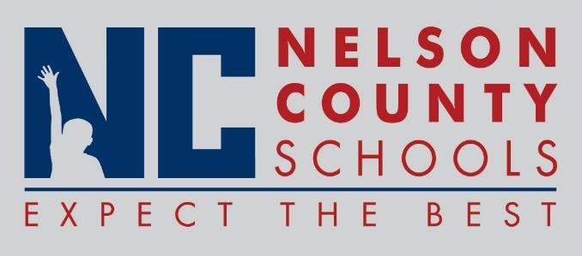

Decision Paper
To: | Nelson County Board of Education
From: | Tim Hockensmith, Chief Operating Officer
cc: | Tom Brown, Superintendent
Date: | August 15, 2017
Re: | School Resource Officer (SRO) Program

RECOMMENDATION: Approve the Establishment of a SRO Program in Nelson County Schools

RECOMMENDED MOTION: I move that the Nelson County Board of Education Approve the Establishment of a School Resource Officer (SRO) Program.

SRO Program

