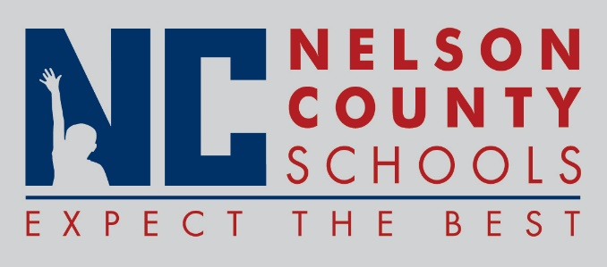

Decision Paper
To: | Nelson County Board of Education
From: | Dr. Anthony Orr, Superintendent
Date: | July 18, 2017
Re: | Contract agreement with Bardstown City Schools to provide Hearing Impaired Services to student in Bardstown district.

RECOMMENDATON: Approve agreement between Nelson County Schools and Bardstown City Schools for NC Hearing Impaired teacher to provide services to Bardstown HI students for a fee during the 17-18 school year.
RECOMMENDED MOTION: I move that the Nelson County Board of Education approve the Contract agreement as presented.

