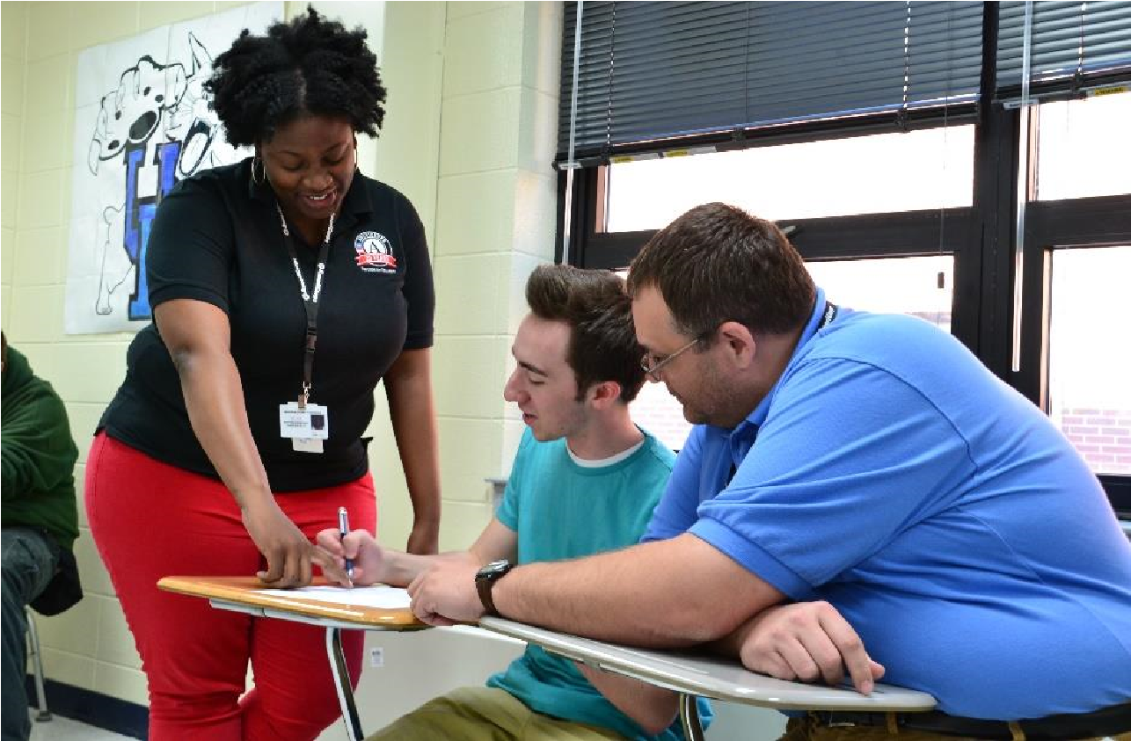 PartnerCorps STEM

PartnerCorps: STEM is an AmeriCorps program that increases student competency in the science, technology, engineering and mathematics, or “STEM” fields. PartnerCorps will place 10 full-time members to serve within Algebra I, II, and Geometry courses at Breathitt County High School to provide in-class tutoring and assistance.
Each full-time member selected to serve will receive the following:
- A living allowance in the monthly amount of $1248.36 over a 4-5 month service period while serving in a full time capacity;

- Health insurance, if needed, for the member only;

- Members may qualify for child care assistance (dependent upon the state guidelines for subsidized child care);

- Members may also qualify for postponement, or forbearance, of the repayment of federal student loans during service; and

- At the conclusion of the 1200 hour commitment, if service has been completed satisfactorily, each member will receive an educational award. The education award may be used to pay educational costs at eligible post-secondary institutions, as well as to repay qualified student loans. The dollar amount of a full-time award is tied to the maximum amount of the U.S. Department of Education’s Pell Grant, thus it can vary from year to year. Currently, AmeriCorps members may earn up to the value of two full-time education awards and have seven years from the date they earned each award to use it.
TO APPLY CONTACT: Linda Poppas | linda_poppas@berea.edu | 606.666.5711
Project Director, Partnercorps, STEM
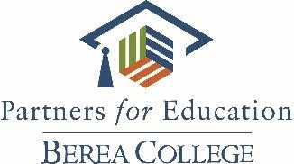
www.berea.edu/pfe

