SPENCER COUNTY PUBLIC SCHOOLS
Board of Education Agenda Item

Item # ____________________________ Meeting Date: December 16, 2021
Topic/Title: Request To Approve Breakfast And Lunch Price Increases
Presenter: Jeff Rogers

Origin
◻ Topic presented for information only (no board action required).
☑ Action requested at this meeting.

◻ Item is on the consent agenda for approval.
◻ Action requested at future meeting, ___________________ (date).
◻ Board review required by –
◻ State or federal law or regulation
◻ Board of Education policy
◻ Other ___________________________________________

Previous Review, Discussion or Action
☑ No previous Board review, discussion or action
◻ Previous review or action
Date:
Action:

Background/Summary of Information

Lunch Prices for Adults:
In order to bring the current lunch price shortfalls, up to date, the Paid Lunch Equity (PLE) Tool is requiring that we make the average weighted lunch price at the required SY 2021-22 rate of $4.58 ($.53 increase) per lunch and $2.73 ($.08 increase) for breakfast. SFA’s have until December 16, 2021, to adjust their adult price to meet the statewide minimum adult meal price and submit documentation to verify the requirement is met.

Impact on Resources (REQUIRES FINANCE OFFICER’S INITIALS OF REVIEW)

_______ Finance Officer

SUPERINTENDENT’S RECOMMENDATION
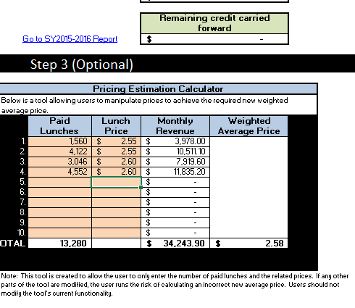
Recommend as presented

