Curriculum, Instruction, and Assessment
Board Agenda
Wednesday, November 28, 2018
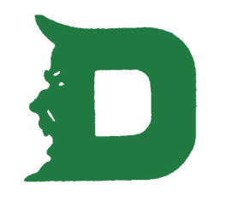
PROFESSIONAL DEVELOPMENT
- For our first Professional Learning day in November, each building focused on analyzing data and creating the School Improvement Plan.

ASSESSMENT
- At LES, the MAP assessment will be given for the second time in December, the AIMSweb benchmarking will take place again, and the CASE assessment will be taken again.
- At DHS, students in grades 9 – 12 will be taking the CERT assessment for a second time, and 7 – 8 grade students will be taking the CASE assessment.

CURRICULUM/INSTRUCTION
- We continue to meet in content area groups in grades 4 – 12 during our district wide early release Wednesday meetings. Teachers are analyzing data and assessments during these meetings. Last week ELA and SS teachers scored writing pieces together and determined strengths and areas of growth for our 8th grade students.
- Flashback meetings and PLC meetings are taking place weekly at LES and DHS.

NEW TEACHERS
- Our fourth new teacher meeting took place on Tuesday, November 13. The focus of this meeting was on instructional strategies and student engagement.
- All brand new teachers are also attending the first ever Regional New Teacher Meetings. These meetings take place at NKCES. These meetings are attended by first year teachers from all the 19 school districts in Northern Kentucky.

