Regular Meeting Boone County Board of Education
October 10, 2019 7:30 PM
Ralph Rush Professional Development Center
99 Center Street
Florence, Kentucky 41042

I. CALL TO ORDER

The Regular meeting of the Boone County Schools Board of Education October 10, 2019 was called to order by Chairperson Karen Byrd at the Ralph Rush Staff Development Center.
Attendance Taken at 7:30 PM:

Present Board Members:
Dr. Maria Brown
Ms. Karen Byrd
Mr. Troy Fryman
Mr. Matt McIntire
Mrs. Julia Pile

Claire Parsons attended as Board Attorney
Karen Evans, Board Secretary, recorded the minutes.
Eric McArtor, Deputy Superintendent COO, sat in for Dr. Poe.

II. NATIONAL ANTHEM
The National Anthem was led by students of Boone County High School.

III. PLEDGE TO THE FLAG
The Pledge to the Flag was led by students from Thornwilde Elementary.

IV. STUDENT BOARD MEMBER REPRESENTATIVE REPORT
Jessica Engler gave the Student Board Member Representative report. Ms. Engler reported on the Council meeting and the efforts to get students involved in the Drug Free Club program and reported the audits have been done in all high schools.

V. GOOD NEWS
V.A. The board recognized and congratulated the October 2019 Break the Mold recipient, Ms. Shannon Smith, Instructional Coach at Erpenbeck Elementary,
V.B. The board recognized Mr. Doug Logan, History teacher at Cooper High school for being awarded the 2019 Kentucky History Teacher of the Year.
V.C. The board ecognized Ms. Amanda Stalnaker, teacher at Ockerman Middle School, for being awarded the 2099-2020 Ky Middle School Physical Education Teacher of the Year.
V.D. The board recognized the 2019 Valvoline Teacher Achievement Award recipients: Teacher of the Year Semifinalist: Meredith Larison, LBES and Jessica Holman, BCHS. Teacher Award Recipients: Katy Piercefield, EES, Melinda Earsing, BMS, Brittany Embry, RAJ, Taylor Sullivan, RHS.
V.E. 2019 Golf Outing Fund Raiser Check Presentation by the Boone County Business Association will be postponed until November 2019 board meeting.
V.F. The board recognized and congratulated the PBIS Fidelity Boone County Schools.

PBIS Fidelity
Gold Level:
Conner High
Cooper High
Camp Ernest Middle
Ockerman Middle
Florence Elementary
Kelly Elementary
Longbranch Elementary
Ockerman Elementary
Thornwilde Elementary

Silver Level
Boone County High
Conner Middle
Burlington Elementary
Erpenbeck Elementary
Mann Elementary
North Pointe Elementary
Yealey Elementary
Bronze Level
Gray Middle
Jones Middle
Collins Elementary
New Haven Elementary
V.G. The board recognized the October 2019 Sportsmanship Award Recipients.
Congratulations to the following Sportsmanship Award Recipients:
BCHS: John Wharton
CHS: Ryan Lamblez
RCHS: Carson Woolums
RHS: Caitlyn Richardson

- State Representative Ed Massey attended the meeting and updated the board on the Committee for Tech Ed Task Force. Representative Massey spoke on the upcoming session which will start on January 7th and end on April 15 and this is a budget year for Kentucky. Representative Massey invited anyone with any questions on the session or what will be happening to call his office and he would be available to converse.

VI. RECOMMENDED ACTION - CONSENT AGENDA

Mr. Eric McArtor, Deputy Superintendent COO, recommended the following Consent Agenda items A- EEE for Board approval, as presented.

- A motion was made by Maria Brown, seconded by Matt McIntire, recommended the Consent Agenda items A-EEE for Board approval, as presented. Karen Byrd, Maria Brown, Matt McIntire, Julia Pile, and Troy Fryman voted, “aye.” MOTION: The motion passed 5-0.

VI.A. Minutes of the regular board meeting of Sept. 12, 2019.
The board approved the minutes of the regular board meeting of Sept. 12, 2019, as presented.
VI.B. Special Board Workshop Meeting on Sept. 19, 2019 Strategic Plan Reflection and #Boone2020
The board approved the Special Board Workshop Meeting on Sept. 19, 2019 Strategic Plan Reflection and #Boone2020, as presented.
VI.C. Bill List
VI.C.1. Leaves of Absence
The following persons submitted unpaid leave of absence requests and are approved by the board:
Recommended by Principal/Supervisor for approval:
Farrell, Sena, Bus Driver @ Transportation 9/12/2019 – 10/24/2019
Gelement, Bethanie, Teacher @ Florence ES 10/25/2019 – 1/5/2020
Giron, Sagat, Bus Driver @ Transportation 9/23/2019- 11/18/2019
Heap, Sarah, Bus Driver @ Transportation 9/25/2019 – 10/21/2019
Lehn, Ashley, Teacher @ Boone County HS 9/12/2019 - EOY
Madison, Rodgers, Bus Driver @ Transportation 9/25/2019 – 12/9/2019
Moore, Erin, Teacher @ Collins ES10/1/2019 – 10/18/2019
Patton, Devinn, Teacher @ Ockerman ES 10/3/2019 – 11/19/2019
Tribbe, Carrie, Family Resource @ Ryle HS 10/8/2019 – 12/20/2019
Woodward, Marsha, Café Manager @ Conner MS 8/26/2019 – 9/30/2019
Wright, Cynthia, Teacher @ Long Branch ES 09/19/2019 – 10/10/2019
Not Recommended by Principal/Supervisor for approval:
None
Amended Leaves:
Black, Timothy, Custodian @ Thornwilde ES 6/21/2019 -10/3/2019
Miskiewics, Janice, Bus Driver @ Transportation 9/4/2019 – 12/1/2019
Offill, Melissa, MS Secretary @ Ockerman MS 8/15/2019 – 9/10/2019
Skidmore, Jillian, Teacher @ Ballyshannon MS 9/13/2019 – 11/11/2019
Yarman, Megan, Teacher @ Collins ES 8/12/2019 – 9/13/2019
Ziegler, Mekenzie, Teacher @ Camp Ernst MS 8/14/2019 – 11/11/2019
Cancelled Leaves:
Haley, Tina, Café Manager @ R.A. Jones 8/6/2019-8/22/2019
Hall, Cynthia, Bus Driver @ Transportation 9/19/2019 – 10/10/2019

VI.D. Treasurer's Report was given by Mrs. Linda Schild.
VI.E. Contract- Stand Energy Corporation, Natural Gas Purchase Agreement
The board approved the Contract- Stand Energy Corporation, Natural Gas Purchase Agreement, as presented.
VI.F. Facility Use Agreement- Yealey Elementary with BCPWAA Rebel Starter Cheerleading
The board approved the Facility Use Agreement- Yealey Elementary with BCPWAA Rebel Starter Cheerleading to use the cafeteria for practice, as presented.
VI.G. Sales Campaign Approvals
The board approved the Sales Campaigns, as presented.
VI.H. Bus Request from St. Henry District High School to Pioneer Park
The board approved the Bus Request for St. Henry District High School to Pioneer Park on October 8, 2019, as presented.
VI.I. Field Trips
The board approved the Field trips, as presented.

School | Date Of Trip | Location | Reason
Ryle High School | 8/21-22/20 | Gatlinburg, TN | Girls Soccer Tournament
Conner High School | 4/2-7/20 | Disney World | Music Career Training
Boone County High School | 11/11-12/19 | Morehead State University | Honor Choir
Burlington Elementary | 4/29/20 | COSI | 4th Grade

All travel by commercial carrier is due to schedule/cost

VI.J. Bus Request- Union Pointe Academy to the Aronoff
The board approved the bus request from Union Pointe Academy to the Aronoff, as presented.
VI.K. Contract for Conner High School Prom at Receptions
The board approved the Conner High School Prom at Receptions on 4/28/20, as presented.
VI.L. Facility Use Agreement for Yealey Elementary and Boone County Historic Courthouse
The board approved the Facility Use Agreement for Yealey Elementary and Boone County Historic Courthouse on January 20, 2020, as presented.
VI.M. Yealey Elementary and Lifetouch for 2019-2020 Yearbook Contract
The board approved the contract with Yealey Elementary and Lifetouch for 2019-2020 Yearbook, as presented.
VI.N. Facility Use Agreement-Yealey Elementary with BCPWAA Rebel Starter Football Team
The board approved the Facility Use Agreement-Yealey Elementary with BCPWAA Rebel Starter Football Team to use the cafeteria for banquet on November 14, 2019, as presented.
VI.O. Facility Use Agreement- Cooper High School and YMCA
The board approved the facility Use Agreement- Cooper High School and the YMCA Indoor Pool for the Swim Team, October 1, 2019 to Feb. 6, 2020, as presented.
VI.P. Contract- Boone County High Girls Soccer Banquet and Receptions Event Center
The board approved the contract for the Boone County High School Girls Soccer Banquet and Receptions Event Center, as presented.
VI.Q. Contract for Cooper High School and Party Pleasers DJ for Prom
The board approved the contract for Cooper High School and Party Pleasers DJ for Prom on 4/18/20, as presented.
VI.R. Longbranch Elementary and Lifetouch Contract for Yearbook 19-20
The board approved the Longbranch Elementary and Lifetouch Contract for Yearbook 19-20, as presented.
VI.S. Contract Lakefront Lines and Burlington Elementary to COSI
The board approved the Contract with Lakefront Lines and Burlington Elementary to COSI on April 29, 2020, as presented.
VI.T. Contract with Burlington Elementary and The Children's Theatre
The board approved the Contract with Burlington Elementary and The Children's Theatre, as presented.
VI.U. Contract - Ockerman Elementary and The Children's Theatre
The board approved the Contract with Ockerman Elementary and The Children's Theatre, as presented.
VI.V. Cooper High School Contract with Old Kentucky Chocolates Fund Raiser
The board approved the Cooper High School Contract with Old Kentucky Chocolates Fund Raiser, as presented.
VI.W. Ryle High School Girls Soccer Banquet and Receptions Event Center Contract
The board approved the Ryle High School Girls Soccer Banquet and Receptions Event Center Contract for November 6, 2019, as presented.
VI.X. Erpenbeck Elementary School Copier Lease and Maintenance Agreement
The board approved the Erpenbeck Elementary School Copier Lease and Maintenance Agreement with Toshiba Business Solutions, as presented.
VI.Y. Memorandum of Agreement with the Social Express and Florence Elementary School
The board approved the Memorandum of Agreement with the Social Express for 31 licensed users to Cool School Curriculum, Social Express Curriculum Career Path virtual learning, for Florence Elementary School, as presented.
VI.Z. Memorandum of Agreement Between Gray Middle School and Study.com Membership
The board approved the Memorandum of Agreement Between Gray Middle School and Study.com Membership, as presented.
VI.AA. Memorandum of Agreement Between Gray Middle School and Newsela
The board approved the Memorandum of Agreement Between Gray Middle School and Newsela ,as presented.
VI.BB. Memorandum of Agreement between Jones Middle School and Nearpod
The board approved the Memorandum of Agreement between Jones Middle School and Nearpod, as presented.
VI.CC. Memorandum of Agreement between Florence Elementary School and Imagine Learning
The board approved the Memorandum of Agreement between Florence Elementary School and Imagine Learning, as presented.
VI.DD. Memorandum of Agreement between Collins Elementary School and Imagine Learning
The board approved the Memorandum of Agreement between Collins Elementary School and Imagine Learning, as presented.
VI.EE. Memorandum of Agreement with Homebuilders/Building Industry Association Instructors
The board approved the Memorandum of Agreement with Homebuilders/Building Industry Association Instructors, as presented.
VI.FF. Memorandum of Agreement between Boone County Schools and Art Opportunities, Inc for Blink 2019
The board approved the Memorandum of Agreement between Boone County Schools Art Students and Art Opportunities, Inc for participation in the Blink 2019 parade, as presented.
VI.GG. Memorandum of Agreement between Ockerman Middle School and Achieve3000
The board approved the Memorandum of Agreement between Ockerman Middle School and Achieve3000 to purchase the Pro Differentiated Literacy Solution Site, as presented.
VI.HH. Superior Dental Care, Inc. Dental Insurance Supplier
The board approved the Superior Dental Care, Inc. supplier for dental insurance, as presented.
VI.II. Renewal of Trane HVAC Maintenance Agreement for Conner Middle School
The board approved the Renewal of Trane HVAC Maintenance Agreement for Conner Middle School, as presented.
VI.JJ. Bob Rogers Travel for Cooper High School Choir to Disney World Florida
The board approved the Bob Rogers Travel for Cooper High School Choir to Disney World Florida, as presented.
VI.KK. Memorandum Related to Kentucky 21st CCLC Community Learning Centers Contractual Agreement the Carnegie
The board approved the Memorandum Related to Kentucky 21st CCLC Community Learning Centers Contractual Agreement the Carnegie, as presented.
VI.LL. Modification of Job Description -HR Benefits Specialist
The board approved the Modification of Job Description -HR Benefits Specialist, as presented.
VI.MM. BG-1 Application for Erpenbeck Elementary Upgrades, BG#20-122
The board approved the BG-1 Application for Erpenbeck Elementary Upgrades, BG#20-122, as presented.
VI.NN. BG-1 Application for Boone County High School, Electric Upgrades, BG#20-116
The board approved the BG-1 Application for Boone County High School, Electric Upgrades, BG#20-116, as presented.
VI.OO. BG-1 Application for Plumbing Upgrades for Kelly Elementary, BG#20-106
The board approved thee BG-1 Application for Plumbing Upgrades for Kelly Elementary, BG#20-106, as presented.
VI.PP. BG-1 Application for Ockerman Elementary HVAC Upgrades, BG #20-121
The board approved the BG-1 Application for Ockerman Elementary HVAC Upgrades, BG #20-121, as presented.
VI.QQ. BG-1 Application for Gym Upgrades-Conner and Ryle High Schools, BG#20-105
The board approved the BG-1 Application for Gym Upgrades-Conner and Ryle High Schools, BG#20-105, as presented.
VI.RR. BG-1 Application for Geothermal Upgrades, BG#20-119
The board approved the BG-1 Application for Geothermal Upgrades, BG#20-119, as presented.
VI.SS. BG-1 Application for Boone County High School Tuckpointing, BG #20-115
The board approved the BG-1 Application for Boone County High School Tuckpointing, BG# 20-115, as presented.
VI.TT. BG-1 Application for Paving 2020 BG #20-117
The board approved the BG-1 Application for Paving 2020, BG #20-117, as presented.
VI.UU. BG-1 Application for Central Office-Fiber Relocation, BG #20-118
The board approved the BG-1 Application for Central Office-Fiber Relocation, BG #20-118, as presented.
VI.VV. BG-1 Application for Access Controls- Phase 2, BG #20-109
The board approved the BG-1 Application for Access Controls- Phase 2, BG #20-109, as presented.
VI.WW. Bidding Documents and BG-3 for Roofing 2020, BG #19-318
The board approved the Bidding Documents and BG-3 for Roofing 2020, BG #19-318, as presented.
VI.XX. Bidding Documents and BG-3 for Steeplechase Bid Package #2, BG #19-078
The board approved the Bidding Documents and BG-3 for Steeplechase Bid Package #2, BG #19-078, as presented.
VI.YY. BG-2 and BG-3 and Schematic Design/Design Development Drawings for Conner High School HVAC Improvements, BG# 19-319
The board approved the BG-2 and BG-3 and Schematic Design/Design Development Drawings for Conner High School HVAC Improvements, BG# 19-319, as presented.
VI.ZZ. Contract-School Datebooks with Gray Middle for Agendas
The board approved the Contract-School Datebooks with Gray Middle for Agendas, as presented.
VI.AAA. Lakefront Lines- Burlington Elementary to Perryville Battlefield 4/21/20
The board approved the Lakefront Lines- Burlington Elementary to Perryville Battlefield on 4/21/20, as presented.
VI.BBB. Lakefront Lines-Burlington Elementary to Perryville Battlefield 4/22/20
The board approved the Lakefront Lines-Burlington Elementary to Perryville Battlefield on 4/22/20, as presented.
VI.CCC. Lakefront Lines-Burlington Elementary to Perryville Battlefield 4/23/20
The board approved the Lakefront Lines-Burlington Elementary to Perryville Battlefield on 4/23/20, as presented.
VI.DDD. Bid Award and Revised BG-1 for Steeplechase Elementary Bid Package #1 Grading BG#19-078
The board approved the Bid Award and Revised BG-1 for Steeplechase Elementary Bid Package #1 Grading BG#19-078, as presented.

VII. RECOMMENDED ACTION - OLD BUSINESS
No Old Business

VIII. RECOMMENDED ACTION - NEW BUSINESS
VIII.A. Request for Emergency Day for Conner Middle School August 23, 2019
Mr. Eric McArtor, Deputy Superintendent COO, recommended the board approve the Request for Emergency Day for Conner Middle School August 23, 2019, as presented.

- A motion was made by Maria Brown, seconded by Matt McIntire, to approve the Request for Emergency Day for Conner Middle School August 23, 2019, as presented. Karen Byrd, Maria Brown, Matt McIntire, Julia Pile, and Troy Fryman voted, “aye.” MOTION: The motion passed 5-0.

VIII.B. Request for Emergency Day for Conner High School August 23, 2019
Mr. Eric McArtor, Deputy Superintendent COO, recommended the board approve the Request for Emergency Day for Conner High School August 23, 2019 due to no electricity, as presented.

- A motion was made by Julia Pile, seconded by Maria Brown, to approve the Request for Emergency Day for Conner High School August 23, 2019, as presented. Karen Byrd, Maria Brown, Matt McIntire, Julia Pile, and Troy Fryman voted, “aye.” MOTION: The motion passed 5-0.

VIII.C. Request for Emergency Day for Goodridge Elementary August 23, 2019
Mr. Eric McArtor, Deputy Superintendent COO, recommended the board approve the Request for Emergency Day for Goodridge Elementary, August 23, 2019 due to no electricity, as presented.

- A motion was made by Maria Brown, seconded by Julia Pile, to approve the Request for Emergency Day for Goodridge Elementary School, August 23, 2019, as presented. Karen Byrd, Maria Brown, Matt McIntire, Julia Pile, and Troy Fryman voted, “aye.” MOTION: The motion passed 5-0.

VIII.D. Bus Purchase
Mr. Eric McArtor, Deputy Superintendent COO, recommended the board approve the bus purchase for aging vehicles and anticipated growth for 7 Passenger Buses at the cost of $766,780.00, as presented.

- A motion was made by Maria Brown, seconded by Matt McIntire, to approve the request for the bus purchase for aging vehicles and anticipated growth for 7 Passenger Busses at the cost of $766,780.00 as presented. Karen Byrd, Maria Brown, Matt McIntire, Julia Pile, and Troy Fryman voted, “aye.” MOTION: The motion passed 5-0.

- Karen Byrd publicly acknowledged and thanked Mr. Bob Barrix, Transportation Director, for his leadership and organization that he has brought to the transportation department. Ms. Byrd, stated it is a huge effort everyday to keep our buses running and our children safe, and she also thanked the bus drivers for the team effort.

VIII.E. Bus Duty Pay for Classified Hourly Personnel
Mr. Eric McArtor, Deputy Superintendent COO, recommended the board approve the Bus Duty Pay for Classified Hourly Personnel, as presented.

- A motion was made by Matt McIntire, seconded by Maria Brown, to approve the request for Bus Duty Pay for Classified Hourly Personnel, as presented. Karen Byrd, Maria Brown, Matt McIntire, Julia Pile, and Troy Fryman voted, “aye.” MOTION: The motion passed 5-0.

IX. SUPERINTENDENT'S REPORT
Mrs. Krista Decker, LSS Director of Assessment, presented via prerecorded video, the update of the Districts 2019 Spring Data (ACT, AP and KPREP). Dr. Detwiler and Jenny Watson answered questions.

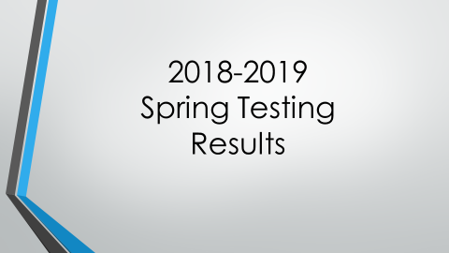

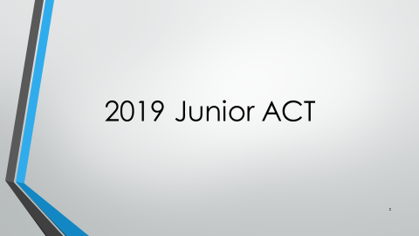

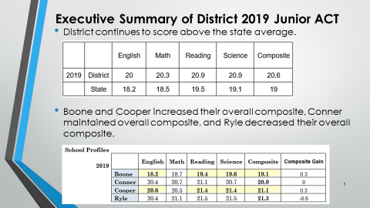

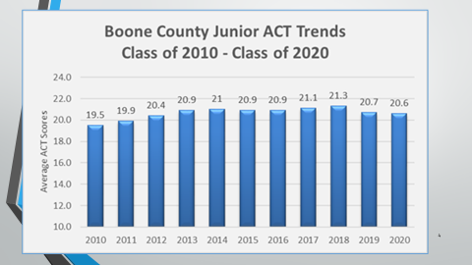

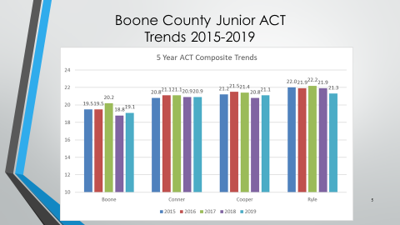

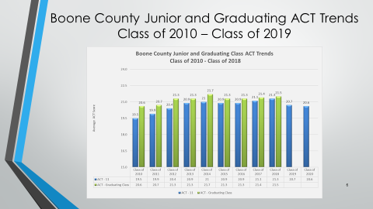

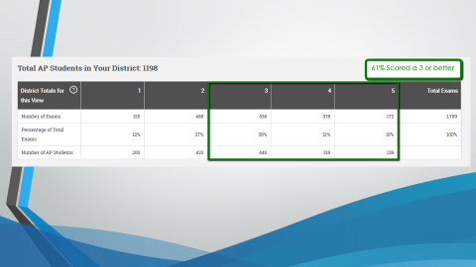
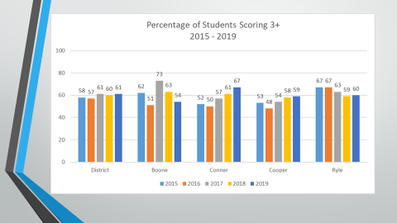

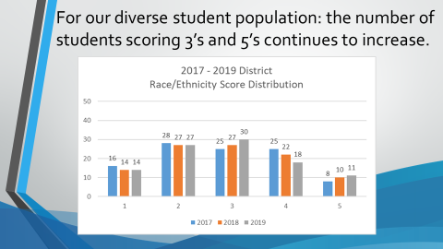

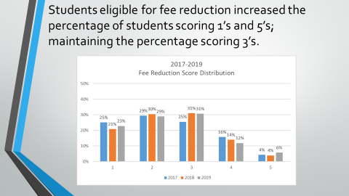

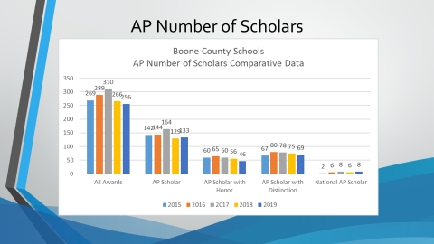

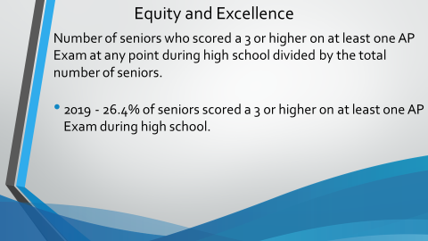
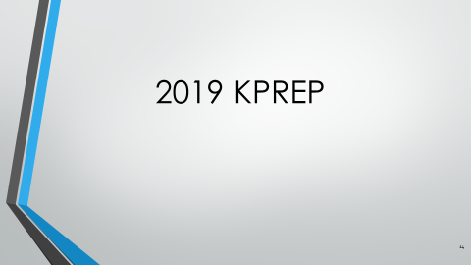
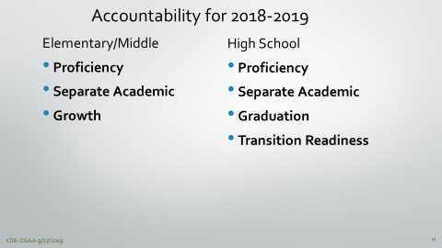

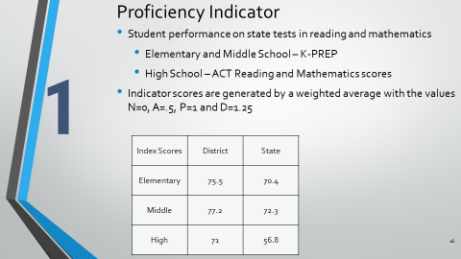

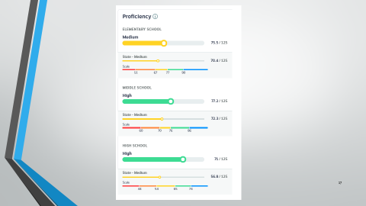

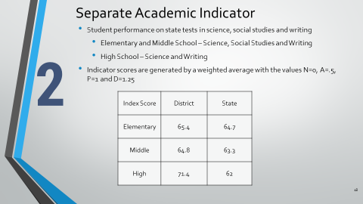

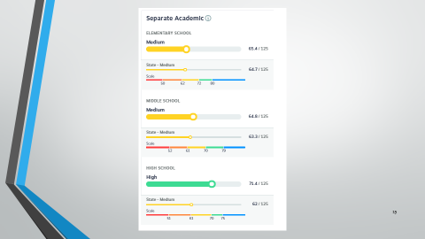

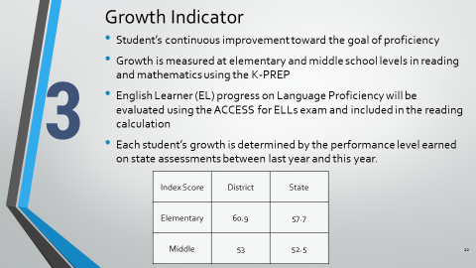

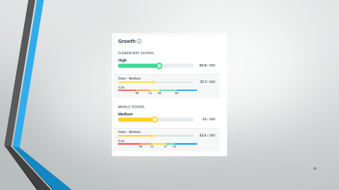

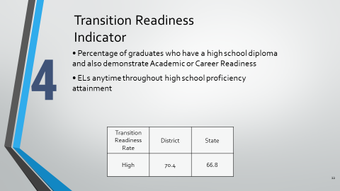

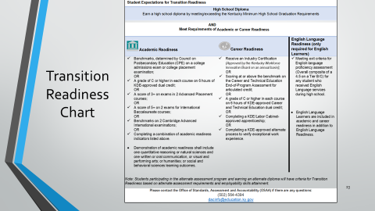

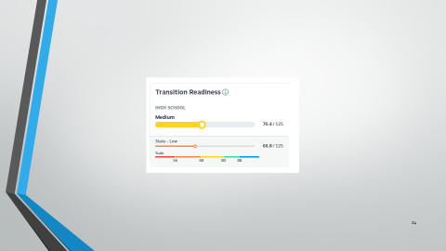

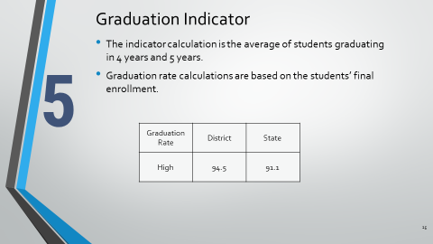

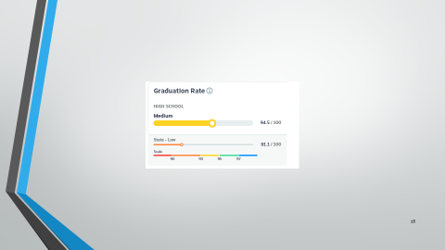

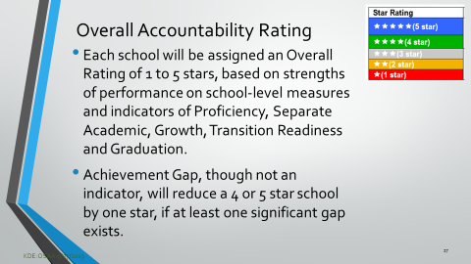

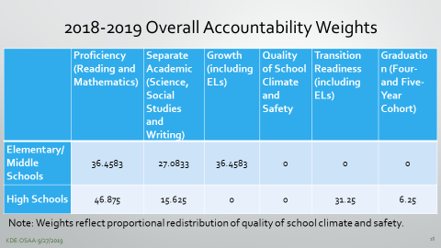

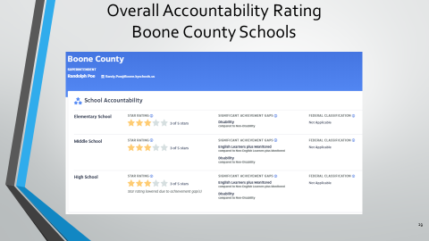

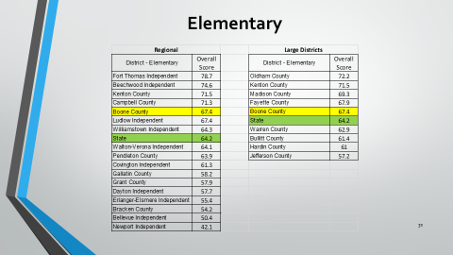

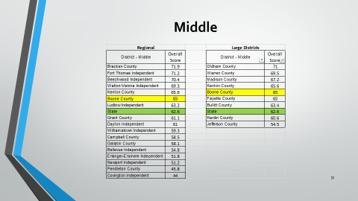

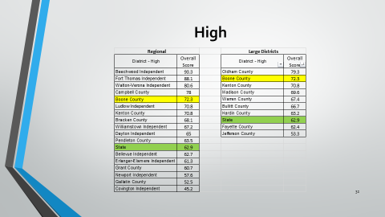

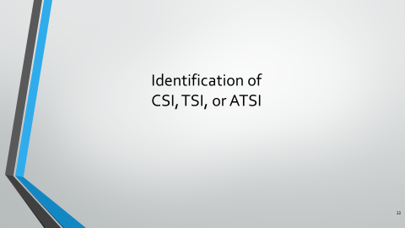

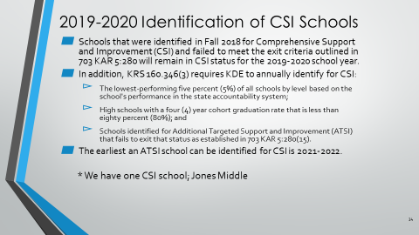

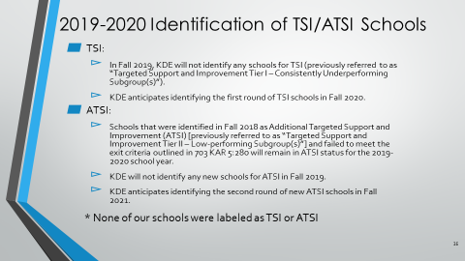

- Karen Evans, Executive Coordinator to the Superintendent, reported on the October 3 professional development training. The Communication Training management training was led by Susan Arlin, Emotional Intelligence Trainer. Two sessions of two hours each was held at the Ralph Rush Center and was attended by 112 front office staff support. The training surveys stated that Ms. Arlin was engaging, enthusiastic and helped the staff become more aware of the verbal triggers and nonverbal actions in the way we respond to customers. The training was well received and the staff felt the sessions were needed and informative.

X. INFORMATION, PROPOSALS, COMMUNICATIONS
X.A. Human Resource Actions
X.B. Worker's Compensation Claims
X.C. Overtime Report
X.D. Construction Status Report
X.E. Energy Management Report

-Eric McArtor announced the Nov. 4th Special Board Workshop at LSS starting at 6:30 pm on Governance with Dr. Mike Wilson.
XI. AUDIENCE OF CITIZENS
The following education majors attended the board meeting: NKU- Will Lytle, Shelby Leach, Jessica Harris, Gabi Richardson, Josie Hyden, Melissa Bowman, Grace Frecke, Grace Hall, Veronica Llg, Anna Dressman. Conner High – Sierra Moore, Chloe Keen, Mindy Nguyen, Hope McCullah, Samantha Roach, Jenna Foltz. Gateway – Brittainy Brandenburg. Asbury College – Kendra Hughes. Univ. Cumberlands – Shelby Willard.

XII. CLOSED EXECUTIVE SESSION PER KRS 61.810
XII.A. No closed session

XIII. ADJOURN

- A motion was made by Maria Brown, seconded by Julia Pile, to adjourn the meeting. Karen Byrd, Maria Brown, Julia Pile, Matt McIntire, and Troy Fryman voted, “aye” MOTION: The motion passed 5-0.

Meeting was adjourned at approximately 8:52pm.

_____________________________________
Karen Byrd /Chairperson

_________________________________
Karen Evans/Secretary

