John Hardin SBDM Council
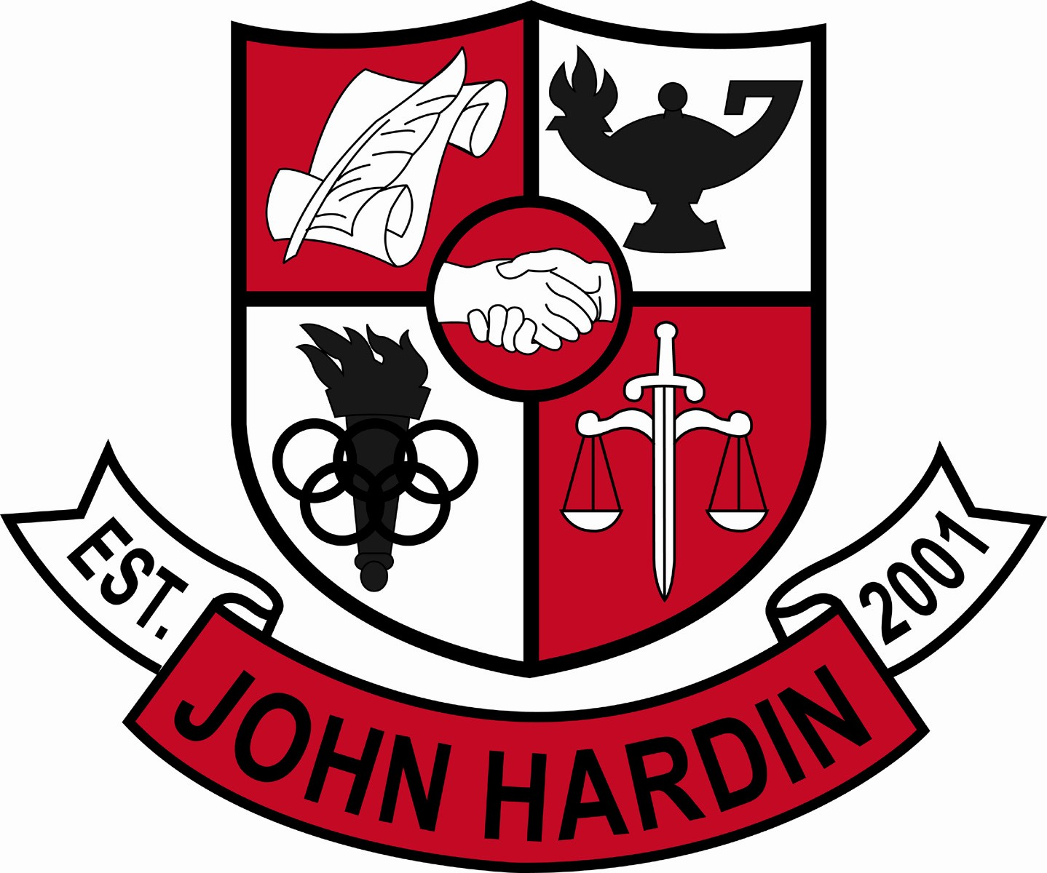
Meeting Minutes

February 11, 2016
4:00 p.m.

- Call to Order at 4:02 pm
Members present: Mark Wells, Alex Shearer, Aurora Selbe, Kelly Smith, Stacey Moore, and Jan O’Daniel
Visitors: Brahim Benmoussa and Peggy Snow
- Approval of Agenda ORDER #15-16/0052
The council approved the agenda as written.
Motion: O’Daniel Second: Moore
Selbe – Yes
O’Daniel – Yes
Shearer– Yes
Wells – Yes
Smith – Yes
Moore - Yes
- Approval of Minutes ORDER #15-16/0053
The council approved the minutes as written.
Motion: Moore Second: O’Daniel
O’Daniel – Yes
Selbe– Yes
Smith – Yes
Wells – Yes
Moore – Yes
Shearer – Yes
- Good News Report
  - Academic Team – The team won the Scholastic Bowl Championship in overtime against Larue Co.
  - DECA – Eleven students placed in the Regional Career Development Conference in Bowling Green. 1-1st, 7-3rd, 1-4th, 2-5th
- Public Comment
  - No comments from visitors.
- Principal’s Update
  - Trimester Two Extension and Finals – The trimester is extended until February 26, Biology EOC is Feb. 19, and the US History EOC is Feb 23. Finals will be given on February 25 and 26.
  - 2016-2017 Staffing Allocation Update – There will not be a reduction in certified staff for the 2016 - 2017 school year.
- JHHS YSC FY17-18 Continuation Program Review
Ms. Snow presented and explained the Continuation Program Review.
- Financial Report ORDER#15-16/0054
The Financial Report for January was reviewed and accepted
Motion: Shearer Second: Selbe
O’Daniel – Yes
Shearer – Yes
Wells – Yes
Moore – Yes
Selbe – Yes
Smith – Yes
- Dual Credit Grading/Attendance Points Policy 2nd Reading ORDER #15-16/0055
The policy was approved as written. College grades are equated to high school grades and no attendance points will be awarded.
Motion:Selbe Second: O’Daniel
Smith – Yes
Wells – Yes
Selbe – Yes
Moore - Yes
Shearer - Yes
- PD Plan ORDER #15-16/0056
Survey was sent to the teachers regarding types of professional development and dates. The council approved the plan as written.
Motion: Moore Second: Selbe
O’Daniel – Yes
Shearer – No
Smith – Yes
Wells – Yes
Selbe – No
Moore – Yes
- Personnel
Hired; Taylor Wood for Asst. Wrestling Coach, Mark Thompson for Freshmen Softball Coach.
Vacancies: Custodian
- New Business
- Parent involvement – Because the school is without a PTA or PTO, a parent representative can not be considered for the Superintendent Search Screening Committee. Parent involvement for the school needs to increase.
- Agenda Items for Next Meeting
- Needs List
- OCR Report
- Adjourn
The meeting was adjourned at 5:30 p.m. The motion was made by Mr. Shearer and seconded by Ms. Selbe

