Tax Hearing Public Forum Meeting Boone County Board of Education
August 29, 2019 7:00 PM
Ralph Rush Professional Development Center
99 Center Street
Florence, Kentucky 41042

I. CALL TO ORDER

The Tax Hearing Public Forum meeting of the Boone County Schools Board of Education August 29, 2019 was called to order by Chairperson Karen Byrd at the Ralph Rush Staff Development Center.
Attendance Taken at 7:00 PM:

Present Board Members:
Dr. Maria Brown
Ms. Karen Byrd
Mr. Troy Fryman
Mr. Matt McIntire
Mrs. Julia Pile

Gerry Dusing attended as Board Attorney
Karen Evans, Board Secretary, recorded the minutes.

II. PLEDGE TO THE FLAG
The Pledge to the Flag was led by Ms. Karen Byrd, Chairperson.

III. INFORMATION ON TAX RATE LEVY (ATTACHMENTS ON EMEETING)
(Brief Summary) (Tax Rate Levey and Property Assessment reports can be found on the District Website under Emeeting)

Mr. Eric McArtor, Deputy Superintendent COO, lead the meeting with the following PowerPoint and discussion from individual departments. Mr. McArtor stated the Budget Committee has agreed in to recommend the 4% rate increase for the needed support for students as follows: Student access to technology, Social emotional support and school safety, resources for English language learners and early learning opportunities in Pre-K.
Linda Schild, Director of Finance, reviewed the current rate of 64.6 and the new tax revenues with the compensating rate or additional revenues of 1%, 2%, 3% and the recommended 4% with reduction estimates on Tax Collection Fees, SEEK funding reductions, net new tax revenues available for district priorities, restricted for capital project funds and available operating funds with each rate (see power point slide below).
Dr. Jim Detwiler, Deputy Superintendent CAO, to ensure educational equity with our students, he addressed the growing need for digital devices, in order to bring our number of student devices to 1-1, we will need 1200 new devices along with a replacement of 1,320 devices for high school. KDE will be administering all state assessment online at the start of May 2020, this is a mandate that all students mush have a digital devises to align our network.
The following PowerPoint was given to each board member and reviewed in length at the meeting for discussion. See full report on the proposal below:

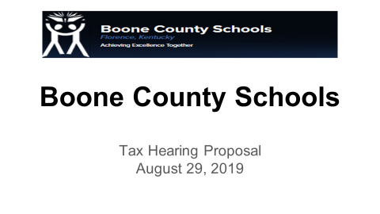

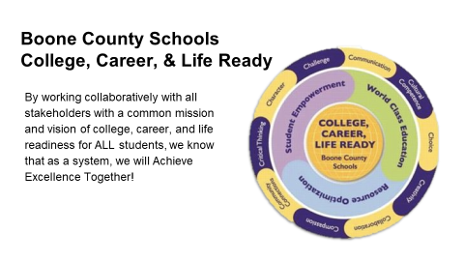

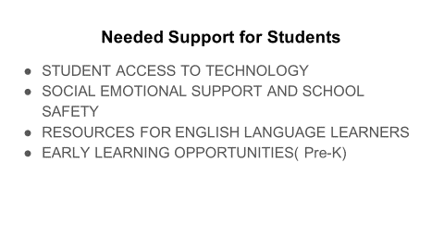

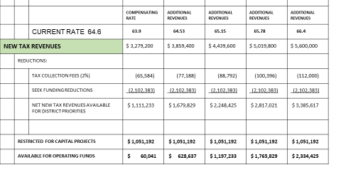

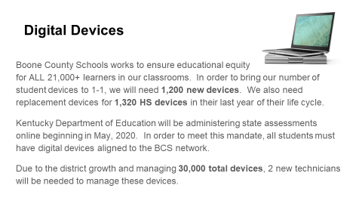

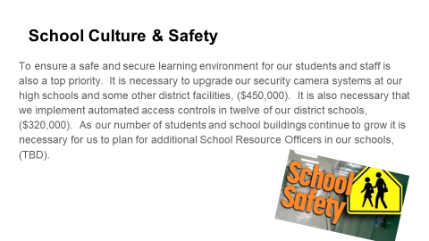

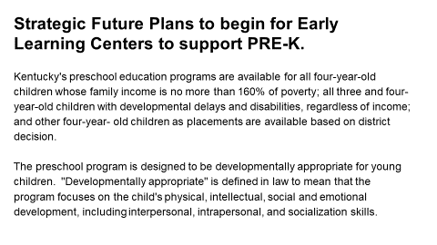

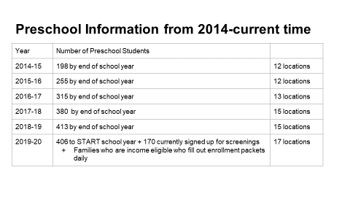

- Dr. Poe discussed the breakdown in rates and to remind this does not take into account each year the district has a step increase of 1 million and the compensating rate of 1% would not be able to meet this increase and this would be an issue come spring. The SEEK reduction, no matter what we do it will correlate with property assessment and we must set aside 1 million every year for Capital Projects.

IV. PUBLIC HEARING
IV.A. To hear comments from the public on the Tax Rate Levy
(Brief Summary)
- Paula McPeake, spoke to the board and asked the increase be invested in the English Language Learners in our schools system. Ms. McPeake discussed the generational poverty in students that already support their families and would like to see educational skills so that they can learn to support their families with an education.
- Bernie Kunkel, spoke to the board and asked the board to not raise the taxes. Mr. Kunkel stated the board needed to look for and cut out wasted expenses, such as the central office and the layers of employees. He discussed various reasons the board should not raise the tax.

V. ADJOURN

- A motion was made by Maria Brown, seconded by Troy Fryman to adjourn the meeting. Troy Fryman, Matt McIntire, Karen Byrd, Maria Brown, and Julia Pile voted, “aye.” MOTION: The motion passed 5-0.

The meeting was adjourned at approximately 7:32 p.m.

_____________________________________
Karen Byrd/Chairperson

_____________________________________
Karen Evans/Secretary

