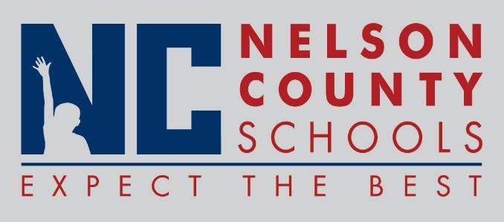

Decision Paper
To: | Nelson County Board of Education
From: | Kimberly Brown, Director of Secondary Education
cc: | Tom Brown, Superintendent
Date: | October 17, 2017
Re: | Administration of High School Civics Test

RECOMMENDATION: Approve the administration of a Civics Test for high school students in grades 9 – 12.

RECOMMENDED MOTION: I move that the Nelson County Board of Education Approve the administration of a Civics Test for high school students in Grades 9 – 12.

