John Hardin SBDM Council
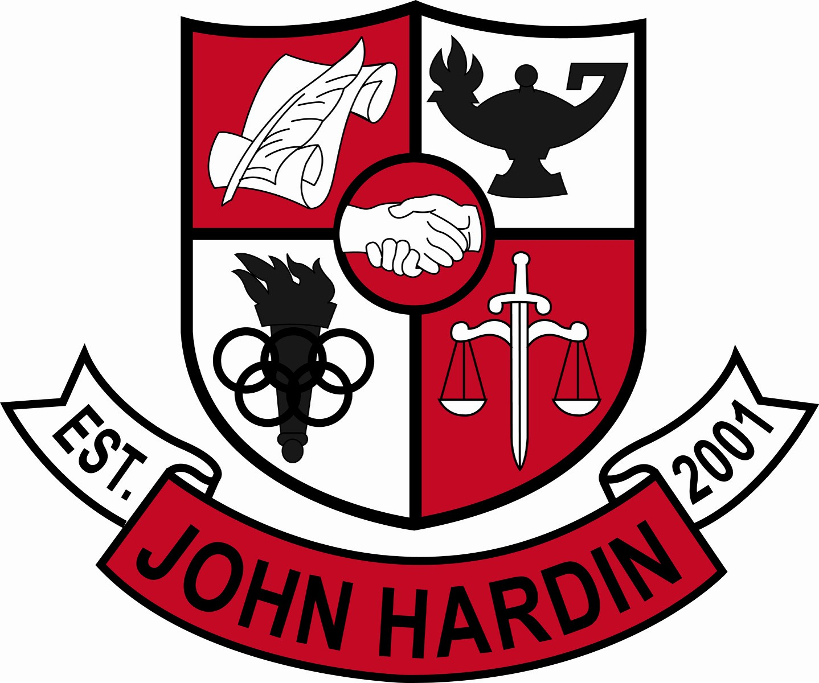
Meeting Minutes

July 11, 2013
1:00 p.m.

- Call to Order at 1:02 p.m.
Members present: Alex Shearer, Jana Haws, Stacey Moore, and Lynne Gibson
Members Absent: Pauline Crittenden Resigned: Abby Lentz
- Approval of Agenda ORDER #13-14/0001
The council approved the agenda as written.
Motion: Moore Second: Shearer
Crittenden – Absent
Gibson – Yes
Haws – Yes
Lentz – Resigned
Moore – Yes
Shearer - Yes
- Approval of Minutes ORDER #13-14/0002
The council approved the minutes as written.
Motion: Moore Second: Shearer
Crittenden – Absent
Gibson – Yes
Haws – Yes
Lentz – Resigned
Moore – Yes
Shearer - Yes
- Principal’s Update
- Council Elections – Ms. Lentz has taken a job at the district level and we will need to organize an election for another teacher rep. Volunteers to run the election will be solicited on Opening Day. If the election doesn’t yield a minority member, a second election will need to be held to add a minority member rep (teacher or parent)
- Enrichment – The committee has started work to line this program out. The goal is to better every students test scores. (ACT, PLAN, Compass, ASVAB, KOSSA, etc.)
- Update of Policies/By-Laws – The council will begin the revision process after the school year has started and we’ve had a chance to settle in; Talk to other high performing high schools and use their policies as a draft; Start adding the policies a few at a time to each council meeting.
- Emergency Plan/SB 8 – The council has to address the plan and approve a final draft. A safety committee is being formed to establish this plan

- Committees/Charges ORDER #13-14/0003
The following committees were approved by the council: Incentive; Culture/PR; PD; Scholarship; Technology; Safety; PBIS; Enrichment; AdHoc-Title IX
Motion: Moore Second: Shearer
Crittenden – Absent
Gibson – Yes
Haws – Yes
Lentz – Resigned
Moore – Yes
Shearer - Yes
- Student Achievements – FFA was recognized at the state convention; our chapter was recognized at one of the top 15! ACT Scores- improvements in ALL areas!!
- Financial Report ORDER #13-14/0004
The council reviewed and accepted the financial reports for May, June and the 2012-13 school year.
Motion: Shearer Second: Moore
Crittenden – Absent
Gibson – Yes
Haws – Yes
Lentz – Resigned
Moore – Yes
Shearer - Yes
- Meeting Dates for 2013-14 ORDER #13-14/0005
The council meetings for the 2013-14 school year will remain at 4:00 p.m. on the second Thursday of each month unless otherwise noted.
Motion: Moore Second: Shearer
Crittenden – Absent
Gibson – Yes
Haws – Yes
Lentz – Resigned
Moore – Yes
Shearer - Yes
- Classroom Locations ORDER #13-14/0006
The council approved the room location revisions as presented.
101-Health Sciences 221-Vacant/English
103-IT 223/224-Vacant/Spec Ed
201-ESL 230-Social Studies
202-Science 312-Vacant
215-Vacant/Math 408-TVP
Motion: Shearer Second: Moore
Crittenden – Absent
Gibson – Yes
Haws – Yes
Lentz – Resigned
Moore – Yes
Shearer – Yes

- Personnel
Interviews are scheduled this week for Spanish and Health/PE this week.
Vacancies: Spanish; Health/PE; Math; Special Ed; Guidance Clerk; Volleyball Coach; Asst. Volleyball Coach; Girls Tennis Coach; Cheer Coach
Hired: Pam Roberts, Abby Wilkinson and Mark Burden for Science positions; Brenda Harting for Art; Nathan Kiser for Social Studies; Jennifer Butler for English; Mark Wells and Fawnda Cox for Assistant Principals
- Questions and Concerns from Council
Ms. Gibson has reviewed and studied the council’s concerns from the interview process and will addressing all items.
- Agenda Items for Next Meeting
- Policies – Introduction of SBDM Policies -1st Reading, Final
- Adjourn
The meeting was adjourned at 2:51 p.m. The motion was made by Ms. Moore and seconded by Ms. Haws

