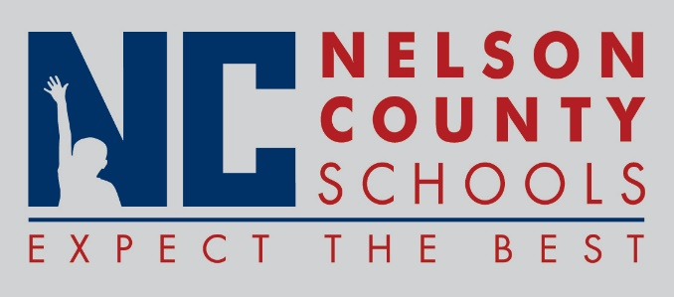

Decision Paper
To: | Nelson County Board of Education
From: | Cheryl Pile, Director of Special Education
cc: | Dr. Anthony Orr, Superintendent
Date: | July 7, 2016
Re: | MOA between Nelson County Schools and Office of Vocational Rehabilitation

RECOMMENDATION: Approve Memorandum of Agreement for Transition Services between the Nelson County Board of Education and The Office of Vocational Rehabilitation.

RECOMMENDED MOTION: I move that the Nelson County Board of Education approve the Memorandum of Agreement for The Office of Vocational Rehabilitation.

