Grandview Elementary
Board Report
November 22, 2021

Great things happening at GES……
- GES Veteran’s Day’s Day program was a success! We had 25 veterans attend our breakfast and assembly. This was our 1st assembly in two years. The students were respectful and represented Grandview well! Thank you to Alex Thompson, Mandy Hyams, Mr. Wheeler and the BHS band.
- Flooring replacement began Monday, Nov.15th. They started on the 2nd floor and will make their way down. Also, the rock wall on the front entrance is also starting to take shape!
- We are in the process of developing our CSIP goals for the 2022-2023 school year.

GES Construction progress
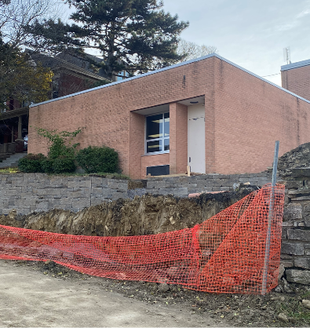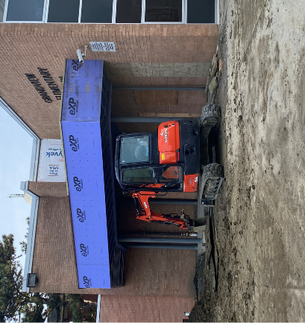

GES Veteran’s Day Assembly
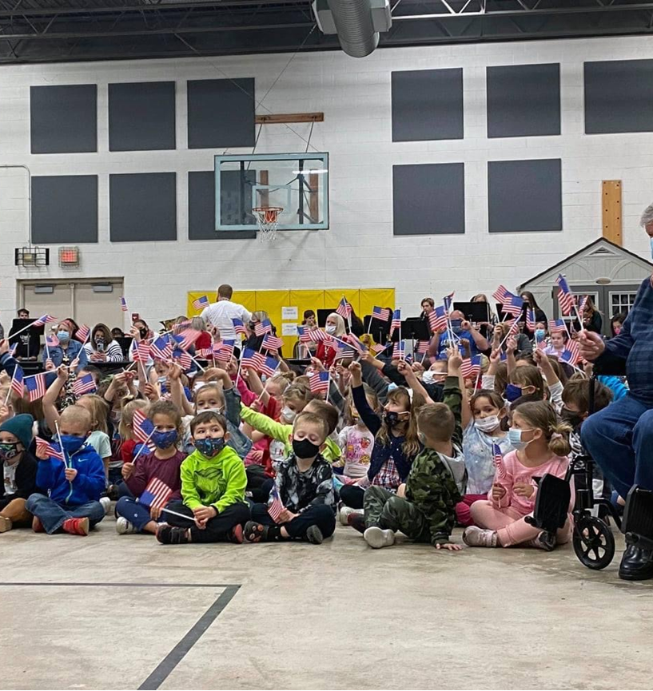

Colton and Mr. Alex
dressed for success!
Upcoming Dates
Nov 15-19th Grandview Can Food Drive
Nov 16th & 18th PLC- Teacher Reflection
Nov 18th Thankful Thursday -Staff Hot Apple Cider Bar
Nov 19th GES Cafeteria Thanksgiving Feast Lunch
Nov 24-26th No School- Thanksgiving Break
Dec. 7th Kinder-3rd field trip to Children’s Theatre
Nov/Dec 4th/5th Archery (Ms. Henry)
Dec 4th Grade STEM (Ms. Henry)

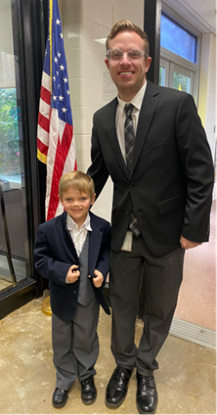
GESLeaders Philosophy
Our goal is to build intentional relationships, inspire passionate learners, provide personalized learning, identify leadership in self, staff and students and challenge our team to exceed expectations.

