John Hardin SBDM Council
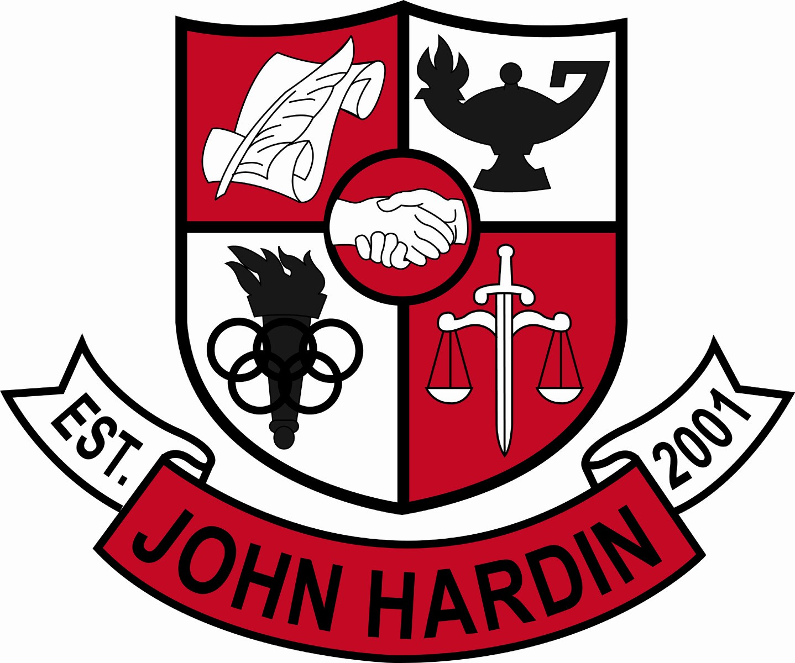
Meeting Minutes

November 10, 2016
4:00 p.m.

- Call to Order at 4:02
Members present: Mark Wells, Alex Shearer, Aurora Selbe, Jan O’Daniel, Kelly Smith,
and Michael Moritz.
- Approval of Agenda ORDER #16-17/0023
The council approved the agenda as written.
Motion: Selbe Second: O’Daniel
Selbe – Yes
O’Daniel – Yes
Shearer– Yes
Wells – Yes
Smith - Yes
Moritz – Yes
- Approval of Minutes ORDER #16-17/0024
The council approved the minutes as written.
Motion: Moritz Second: O’Daniel
O’Daniel – Yes
Selbe– Yes
Wells – Yes
Shearer – Yes
Smith - Yes
Moritz – Yes
- Good News Report –
  - Band of America (BOA) – The John Hardin Band received the honor of being invited to perform this year in Indiana. Students at John Hardin watched the band perform during lunch in the commons and in their classroom.
  - The boys cross country team qualified for state. Jenna Grogan, girls cross country, qualified for state.
- Public Comment – No comments
- Principal’s Update
  - Banners – Banners celebrating distinguished years and students who are college and/or career ready will be displayed.
  - 2nd Trimester – The transition between trimesters went smoothly.
- Financial Report ORDER #16-17/0025
The Financial Report for October was approved as written.
Motion: Shearer Second: Selbe
O’Daniel – Yes
Selbe– Yes
Wells – Yes
Shearer – Yes
Smith - Yes
Moritz – Yes
- PBIS
Mr. Moritz explained the Positive Behavior Intervention System and presented data.
- SBDM Needs List
The council added $3000 for Project Lead the Way.
- Scheduling ORDER #16-17/0026
The council approved the proposed changes to class offerings for the 2017-18 school year with the addition of Forensic Math as a math credit and the deletion of Honors US History.
Motion: Selbe Second: Shearer
Selbe – Yes
Shearer- Yes
O’Daniel – Yes
Moritz – Yes
Smith – Yes
Wells – Yes
- SBDM Needs List ORDER #16-17/0027
The SBDM Needs List was sent and approved as written via email on November 15.
Selbe – Yes
Moritz – Yes
Shearer- Yes
O’Daniel – Yes
Smith – Yes
Wells – Yes
- SBDM Needs List Additions ORDER #16-17/0028
The additions of a new score table for the large gym and sound systems for the large gym, small gym and the football stadium were sent and approved as written via email on December 1.
O’Daniel – Yes
Moritz – Yes
Smith – Yes
Selbe – Yes
Shearer- Yes
Wells – Yes
- Personnel
Hired: No Hires
Vacancies: Freshmen Volleyball Coach; 50% Stipend; Freshmen Baseball Coach; Asst. Wrestling Coach, 35% Stipend; Asst. Bowling Coach, 25% Stipend
- New Business
- Agenda Items for Next Meeting
  - Title IX Audit Review Report
  - Climate and Culture Committee Report
- Adjourn
The meeting was adjourned at 4:55 p.m. The motion was made by Ms. Selbe and seconded by Mr. Moritz

