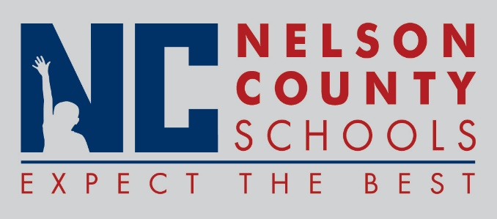

Decision Paper
To: | Nelson County Board of Education
From: | Tom Dekle
cc: | Dr. Anthony Orr, Superintendent
Date: | October 20, 2015
Re: | Horizons Academy Fender Music Foundation grant program

Horizons Academy wishes to apply for a grant award of instruments and equipment provided through the Fender Music Foundation. These items are slightly used, blemished or otherwise imperfect and have been collected from manufacturers and retailers. Descriptions regarding specific imperfections of each instrument will be available to selected programs. Horizons Academy has a fledgling music program through teacher Kirk McElroy, a certified music teacher. This grant application does not have a specific dollar amount attached.
RECOMMENDATION: I recommend the Nelson County Board of Education approve the request for grant application for music instruments through the Fender Music Foundation.

RECOMMENDED MOTION: I move that the Nelson County Board of Education approve the request for grant application for music instruments through the Fender Music Foundation.

