John Hardin SBDM Council
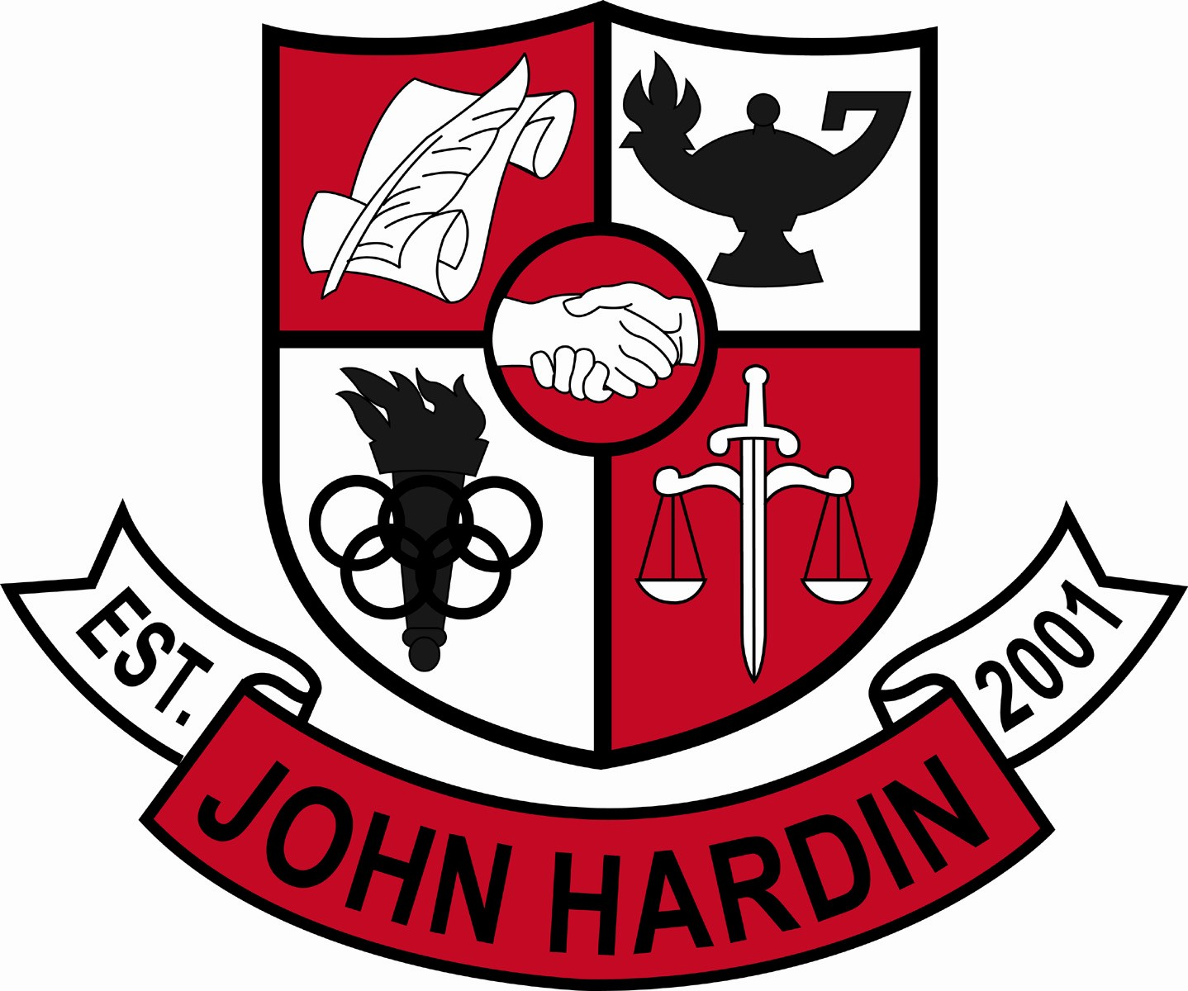
Meeting Minutes

August 16, 2018
4:00pm

- Call to Order at 4:02 pm
Members present: Mark Wells, Alex Shearer, Michael Robinson, Jan O’Daniel, Kelly Smith, Scott Sonsalla, and Carlotta Hunter.
- Approval of Agenda ORDER #18-19/0009
The council approved the agenda as written.
Motion: Sonsalla Second: Shearer
Smith – Yes
O’Daniel – Yes
Shearer– Yes
Robinson – Yes
Sonsalla – Yes
Hunter - Yes
Wells – Yes
- Approval of Minutes ORDER #18-19/0010
The council approved the minutes as written.
Motion: Shearer Second: O’Daniel
O’Daniel – Yes
Hunter – Yes
Robinson - Yes
Smith– Yes
Wells – Yes
Sonsalla - Yes
Shearer – Yes
- Principal’s Update
  - CCR Update – The CCR coach will meet with every senior to establish a plan. She will also meet with the juniors.
  - Back to School – The beginning of the school year has started off really well. Our current enrollment is 849.
- SBDM Member Requirements – Information regarding training dates was provided to the council. The Kentucky Open Records and Open Meeting Act “Your Duty Under the Law” and Managing Government Records A Cooperative Undertaking were given to all council members.
- SBDM Meeting Dates – The council will meet the 2nd Thursday of each month at 4:00 pm with the exception of January. In January, we will meet the 3rd Thursday.
- Financial Report ORDER #18-19/0011
The Financial Report for July was reviewed and accepted.
Motion:Robinson Second: Smith
O’Daniel – Yes
Shearer - Yes
Robinson – Yes
Sonsalla – Yes
Hunter - Yes
Smith– Yes
Wells – Yes
- 2018-2019 Title I Part A Schoolwide Program ORDER#18-19/0012
The program was reviewed and approved. All members signed.
Motion:Sonsalla Second: O’Daniel
O’Daniel – Yes
Hunter – Yes
Robinson - Yes
Smith– Yes
Wells – Yes
Sonsalla - Yes
Shearer – Yes
- 18-19 Committees ORDER#18-19/0013
The council approved the committees as follows: Culture, CSIP, Focus 40, Governor’s Scholar, PBIS, Professional Development, Project Graduation, Safety (Adhoc), and Title IX.
Motion: Smith Second:O’Daniel
O’Daniel – Yes
Robinson – Yes
Hunter – Yes
Sonsalla - Yes
Smith – Yes
Shearer – Yes
Wells – Yes
- Personnel
Hired: Gerrick Luken -Boys Soccer Assistant, 50% Stipend; Andy Giles – Girls Soccer Assistant, 10% Stuipend; Rocco Addesa, Softball Coach; Marcus Young, Custodian – 3rd shift 10 month; Andrew Wade, Custodian – 2nd shift 10 month; Courtney Lyttle, Instructional Assistant; Lori O’Millian, Instructional Assistant; Tasonja Gonsalves, Social Studies Teacher; Kayla Honaker, English Teacher; Christopher Duvall (CW3), JROTC Instructor; Christopher Upton, Low Incidence Teacher

Vacancies: Coach – Golf Assistant; Coach – Assistant Softball; Coach - 9th Grade Softball; Coach – Wresting Assistant; Coach – Girls Freshmen Basketball; Coach – Boys Track
- Agenda Items for Next Meeting
- Adjorn
The meeting was adjourned at 4:42 p.m. The motion was made by Mr. Shearer and seconded by Mr. Robinson.

