THIS IS A DECISION PAPER
TO: HARDIN COUNTY BOARD OF EDUCATION
FROM: TERESA MORGAN, SUPERINTENDENT
DATE: JANUARY 18, 2024
SUBJECT: Approve Contract T and T for Early Learning Academy
FACTS:
After aggressively negotiating and revising the scope of work for the project, we are ready to move forward with a contract with T and T to renovate the old Radcliff Library.
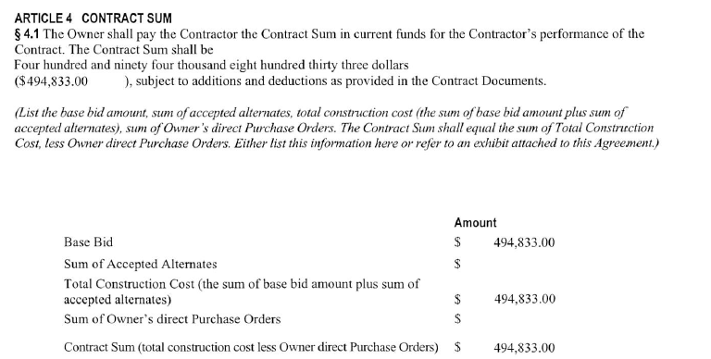

See Attached:

RECOMMENDATION
I RECOMMEND THE HARDING COUNTY BOARD OF EDUCATION APPROVE A CONTRACT WITH T and T FOR THE EARLY LEARNING ACADEMY PROJECT.
RECOMMENDED MOTION
I MOVE THE HARDIN COUNTY BOARD OF EDUCATION APPROVE A CONTRACT WITH T AND T FOR THE EARLY LEARNING ACADEMY PROJECT.

