Regular Meeting Boone County Board of Education
October 08, 2020 7:30 PM

Due to the Governor's directive of no more than 50 to gather for safety during the Covid-19 Pandemic, we were able to accommodate 50 people in the room when the Board Meeting took place. There was an added overflow space, which allowed anyone to view the live feed at Florence Elementary. All that attended were given the opportunity to speak during the audience of citizens portion of the meeting.
The Board of Education will also broadcast the meeting on YouTube page.https://www.youtube.com/user/BooneCountySchools
Ralph Rush Prof. Dev. 99 Center St. Florence, KY 41042

I. CALL TO ORDER
The Regular meeting of the Boone County Board of Education of October 8, 2020, was called to order by Chairperson Matt McIntire.

Attendance Taken at : 7:30 PM
Present Board Members:
Dr. Maria Brown
Ms. Karen Byrd
Mr. Troy Fryman
Mr. Matt McIntire
Mrs. Julia Pile

Gerry Dusing, Board Attorney
Karen Evans, Board Secretary
II. PLEDGE TO THE FLAG
The Pledge to the Flag was led by Mr. Matt McIntire, Chairperson.
AMENDED AGENDA

Matt McIntire recommended the board to amend the agenda and move the Superintendents report after the Good News Items, as presented.

- A motion was made by Dr. Maria Brown, seconded by Karen Byrd, to amend the agenda and move the IX Item Superintendents report after the Good News Items on the agenda, as presented. Matt McIntire, Dr. Maria Brown, Karen Byrd, Troy Fryman, and Julia Pile voted, “aye” MOTION: The motion passed 5-0.

The agenda item request to move was for the board to hear the reports before the New Business items due to relevancy of the material in the report to the agenda item.

III. STUDENT BOARD MEMBER REPRESENTATIVE REPORT
Ms. Toni Clevenger gave the Student Board Member Representative report. Ms. Clevenger reported the council has received over 100 responses for participation on the council and reviewed the process for approval of the students. The council has made some progress in meeting with the high schools during this Covid time in education.
IV. GOOD NEWS
A. The board recognized and congratulated the Kentucky Department of Education and Valvoline Outstanding Educator Recipients for the 2021 Valvoline Teacher Achievement Awards-Ms. Stephanie Groathouse, New Haven Elementary, Ms. Tia Wood, Ballyshannon Middle School and Ms. Lori Knapp-Lindsay, Boone County Ignite Academy.
B. The board congratulated and recognized Mr. Phil Sheehy, Human Resources Director, on his retirement as of November 2020.
- Matt Turner, Superintendent, announced the two upcoming Public Forums for the redistricting for the new Steeplechase Elementary will be on October 13, 2020 and October 29th, 2020 at 7:00 pm, Ralph Rush Professional Development Center. Public is invited to give their concerns and questions to the redistricting committee.

V. SUPERINTENDENT'S REPORT
Mr. Matt Turner, Superintendent, led the informational update on the status of schools and system in regards to Hybrid Model and moving forward. Each department gave Instructional Division and Operational Division reports; Mrs. Jenny Watson, LSS Assistant Superintendent, Kathy Reutman, Executive Director of Student Services, Dr. Jason Radford, Assistant Superintendent of Schools and Systems Improvement. Board members discussed the following presentation and asked questions.

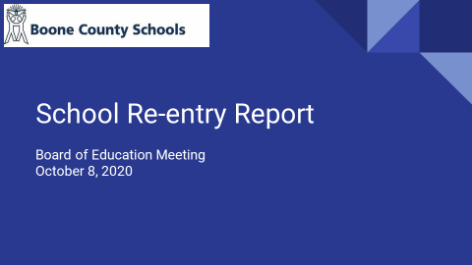

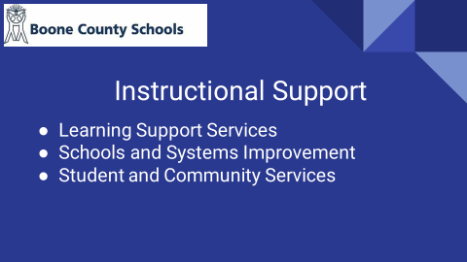

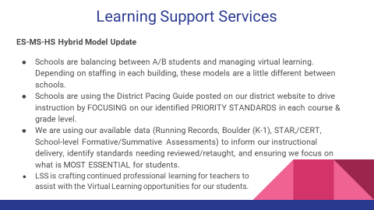

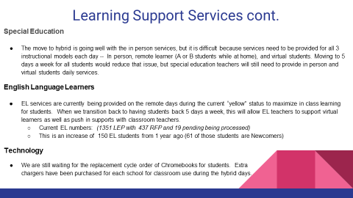

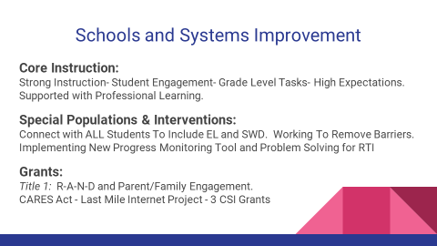
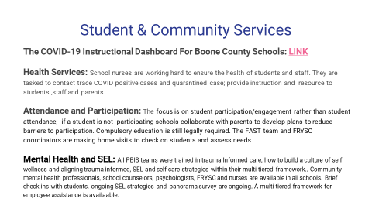

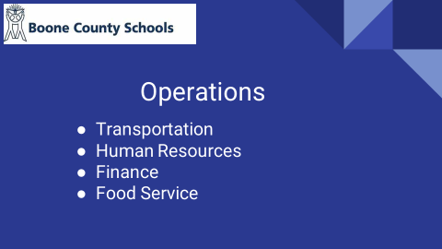

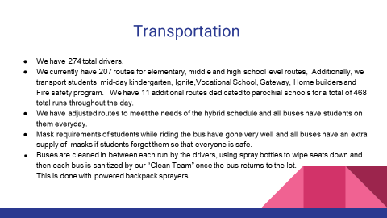

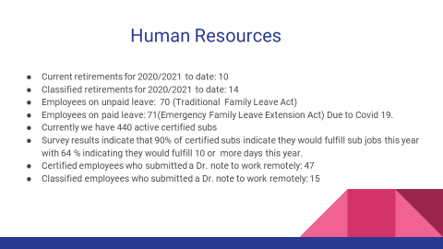

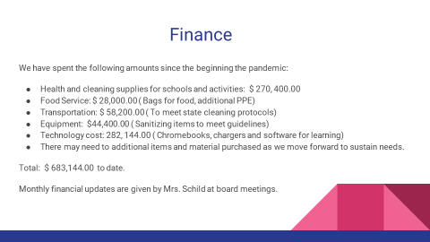

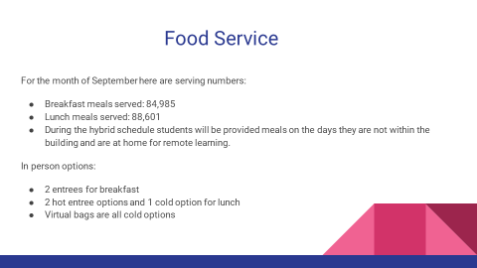

- Julie Pile asked about how we insure students staying on content, Ms. Watson explained CERT and STAR and the guides to develop next steps. Discussion on EL student and collaboration with families, survey to see how it is going. Troy Fyrman discussed the chromebooks that are on back order. Karen Byrd discussed virtual learning and a survey needed to see what needs to be done to make it better for our students.

VI. AUDIENCE OF CITIZENS
(brief summary)
- Tiffany Buller-Schussler, parent, discussed the safety measures at her business and the safety measures work in her dental office and asked the board to trust their process and protocols it will protect you.
- Sarah Cheek, parent, discussed mental health and suicide death numbers is higher than death rate of Covid. The decisions the board makes will make the suicide numbers higher. Discussed Kenton and Campbell school open and asked the board to let the teachers do their jobs.
- Marjory Hughes, parent, discussed we are not able to teach our kids, highly disappointed for lack of plan to get our kids back in school. Discussed COVID survival rates in Ohio.
- Amber Hamm, parent, discussed making sure everyone is aware of how this is effecting our children with autism, not meeting IEP’s, no one-on-one attention. Do better for these kids.
- Kimberly Ferrara, parent, discussed children are not getting a voice, teachers are doing what they can, staff not feeling safe, employees going back and don’t have what they need.
- Shannon Hornback, parent, discussed that we should be ashamed we don’t have teachers back teaching, discussed a need for a better plan and do better than a plan.
- Christina Haynes, student, spoke on depression and anxiety from this pandemic on her friends, along with schoolwork and grade work. Asked to go back to 5-day instruction.
- Dustin Haynes, student, concern for mental health with students, and would like to be back 4 or 5 days.
- Timothy Nicoli, teacher, discussed we are aware of all the situations that were brought up, going back 4 or 5 days will not allow for social distancing. Discussed bringing back students is not good plan without social distancing, but if we maintain virtual students, or students going 4 days and one day virtual- there will be no time to do both at the same time.
- Bailey Hamm, student, discussed not having much instruction and so many assignments due at once during virtual instruction.
- Jennifer Hanes, parent, question on liability waivers the parents can sign if that is an issue, volunteers to assist, they will help if we open back up the schools.

VII. RECOMMENDED ACTION - CONSENT AGENDA
Mr. Matt Turner, Superintendent, recommended the board approve the Consent Agenda items A – UUU, as presented.
- A motion was made by Dr. Maria Brown, seconded by Karen Byrd, to approve the Consent Agenda items A-UUU, as presented. Matt McIntire, Dr. Maria Brown, Karen Byrd, Troy Fryman, and Julia Pile voted, “aye” MOTION: The motion passed 5-0.

A. Minutes of the regular board meeting of the September 10 2020.
The board approved the minutes of the regular board meeting of September 10, 2020, as presented.
B. Minutes of the Special Board Meeting Workshop Redistricting Steeplechase Boone County Board of Education September 3, 2020.
The board approved the Minutes of the Special Board Meeting Workshop Redistricting Steeplechase Boone County Board of Education September 3, 2020, as presented.
C. Tax Hearing Public Forum Special Board Meeting Boone County Board of Education September 3, 2020 at 6:30 pm.
The board approved the Tax Hearing Public Forum Special Board Meeting Boone County Board of Education September 3, 2020 at 6:30 pm, as presented.
D. Tax Hearing Special Board Meeting Boone County Board of Education September 3, 2020 at 7:00 pm Meeting Minutes
The board approved the Minutes of the Tax Hearing Special Board Meeting Boone County Board of Education September 3, 2020 at 7:00 pm, as presented.
E. Bill List
F. Treasurer's Report was presented by Mrs. Linda Schild.
G. Leaves of Absence
The following persons leaves of absence requests were board approved:
Recommended by Principal/Supervisor for approval:
Arce, Aida, Café Worker @ Ballyshannon MS 8/18/2020 – 10/16/2020
Armstrong, John, Head Custodian @ Ockerman MS 08/17/2020-10/2/2020
Aylor, Brooke, Teacher @ Collins ES 11/06/2020-11/24/2020
Caldwell, Phebe, Para @ Mann ES 08/18/2020-09/25/2020
Ginter, Stefanie, Teacher @ Goodridge ES 10/08/2020 – 11/06/2020
Hughes, Elizabeth, Transportation Aide @ Transportation 08/18/2020 – 10/18/2020
Marston, Michelle, Teacher @ Cooper HS 11/19/2020 – 05/28/2020
Simpson, Heather, Staff Support @ Ballyshannon MS 09/09/2020 – 09/24/2020
Payne, Samantha, Teacher @ Mann ES 10/23/2020 – 12/18/2020
Piner, Leslie, Para @ Gray MS 08/18/2020 – 09/25/2020
Ryan, Rebekah, Teacher @ Boone County HS 09/21/2020 – 11/02/2020
Walden, Stacey, Bus Driver @ Transportation 10/16/2020 – 12/18/2020
Ziegelmeyer, Stephanie, Teacher @ Florence ES 12/04/2020 – 01/14/2021
Not Recommended by Principal/Supervisor for approval:
None
Amended Leaves:
None
Cancelled Leaves:
None
H. Pre School Program Copier Maintenance Agreement: Toshiba Business Solutions
The board approved the Pre School Program Copier Maintenance Agreement: Toshiba Business Solutions, as presented.
I. Ryle High School (RHS) Copier Bid Award/Lease and Maintenance Agreement:Toshiba Business Solutions
The board approved the Ryle High School (RHS) Copier Bid Award/Lease and Maintenance Agreement:Toshiba Business Solutions, as presented.
J. Memorandum of Agreement Between Imagine Learning and Boone County Schools
The board approved the Memorandum of Agreement Between Imagine Learning and Boone County Schools, as presented.
K. Contract - Ballyshannon Middle with Lifetouch for Pictures
The board approved the Contract - Ballyshannon Middle with Lifetouch for Pictures, as presented.
L. Sales Campaign Approval
The board approved the Sales Campaign Approval, as presented.
M. Contract Revised - Boone County School District with Dell Financial Services for Boone County High Laptops
The board approved the Contract Revised - Boone County School District with Dell Financial Services for Boone County High Laptops, as presented.
N. Contract - Kelly Elementary School with Lifetouch for 2020-21 School Year
The board approved the Contract - Kelly Elementary School with Lifetouch for 2020-21 School Year, as presented.
O. Contract - Conner Middle School with Lifetouch for 2020-21 School Year
The board approved the Contract - Conner Middle School with Lifetouch for 2020-21 School Year, as presented.
P. Contract - Thornwilde Elementary with Lifetouch for 2020-21 School Year
The board approved the Contract - Thornwilde Elementary with Lifetouch for 2020-21 School Year, as presented.
Q. Contract - Erpenbeck Elementary with Lifetouch for 2020-21 School Year
The board approved the Contract - Erpenbeck Elementary with Lifetouch for 2020-21 School Year, as presented.
R. Contract - Ignite Institute with Survey Monkey
The board approved the Contract - Ignite Institute with Survey Monkey, as presented.
S. Contract - Ballyshannon Middle with Lifetouch for Yearbooks
The board approved the Contract - Ballyshannon Middle with Lifetouch for Yearbooks, as presented.
T. Contract - Boone County Schools with VonLehman, CPA and Advisory Firm
The board approved the Contract - Boone County Schools with VonLehman, CPA and Advisory Firm, as presented.
U. Contract - Cooper High School with Theatrical Rights Worldwide for Addams Family School Edition
The board approved the Contract - Cooper High School with Theatrical Rights Worldwide for Addams Family School Edition, as presented.
V. Memorandum of Agreement Between Heggerty-Literary Resources LLC and New Haven Elementary School
The board approved the Memorandum of Agreement Between Heggerty-Literary Resources LLC and New Haven Elementary School, as presented.
W. MOU for Kentucky State University and Ryle High School Dual Credit
The board approved the MOU for Kentucky State University and Ryle High School Dual Credit, as presented.
X. Memorandum of Agreement Between KET/PBS online and Thornwilde Elementary School
The board approved the Memorandum of Agreement Between KET/PBS online and Thornwilde Elementary School, as presented.
Y. Memorandum of Agreement Between Learning A-Z and Mary Queen of Heaven School Through Boone County Schools
The board approved the Memorandum of Agreement Between Learning A-Z and Mary Queen of Heaven School Through Boone County Schools, as presented.
Z. Memorandum of Agreement Between Learning Ally and Cooper High School
The board approved the Memorandum of Agreement Between Learning Ally and Cooper High School, as presented.
AA. Memorandum of Agreement Between Jones Middle School and Mackin Educational Resources
The board approved the Memorandum of Agreement Between Jones Middle School and Mackin Educational Resources, as presented.
BB. Memorandum of Agreement Between Ockerman Middle School and Mackin Educational Resources
The board approved the Memorandum of Agreement Between Ockerman Middle School and Mackin Educational Resources, as presented.
CC. Memorandum of Agreement Between Thornwilde Elementary School and Mackin Educational Resources
The board approved the Memorandum of Agreement Between Thornwilde Elementary School and Mackin Educational Resources, as presented.
DD. Memorandum of Agreement Between NKCES and Immaculate Heart of Mary School Through Boone County Schools
The board approved the Memorandum of Agreement Between NKCES and Immaculate Heart of Mary School Through Boone County Schools, as presented.
EE. Memorandum of Agreement Between Pioneer Valley Books and Longbranch Elementary School
The board approved the Memorandum of Agreement Between Pioneer Valley Books and Longbranch Elementary School, as presented.
FF. Memorandum of Agreement Between Boone County Schools and PTC Inc./Onshape Education
The board approved the Memorandum of Agreement Between Boone County Schools and PTC Inc./Onshape Education, as presented.
GG. Memorandum of Agreement Between Seesaw and Burlington Elementary School
The board approved the Memorandum of Agreement Between Seesaw and Burlington Elementary School, as presented.
HH. Memorandum of Agreement Between Smekens Education Solutions and Prince of Peace Montessori Through Boone County Schools
The board approved the Memorandum of Agreement Between Smekens Education Solutions and Prince of Peace Montessori Through Boone County Schools, as presented.
II. Memorandum of Agreement Between Studies Weekly and Collins Elementary School
The board approved the Memorandum of Agreement Between Studies Weekly and Collins Elementary School, as presented.
JJ. Memorandum of Agreement Between Tierney and Florence Elementary School
The board approved the Memorandum of Agreement Between Tierney and Florence Elementary School, as presented.
KK. Memorandum of Agreement Between Ballyshannon Middle School and Tristan N Vaughn Consulting, LLC
The board approved the Memorandum of Agreement Between Ballyshannon Middle School and Tristan N Vaughn Consulting, LLC, as presented.
LL. Memorandum of Agreement Between New Haven Elementary School and Texthelp, Inc.
The board approved the Memorandum of Agreement Between New Haven Elementary School and Texthelp, Inc., as presented.
MM. Memorandum of Agreement Between VideoShane LLC and Ignite Institute
The board approved the Memorandum of Agreement Between VideoShane LLC and Ignite Institute, as presented.
NN. Memorandum of Agreement Between West Music and Burlington Elementary School
The board approved the Memorandum of Agreement Between West Music and Burlington Elementary School, as presented.
OO. Memorandum of Agreement Between Boone County Schools and Battelle for Kids
The board approved the Memorandum of Agreement Between Boone County Schools and Battelle for Kids, as presented.
PP. Erpenbeck Elementary School (EES) Copier Lease and Maintenance Agreement: Toshiba Business Solution
The board approved the Erpenbeck Elementary School (EES) Copier Lease and Maintenance Agreement: Toshiba Business Solution, as presented.
QQ. Appointment of School Board Attorney
The board approved the Appointment of School Board Attorney, as presented.
RR. Memorandum of Agreement Between Amplified IT and St. Henry High School through Boone County Schools
The board approved the Memorandum of Agreement Between Amplified IT and St. Henry High School through Boone County Schools, as presented.
SS. Memorandum of Agreement with AOPA (Aircraft Owners and Pilots Association) and Boone County High School
The board approved the Memorandum of Agreement with AOPA (Aircraft Owners and Pilots Association) and Boone County High School, as presented.
TT. Memorandum of Agreement Between Boom Learning and Ockerman Elementary School
The board approved the Memorandum of Agreement Between Boom Learning and Ockerman Elementary School, as presented.
UU. Memorandum of Agreement Between Brainpop and Gray Middle School
The board approved the Memorandum of Agreement Between Brainpop and Gray Middle School, as presented.
VV. Memorandum of Agreement Between Brainpop and Longbranch Elementary School
The board approved the Memorandum of Agreement Between Brainpop and Longbranch Elementary School, as presented.
WW. Memorandum of Agreement for Board Certified Analyst
The board approved the Memorandum of Agreement for Board Certified Analyst, as presented.
XX. Declaration as Surplus: Textbooks and Compact Discs from Ryle High School (RHS)
The board approved the Declaration as Surplus: Textbooks and Compact Discs from Ryle High School (RHS), as presented.
YY. Memorandum of Agreement Between Certica TE21, Inc. and Florence Elementary School
The board approved the Memorandum of Agreement Between Certica TE21, Inc. and Florence Elementary School, as presented.
ZZ. Memorandum of Agreement Between Cengage Learning and Jones Middle School
The board approved the Memorandum of Agreement Between Cengage Learning and Jones Middle School, as presented.
AAA. Memorandum of Agreement Between The Eastern Kentucky University and Boone County Schools
The board approved the Memorandum of Agreement Between The Eastern Kentucky University and Boone County Schools, as presented.
BBB. Memorandum of Agreement Between Goodridge Elementary School and ESGI
The board approved the Memorandum of Agreement Between Goodridge Elementary School and ESGI, as presented.
CCC. Memorandum of Agreement Between Boone County High School and ExploreLearning
The board approved the Memorandum of Agreement Between Boone County High School and ExploreLearning, as presented.
DDD. Memorandum of Agreement Between Flocabulary and Longbranch Elementary School
The board approved the Memorandum of Agreement Between Flocabulary and Longbranch Elementary School, as presented.
EEE. Memorandum of Agreement Between Google and Ockerman Middle School
The board approved the Memorandum of Agreement Between Google and Ockerman Middle School, as presented.
FFF. Annual Interagency Agreement Between Children's Home of Northern Kentucky (CHNK) and Boone County Board of Education
The board approved the Annual Interagency Agreement Between Children's Home of Northern Kentucky (CHNK) and Boone County Board of Education, as presented.
GGG. Memorandum Related to Collaborative Service Agreement Between Children's Home of Northern Kentucky and Boone County Schools for Intensive Outpatient Programming (IOP)
The board approved the Memorandum Related to Collaborative Service Agreement Between Children's Home of Northern Kentucky and Boone County Schools for Intensive Outpatient Programming (IOP), as presented.
HHH. Collaborative Service Agreement Between Children's Home of Northern Kentucky and Boone County Board of Education
The board approved the Collaborative Service Agreement Between Children's Home of Northern Kentucky and Boone County Board of Education, as presented.
III. Memorandum Related to Lead Educational Agreement Between the Children's Home of Northern Kentucky and Boone County Schools for Day Treatment Therapeutic Services
The board approved the Memorandum Related to Lead Educational Agreement Between the Children's Home of Northern Kentucky and Boone County Schools for Day Treatment Therapeutic Services, as presented.
JJJ. Memorandum of Agreement Between Psychological Services, Boone County Schools and Ethan's Purpose
The board approved the Memorandum of Agreement Between Psychological Services, Boone County Schools and Ethan's Purpose, as presented.
KKK. Memorandum of Agreement By and Between Fernside and Kelly Elementary School
The board approved the Memorandum of Agreement By and Between Fernside and Kelly Elementary School, as presented.
LLL. Revised BG-1 for Boone County High School Tuckpointing, BG #20-115
The board approved theRevised BG-1 for Boone County High School Tuckpointing, BG #20-115, as presented.
MMM. Correction on September 10, 2020 Consent Agenda Item VI. TTT - Memo Incorrect for Contract-Boone County School District with Dell Financial Services for Boone County High Laptops
The board approved the Correction on September 10, 2020 Consent Agenda Item VI. TTT - Memo Incorrect for Contract-Boone County School District with Dell Financial Services for Boone County High Laptops, as presented.
NNN. Job Description Modification - "Activity Fund Account Supervisor"
The board approved the Job Description Modification - "Activity Fund Account Supervisor", as presented.
OOO. SLN Schlechty Leadership Network Membership 20-21
The board approved the SLN Schlechty Leadership Network Membership 20-21, as presented.
PPP. NSBA Membership 20-21
The board approved the NSBA Membership 20-21, as presented.
QQQ. Northern Kentucky Cooperative for Educational Services Membership Dues 20-21
The board approved the Northern Kentucky Cooperative for Educational Services Membership Dues 20-21, as presented.
RRR. Revised BG-1 for Boone County High Schools Turf Fields, BG #20-184
The board approved the Revised BG-1 for Boone County High Schools Turf Fields, BG #20-184, as presented.
SSS. Memorandum of Agreement between Wevideo, Inc. and Jones Middle School
The board approved the Memorandum of Agreement between Wevideo, Inc. and Jones Middle School, as presented.
TTT. Agreement between Duke Energy Kentucky and Boone County Schools Gas Easement for Camp Ernst Road
The board approved the Agreement between Duke Energy Kentucky and Boone County Schools Gas Easement for Camp Ernst Road, as presented.
UUU. Encore Technologies Auditorium A/V Upgrade Boone County Boardroom
The board approved the Encore Technologies Auditorium A/V Upgrade to the Boone County Boardroom, as presented.
VIII. RECOMMENDED ACTION - OLD BUSINESS
A. No Old Business
IX. RECOMMENDED ACTION - NEW BUSINESS
A. Reopening Schools for Additional Days of In-Person Instruction
Mr. Matt Turner, Superintendent, recommended the board approve the Reopening of Schools for Additional Days of In-Person Instruction as follows, too provide 4 days of in-person instruction for both A & B groups each week on Mon, Tue, Thur, and Fri., to maintain Wednesday as a support and intervention day for our students receiving virtual instruction, to begin this change to our instructional model on Thursday, October 29th. Using the communications process, we will communicate to parents on Thursday, October 22nd, 2020 the status of our instructional model for the following week. In this situation, meaning whether we will start this new model on Thursday, October 29th, as presented.
- A motion was made by Dr. Maria Brown, seconded by Karen Byrd, to approve the Reopening of Schools for Additional Days of In-Person Instruction as follows, to provide 4 days of in-person instruction for both A & B groups each week on Mon, Tue, Thur, and Fri., to maintain Wednesday as a support and intervention day for our students receiving virtual instruction, to begin this change to our instructional model on Thursday, October 29th. Using the communications process, we will communicate to parents on Thursday, October 22nd, 2020 the status of our instructional model for the following week. In this situation, meaning whether we will start this new model on Thursday, October 29th, as presented. Matt McIntire, Dr. Maria Brown, Karen Byrd, Troy Fryman, and Julia Pile voted, “aye” MOTION: The motion passed 5-0.

Mr. Turner, Superintendent, read into the minutes the following statement:
From the onset of this pandemic, three priorities emerged and have been the central part of every conversation regarding reopening our schools:
- Effectively educating our students,
- Keeping our students, employees, and communities safe, and
- The effect of the pandemic on our families and jobs.
Our teachers and our administrators take pride in keeping the needs of our children first, however we must also be mindful of keeping our employees safe and healthy, both physically and mentally. We must all be sure to recognize that changes to the instructional model for administrators and staff are time consuming and energy consuming and these changes are in addition to the work of the instructional model in which they are currently working.
Our school leaders and teachers have worked very hard since June to learn and problem solve on how we can educate our students in a completely different way following guidelines that smash apart the strategies that we use to organize the normal routines of school and the learning processes in our classroom. Our principals have met each week to learn about safety protocols and to share best practices. This year we set up a group of school liaisons that serve as a school’s direct connection to our district leaders and they meet weekly to compare notes and look for needs and trends across the district. All of these tasks have been completed in a constantly regularly changing landscape of regulations and guidelines.
I also worry about the challenges and difficulties that our parents and their children face during this pandemic. The stresses and strain of their jobs and responsibilities are heightened by the pandemic, its effects on childcare and by the challenges presented by not having their children in school each day.
We will continue to serve our students and families that have chosen virtual instruction for the rest of the semester. We will also continue to follow the communications protocol established by the KY Department of Education – where we will evaluate the status of the pandemic and use the closure criteria defined on our district’s COVID-19 dashboard each Thursday evening to determine the status of our entire district for the following week. That closure criteria is as follows:
- Daily new cases per 100K population (7-day rolling average)
- Trend line of daily new cases per 100K population
- Infection rate
- Positive rate
- Quarantine data and its impact on schools
- Successful implementation of school health & safety protocols
- Directives from NKY Health Department

Due to the large size of our school district, we want to specifically target the responses to COVID-19 issues in any of our schools. With this process in place, we will work to be responsive, specific, and precise as possible in the future when we need to close an individual school or parts of a school.
After listening to concerns, gathering input and feedback, speaking with many stakeholders, holding a public forum – I have given these issues considerable and reflection. My recommendation for providing more in-person instruction to our students is …
- To provide 4 days of in-person instruction for both A & B groups each week on Mon, Tue, Thur, and Fri.
- To maintain Wednesday as a support and intervention day for our students receiving virtual instruction.
- To begin this change to our instructional model on Thursday, October 29th. Using the communications process I previously mentioned, we will communicate to parents on Thursday, October 22nd, 2020 the status of our instructional model for the following week. In this situation, meaning whether we will start this new model on Thursday, October 29th.
This schedule will provide three full weeks for our schools & district administrators, teachers, students, and families to prepare. Time will be needed to plan, to organize schedules and routines, and to get furniture and equipment in place. This change will also provide additional time for students and employees to become more comfortable implementing and practicing the school health & safety protocols that are specified in the Guidance on Safety Expectations and Best practices for KY Schools (K-12).
To be honest, this is a great challenge and it will require significant work and energy on behalf of our employees. I do believe this is the right path as many of our students are struggling, especially our families and students in need. I also worry about our staff, as many of our teachers are struggling with the complexities of teaching in a hybrid model, where they are serving the needs of three separate groups of students.
We can accomplish this – schools and districts in other states have opened and stayed opened effectively and safely. We are now the largest district in KY providing any in-person instruction – let’s continue to lead the way as we always do. To track our progress and provide assistance in achieving this goal, I will be providing a weekly update to the board of education on the progress of our schools in preparing for this change of the instructional model.
To achieve this end of adding in-person instruction, we will need additional support from our community in several different ways. Our schools will need parents and community members to rally and volunteer to assist with tasks around the school building or providing resources. Please reach out to your schools or be looking for their requests and take action to support them.
We will also need our parents and community members to assist us in keeping our COVID-19 infection numbers down. Following the safety protocols in our community and at home will be crucial to our success – everyone in Boone County can help us make this happen. Our students must also understand that wearing a mask at school and around others and also following the other safety protocols is NOT OPTIONAL– it is crucial to keeping yourself safe and your classmates and teachers safe.
In closing, I also have significant concerns about the upcoming 4-day weekend and how travel and the gatherings of families and friends may cause increased spread of the virus that may become evident in the next few weeks.
As always, please keep yourself safe, your families’ safe, and your communities safe.

Matt McIntire, chairperson, discussed this will be challenging for our staff this will continually change and the board understand this challenge. We have looked at other schools that have went back and their safety protocols and we feel this can be done successfully. Discussed the community will need to help with keeping everyone safe, reach out to your schools and volunteer where you can and are needed. Troy Fryman, emphasized to be supportive of the process and procedures must be followed to make this work and be supportive of your teachers and staff. Dr. Brown, discussed now we have a plan and protocols in line, we must do this right and understands everyone is nervous about COVID, we all are. We are doing everything we can to make the best of the worst situation. Julia Pile added the board appreciates all the opinions given especially the students, discussed mental health and the need to have the students back in school. Karen Byrd discussed we are a community and family; we all need to help our students and staff at this time. Ms. Byrd addressed the issue of concern some teachers had of cleaning supplies shortage, she asked the operation department to check into this issue and the operation department sent pictures of large stocks of supplies of what the district is using and will have available upon request.
XI. INFORMATION, PROPOSALS, COMMUNICATIONS
A. Human Resource Actions
B. Worker's Compensation Claims
C. Overtime Report
D. Construction Status Report
E. Energy Management Report
- Julia Pile announced October 26th Radical Family Engagement Week, with Parent Camp kicking this off on Monday, from 1:30 to 3:00 pm.

XII. CLOSED EXECUTIVE SESSION PER KRS 61.810
A. No closed session
XIII. ADJOURN
- A motion was made by Karen Byrd, seconded by Dr. Maria Brown, to adjourn the meeting. Matt McIntire, Dr. Maria Brown, Karen Byrd, Troy Fryman, and Julia Pile voted, “aye” MOTION: The motion passed 5-0.

The meeting adjourned at approximately 9:12 pm.

______________________________
Matt McIntire, Board Chair

______________________________
Karen Evans, Board Secretary

