Communication Updates- April 2023
Candace Gibson- Communications and Outreach Coordinator

NEWSLETTER
Since moving our newsletter over to Smore.com, we have much more in-depth analytics to check out! We can see the amount of time that people spend reading the newsletter once opening it in an email, and how many times each embedded link is clicked. After cleaning out invalid email addresses, our number of subscribers has gone down, but we are still seeing an average of more than 425 views each week.

Another benefit to the Smore newsletter system is the ability to edit the newsletter after publishing. After noticing an error in the graduation announcement, I was able to log back in and correct the date. Even with an older link, anyone who clicked into the newsletter would see the updated information.

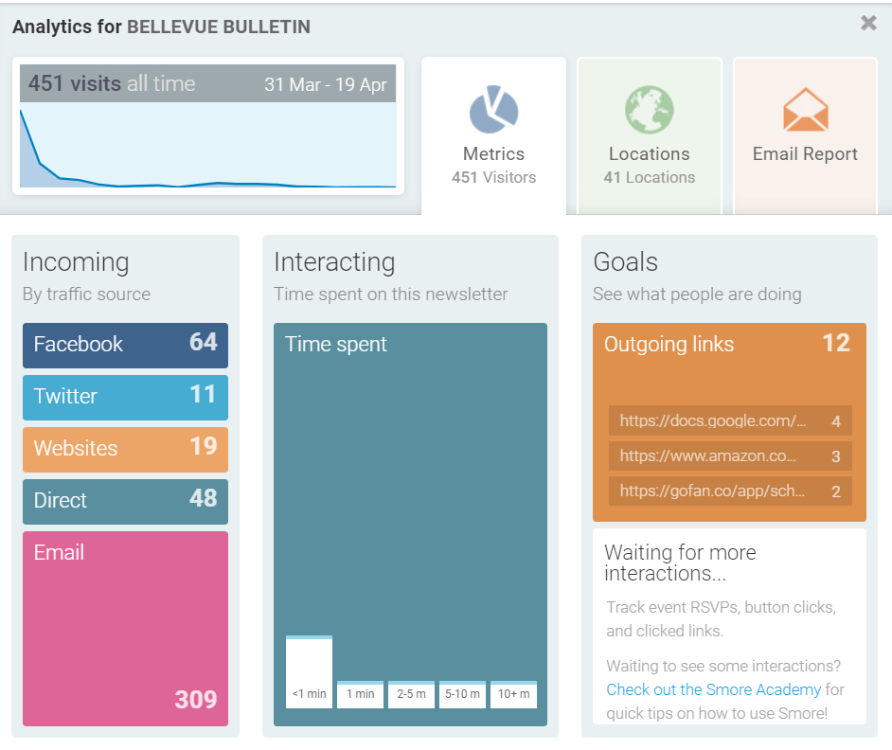

SOCIAL MEDIA
Due to spring break, we had less posts this month than the average. However, the engagement percentages stayed consistent with months where we have higher posts. The current social media plan shows that, even when we go silent for a few days of breaks and holidays, BISD remains part of the conversation.
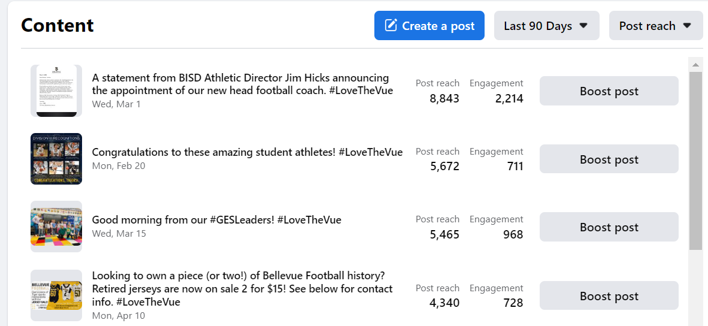
FACEBOOK MONTHLY IMPACT
Total post reach this month | 15,587
Total post engagement (likes, comments, etc) | 8,432
Number of posts this month | 38
New followers; new page likes | +30; +14
Total shares | 114

ADDITIONAL DESIGNS/INFORMATION
Summer camp information is rolling out this week and next, with GES, BMHS, and 6th Grade Academy each having their own designs and online forms.
The new designs for the Portrait of the Bellevue Graduate, Mission & Vision, and Core Values are being uploaded to the website. I am testing out a new, interactive “flipbook” for the portrait of a graduate, and plan to all of the new designs into dynamic, clickable information. Information will be uploaded and tested, but kept unpublished to the public until we are ready to roll out in mid-July. Once all the new media is uploaded, I will share it with central office staff and board members for review.

