Boone County Schools

Boone County School District
2021-2022 Return To School Plan

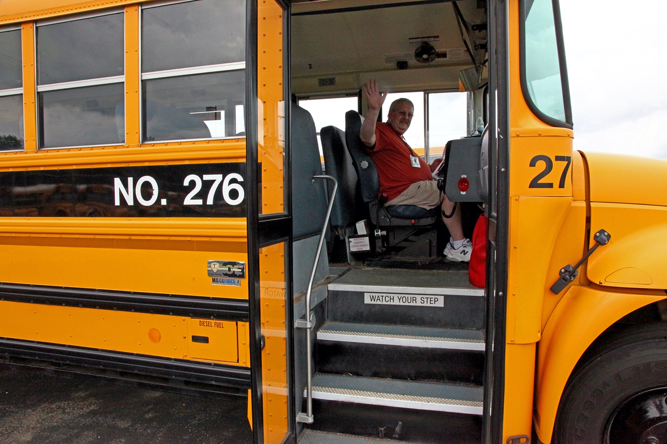

Updated 8/23/2021

Message from the Superintendent

Dear Boone County Parents and Guardians,

The Boone County Schools are committed to providing daily, in-person instruction to our students this year and we will steadfastly work to meet that commitment. We do understand that wearing a mask may not always be easy but we want to have our students in school every day and we want to have our students participate in activities and organizations such as marching band, athletics, and clubs. We will work through this school year together and will focus on doing what is necessary to meet our commitment to daily, in-person instruction. We will follow the Governor’s executive order to start the 2021-2022 school year. Click on this LINK to view the executive order and the accommodations provided.

We are closely monitoring regional and local COVID-19 data to determine the safest path forward for all Boone County Schools’ stakeholders. This data, as well as information from the Governor’s office and the Kentucky Department of Education, will be utilized to provide a safe learning environment for all 21,000+ students and 3,700+ staff of our District. Additionally, we have also paid close attention to other school districts starting their school year and then having to quickly put stricter safety protocols in place due to positive cases and quarantine numbers.
Thank you for your continued support and patience as we work to ensure the safety of our students and employees while maintaining our commitment to providing daily, in-person instruction.

Sincerely,

Matthew L. Turner
Superintendent of Schools
Guiding Principles

- Honor and safeguard the health and safety of students and staff
- Maintain fidelity of instruction ensuring standards are taught and mastered by all students
- Ensuring equity and access for all students
- Support the social-emotional learning and teaching needs of students and educators
- Adhere to guidelines from the state and local health officials at all times to mitigate unhealthy behaviors, reduce the spread of infection and protect the wellness of all individuals
- Respect choices for personal health and preferences when possible for mode of instructions, while asking such commitments be made for no less than a designated period of time to assist with staffing and other decisions, with exceptions allowed for unexpected health concerns
- Recognize unprecedented circumstances may arise that will need to be accommodated
- Communicating effectively with all stakeholders
- Ensuring flexibility to meet the needs of all students, while maintaining fiscal solvency

Vaccination
We recommend that all of our staff, students and our extended family receive the COVID vaccination (we understand and respect that this is an individual/family choice but it is important to note that students/staff who are vaccinated do not have to quarantine unless they become symptomatic).

Social-Distancing/Reduction in Contact
Space planning solutions can be used to reduce transmission of contagious diseases through social distancing. Current guidance for social distancing is 3 feet or more. Boone County Schools will follow the guidance of all state and local health officials on social distancing to the best of our ability. We are limiting non-essential visitors to our schools and buildings.
Testing
We plan to provide voluntary testing for COVID-19 at each of our schools for students and staff.

Isolation

Ensure sick students, teachers or staff stay home if they are having fever and/or symptoms of COVID-19, including:

Fever

New cough

Difficulty breathing

Sore throat

Muscle aches or body aches

Vomiting or diarrhea

New loss of taste or smell

Ensure persons who test positive for COVID isolate away from school for 10 days after the start of their illness. Sick students, teachers or staff who do not test positive for COVID may return when their symptoms resolve.

Quarantining And Contact Tracing

A close contact is someone who was within 6 feet of an infected person for a cumulative total of 15 minutes while the person was considered contagious.

- Exception: In the K-12 indoor classroom setting, the close contact definition excludes students who were at least >3 feet away from an infected student if both students were engaged in consistent and correct use of masks and other K-12 prevention strategies were in place. This exception does not apply to teachers, staff, or other adults in the indoor classroom setting.

Unvaccinated students, teachers or staff who are identified as a close contact should self quarantine. The quarantine can end when the following has been met, and there is no continued contact with the positive case.

Receive a COVID test (if asymptomatic) on day 5 or later, and return to normal activity on day 8, if the COVID test is negative.

Quarantine for 10 days, and if asymptomatic, return to normal activity on day 11.

Fully vaccinated students, teachers or staff do not need to quarantine following exposure to a COVID positive case, if he/she is not experiencing any symptoms, but are recommended to be tested 3-5 days after exposure.
- 702 KAR 1:191E allows for paid COVID-19 quarantine leave in certain circumstances for eligible employees. If an employee is required to quarantine by a medical professional, a public health department, or the Department of Public Health, employees assigned to a school should notify their school nurse and employees not assigned to a school should notify the Director of Health Services, Jennifer Yarger, to determine next steps. The Human Resources team will contact quarantined individuals for determination of quarantine leave status. Per the KAR, quarantine leave is not available if an employee, vaccinated or unvaccinated, has an active COVID-19 infection. The employee may use sick and/or personal leave to cover their absence during an active COVID-19 infection.

Masking And Handwashing

All persons are required to wear masks while indoors in all settings, unless otherwise exempted, regardless of COVID vaccination status. We have been closely monitoring the recent activity of the KY state legislature. We will continue to monitor the guidance from the KY Department of Education. We currently require universal masking; all employees, students and visitors will continue to wear an appropriate face mask in all school buildings and on all school buses.

Our school district will adhere to the following masking decisions based on community transmission data from the KY Department of Public Health, which will remain in place until modified or rescinded by the superintendent or the Boone County Board of Education.

Community Transmission Data
Boone County COVID-19 Daily Incidence Rate from the KDPH Dashboard
LOW  (Less than 1 case per 100,000 people daily) | MODERATE  (Between 1 - 10 cases per 100,000 people daily) | SUBSTANTIAL  (Between 10 – 25 cases per 100,000 people daily) | HIGH  (Greater than 25 cases per 100,000 people daily)
Masks are RECOMMENDED for grades P-12. | Masks are RECOMMENDED for grades P-12. | Masks are REQUIRED for grades P-12. | Masks are REQUIRED for grades P-12.

In accordance with the Kentucky Department of Education’s guidance and other applicable laws, the Boone County School District requires a medical waiver signed by a physician to allow students or staff not to wear face coverings or masks during the school day.

Parent/Guardians who have a concern for the health of their child while wearing mask/face covering, should contact their physician and ask him/her to write a waiver on letterhead.
- Student Name
- Date of Birth
- Medical reason the student cannot wear a mask/face covering at school
- Impact wearing a mask/face covering would have on student health
- Suggested reasonable accommodations if mask/face covering is not worn
- Physician’s signature, printed name and date

We recommend handwashing with soap and water for at least 20 seconds or use of hand sanitizer containing at least 60% alcohol.

Transportation
- Parents shall take their student’s temperature each morning. Any student exhibiting a fever should be kept home.
- Students are required to wear a mask at all times while riding the bus by the mandate of the CDC, KDE, and KDPH, all students and adults must wear a mask while riding a school bus, whether they are vaccinated or not (in accordance with President Biden’s Executive Order and the CDC’s public health order)
- When possible, air flow will be increased on all buses (windows down)
- Hand sanitizer is available on all buses when entering the bus
- Assigned seating will be established on all buses
- Students will be off-loaded buses from the front of the bus to the rear of the bus
- Increased sanitation protocols of buses will occur daily and weekly

School Building Cleaning, Sanitizing and Disinfecting
- Multiple hand sanitizing stations and dispensers are located throughout all schools (Handwashing is still the recommended best practice)
- Frequent cleaning of all aspects of schools and district buildings will occur throughout the day and each evening
- Frequently touched surfaces such as handrails and door knobs will be sanitized throughout the school day
- High traffic areas, such as restrooms, common areas and drinking fountains will be sanitized throughout the school day
- Sanitizing and disinfecting sprays and wipes will be provided to support classroom needs throughout the school day
- Our ventilation systems in our schools and buildings meet all industry standards. We will utilize outdoor spaces when possible.

Food Services

Full In-Person Instruction 5 Day School Week Meal Services

- Breakfast and Lunch Meal Services provided at all schools on a daily basis at No Charge for 2021-22 school year for all enrolled students
- Free/Reduced Meal Applications are still needed and can be completed using Free & Reduced Benefit Application link
- Ala Carte Pricing Meal Prices (2021-2022) link

If you have any questions or concerns please contact Food Services at 859-282-2367

Attendance/Participation

As we approach the start of the new 2021-2022 school year, we are excited to announce that all children enrolled in a Boone County School will be in-person learners starting on the first day of school for students, August 18. This action is in conjunction with the recently communicated expectation from the Kentucky Department of Education that all public schools in Kentucky return to educational settings where daily student attendance is recorded as students are present in their classrooms. We look forward to having our students in their desks Monday through Friday for the upcoming school year.

Teaching and Learning

Students in grades K-12 will attend school in-person 5 days per week. Preschool students will attend school in-person following the normal 4-day, Monday through Thursday, schedule.

When a student, grades K-12, is unable to attend school due to a physical or emotional medical issue or disability and meets the home/hospital criteria, the student can be provided instructional services through the school district’s Home/Hospital Instructional Program. An instructional session may be delivered in person or electronically. Parents who are interested in pursuing the Home/Hospital Program option can contact Mark Raleigh, Assistant Director of Pupil Personnel, at 859-283-3217.

Boone County Schools is now offering a virtual option for 6th – 12th grade students through the Accel Academy. If accepted, students will have a primary enrollment at the Accel Academy and will no longer be enrolled at their district school. Parents should contact their school counselor or administration for more information and to set up an enrollment meeting. Parents can also contact Tracy Schaefer, School Choice and Transitional Programs Coordinator for more information as well at tracy.schaefer@boone.kyschools.us or 859-283-3232.

Our re-entry plan is a living document and is subject to change throughout the school year. We will update the document with any new information given to us from the local, state or federal agencies.

