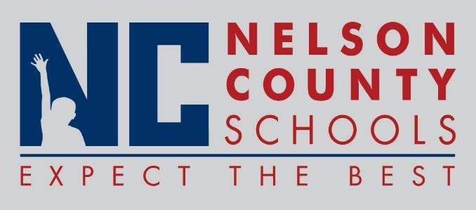

Information Paper
To: | Nelson County Board of Education
From: | Bob Morris Executive Director of Student Support
cc: | Dr. Anthony Orr, Superintendent
Date: | Aug 15, 2017
Re: | Personnel Notifications

New Hires: Anita Whitworth Pass Coach OKH
Rachel Coleman SPED NCHS
Michelle Williams English OKH
Kyle Thomas Counselor HOR
Mona MacCormack Science OKH
Jordan Ruth Teacher FHES
Ana Watson Art OKH
Michael Dunn SPED NCHS
Charles Patrick Social Stud NCHS
Amanda Anderson Counselor New Haven
Kevin Mattingly SPED NCHS
Dylan Lambert Biology NCHS
Alex McCoy Band TNHS
Jeremy Baker PE NCHS
Samantha Seger Teacher BES/BMS
Donald Walker SPED BMS
Dawn Culver Teacher FHS
Kimberly Miller English NCHS
Sunday Clauson SPED NCHS
Kenneth Dolen Social Stud Boston
Donna Zurkuhlen Lib Media BMS
Kellie Spoonamore Art/Music CC
Joshua Dewar AP Boston
Zachary Mayse ELA BMS
Chris Tolliver Social Stud BMS
Mallory Proctor Social Stud NH
Ben Klag PE OKH
Brandon Durbin Social Stud OKH
Holly Smith Business TNHS
Deborah McGreevy Cook/Baker OKH
Terrell Conner IAIII NCHS
Bobbi Nannery FRYSC BOS/NH
Abby Butler IAIII NCHS
Shannon Wilkins IAII BOS
James Price Science OKH
Brooke Newton Pre Teacher ELC
Anne Kral SPED NH
Deborah McGreevy Cook/Baker OKH
Kaylin Whitehouse IAII ELC
Lila Foster IAI BMS
Lea Anne Simpson IAI BES
Jessica Vittitow IAIII OKH
Alicia Newton IAIII OKH
Donnie Wilson Driver Trans
Heather Wantland Teacher CC
Dwayne Powell Spanish TNHS
Deanna Sublett IAII ELC

Transfers:

Reinstatements: None

One Year Certification: Donna Zurkuhlen Librarian BMS
James Price Science OKH
Holly Smith Business TNHS
Sunday Clauson LBD NCHS
Mallory Proctor SS NH
Anne Kral LBD NH
Chris Mattingly Math HOR
Brooke Newton Teacher ELC
Kim Miller English NCHS

Classified Subs:
Certified Substitute:

Student Workers: None

Non-Renewals:

Resignation: Nancy Peden Teacher FHES

Retirements:

Reprimands/Terminations: None

