SCHOOL REPORT TO GALLATIN CO. BOARD OF EDUCATION
Gallatin County Middle School
Curt Bieger, Principal

SPECIAL EVENTS:
Club Day 9/16/13
  - Constitution Day- Tuesday, September 17th
    - 6th Grade- Legislative Branch (power pt and DVD)
    - 7th Grade- Executive Branch (power pt and DVD)
    - 8th Grade- Judicial Branch

PROFESSIONAL DEVELOPMENT ACTIVITIES:
Mr. Currin attended KLA on 8/27/13
Mr. Bieger and Ms. Justice attended PLC training on 9/4/13 in Franklin KY.
Mr. Currin attended ARC Chair training on 9/9/13
Ms. Edmondson and Ms. Jones attended Coaching session at OVEC.
Mr. Bieger attended ISLN on 9/11/13.
Mr. Bieger attended Gates conference on 9/18/13.

SCHOOL IMPROVEMENT PLAN I & I:
Beginning the process of creating new CSIP.

FACULTY MEETINGS AND DISCUSSION
9/4/13
1. PLC-Ms. Justice
2. Discipline- Mr. Currin
3. Assist- Mr. Bieger
4. Last years report card- Mr. Bieger
5. This years results- Mr. Bieger
9/11/13
- Sudent Growth
- CSIP planning

OTHER RELEVANT INFORMATION:
Fall MAP results
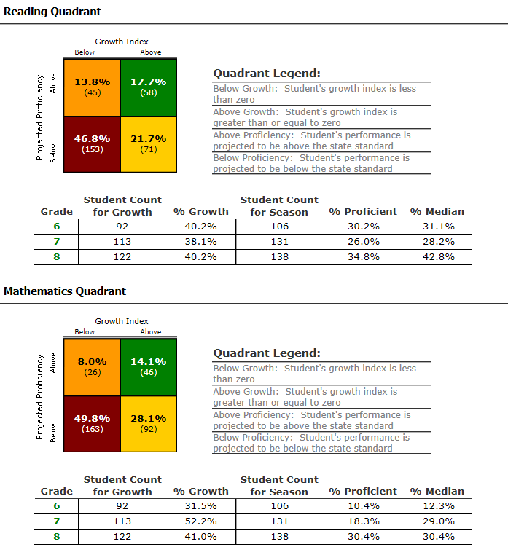

Spring MAP Results
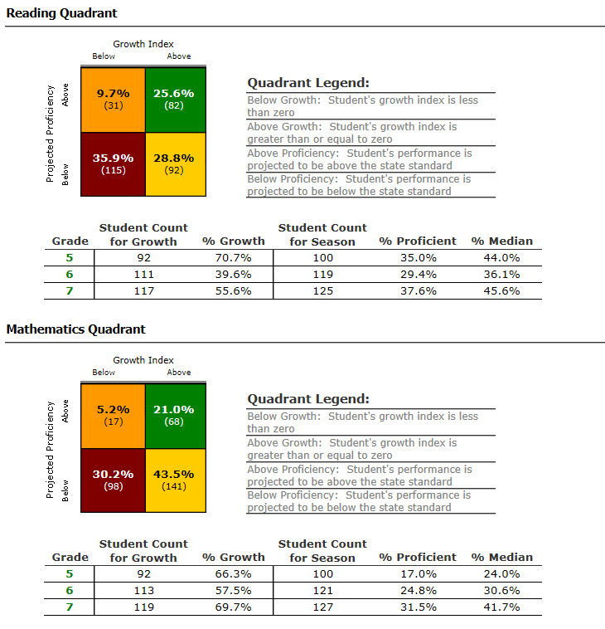

SBDM MONTHLY AGENDA AND MINUTES ATTACHED TO EACH REPORT
Attached

SURPRISES AND DELIGHTS!

