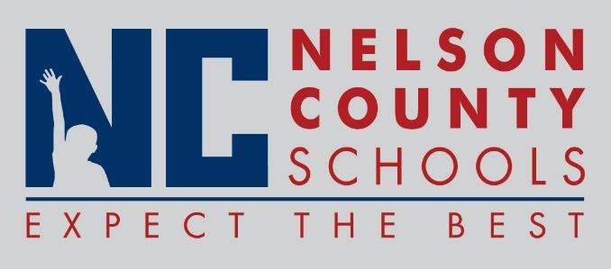

Decision Paper
To: | Nelson County Board of Education
From: | Bob Morris, Director of Student Support
cc: | Dr. Anthony Orr, Superintendent
Date: | June 19, 2017
Re: | Policy Updates for 2017-2018

RECOMMENDATION: Approve the below listed policy updates for 2017-2018 as written for their second reading.

01.1 Legal Status of the Board
01.11 General Power and Duties of the Board
01.111 District Planning
01.42 Regular Meetings
02.1311 Contract Renewal of Superintendent
02.4241 School Council Policies
02.4244 School Hiring (SBDM)
02.44 Accountability (SBDM)
02.441 Assessment of Student Progress
02.442 School Improvement CISP
03.11 Hiring (Certified)
03.2211 Salary Deductions (Classified)

03.112 Certification and Records (Certified)
03.1161 Coaches and Assistant Coaches/Sponsors
03.121 Salaries (Certified)
03.1211 Salary Deductions (Certified)
03.13253 Domestic/Dating Violence Reporting and
Education
03.18 Evaluation (Certified)
03.19 Professional Development (Certified)
03.21 Hiring (Classified)
03.2141 Nonteaching Coaches and Assistant Coaches (Classified)
03.221 Salaries (Classified)
03.23253 Domestic/Dating Violence Reporting and
Education (Classified)

RECOMMENDED MOTION: I move that the Nelson County Board of Education Approve the listed policy updates for 2017-2018.

